

**A Project Report On**

**Course Code -** MCA608A

**Course Name -** Mini Project on Open Source

**Submitted By:**

**Anitha Susan Alex (19MCA003)**

**(Academic Year - 2020-2021)**

**IN PARTIAL FULFILLMENT OF**

**Course Code and Name:** MCA608A - Mini Project on Open Source

**Name of Program: MCA Management**

**As prescribed by MIT-World Peace University**

**MIT-World Peace University School of Management PG, Pune**

# CERTIFICATE

This is to certify that Ms Anitha Susan Alex of MIT-WPU School of Management (PG) have successfully completed the desk research work titled Complaint Management System in partial fulfilment of requirement for **Course** MCA608A **Code and Name** Mini Project on Open Sourceasprescribed by the **MIT-World Peace University**.

This Report is the record of authentic work carried out during the academic year 2020-21.

|  |  |  |
| --- | --- | --- |
| **Dr. Ashish Kulkarni** |  | **Prof. Sagar Kulkarni** |
|  |  | Prof. Dr. T. J. Vidyasagar  Head of School  MITWPU SoM(PG) |

# DECLARATION

I, Ms. Anitha Susan Alex hereby declare that this Research Report is the record of authentic work carried out by us during the academic year 2020-21 and has not been submitted to any other University or Institute towards the award of any degree.

|  |  |  |
| --- | --- | --- |
| **19MCA003** | **Anitha Susan Alex** |  |

# PROJECT DESCRIPTION

**Title –** Complaint Management System

**Team Involved:**

**Member 1 -** Anitha Susan Alex (19MCA003)

# INDEX

|  |  |  |
| --- | --- | --- |
| **SR.NO.** | **TITLE** | **PAGE NO.** |
| 1 | Overview | 6 |
| 2 | Objectives of the System | 7 |
| 3 | Development Environment | 8 |
| 4 | Screen Shots | 9 - 42 |
| 5 | Code Snippet | 43 - 115 |
| 6 | References | 116 |

## 1. Overview of the Project:

Complaint management is the process by which companies handle customer's complaints. It is a management technique for assessing, analyzing and responding to customer complaints. If managed effectively, complaints can help business grow and improve its operations.

Complaints management system is used to record, resolve and respond to customer complaints, requests as well as facilitate any other feedback.

In this project, the customer can register and then login to lodge complaints (or feedback, bugs, comment), check status of complaint, view all complaints and check whom the complaint is assigned to.

The admin can login to view complete complaint list, respond to a complaint or assign a complaint to a particular employee in a department.

The status of complaint is automatically set according to the actions performed by the user and the status can be viewed by the user.

The status of complaint form can be:-

* **Submitted:** If the form is filled and submitted successfully.
* **Viewed:** If the form is viewed by admin.
* **Assigned:** If the form is assigned to another employee.
* **Responded:** If the form is responded by the admin itself.

## 2. Objectives of the System:

### Existing System:

* The customer either has to call or go to the organization to complain.
* Poor customer service that would lead to loss of business.
* The customers have no clarity of their complaints that is if they are being processed or resolved.
* The complaints can be checked by someone who is not concerned with it, i.e., lack of security.
* There are too many manual working involved in the existing system that can be time-consuming and hectic.

### Need for Computerization:

To make complaints easier to coordinate, monitor, track and resolve, and to provide company with an effective tool to identify and target problem areas, monitor complaints handling performance and make business improvements.

## 3. Development Environment:

### Database Server:

MySQL 5.7.31

### Web Server:

Apache 2.4.46

### Software:

Software for coding: Sublime Text 3, Notepad++

Back-end Technology: PHP, MYSQL

Server: Wamp server

### Front End:

HTML, CSS, JavaScript

## 4. Screen Shots (Input Screens and Report Screens):

### Common Pages -

**1.** **Home Page** - index.php & home.php

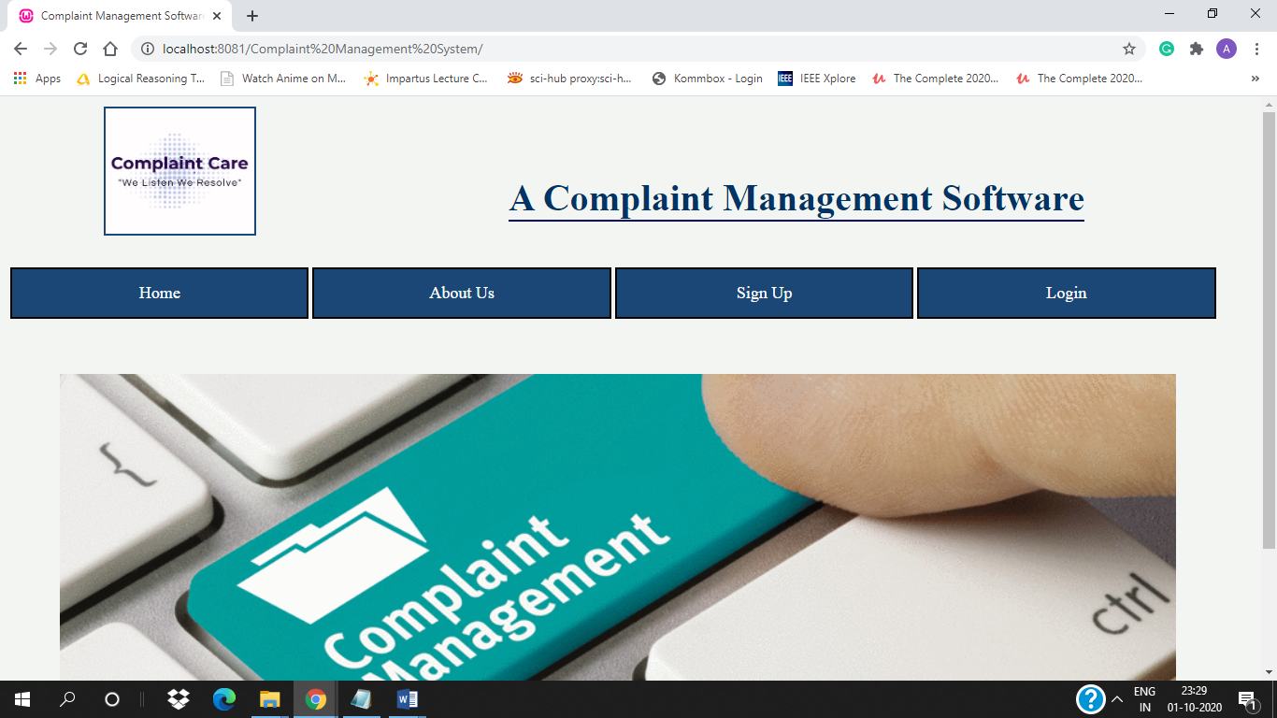

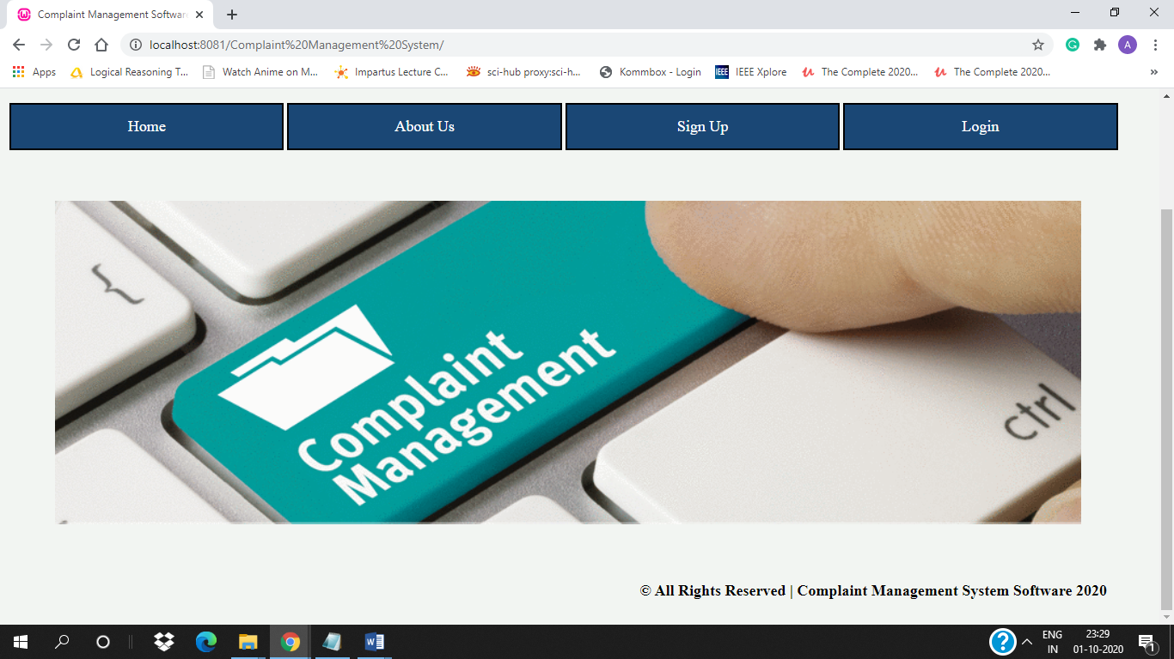

**2. About Us Page** - about_us.php

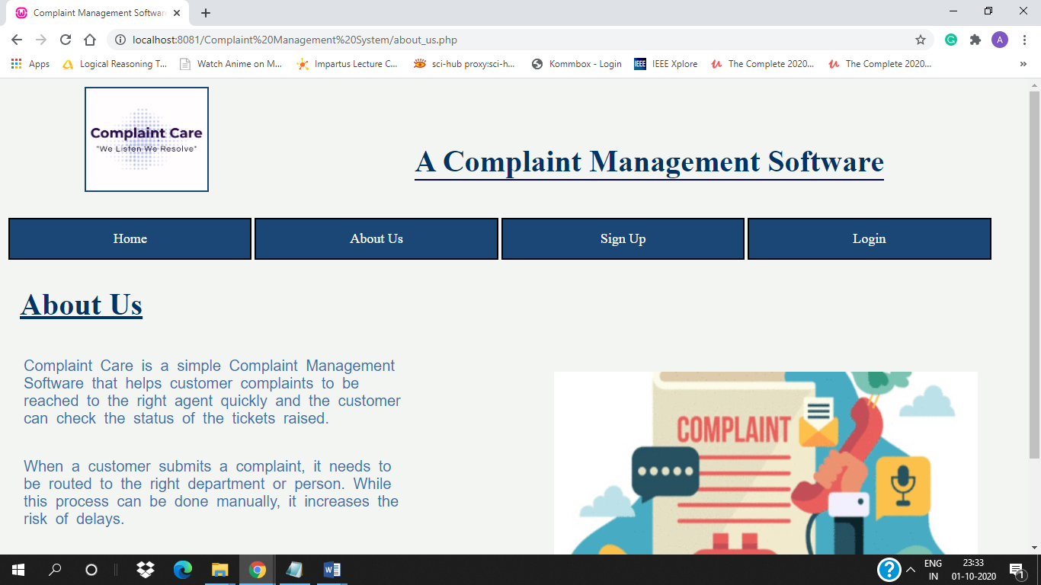

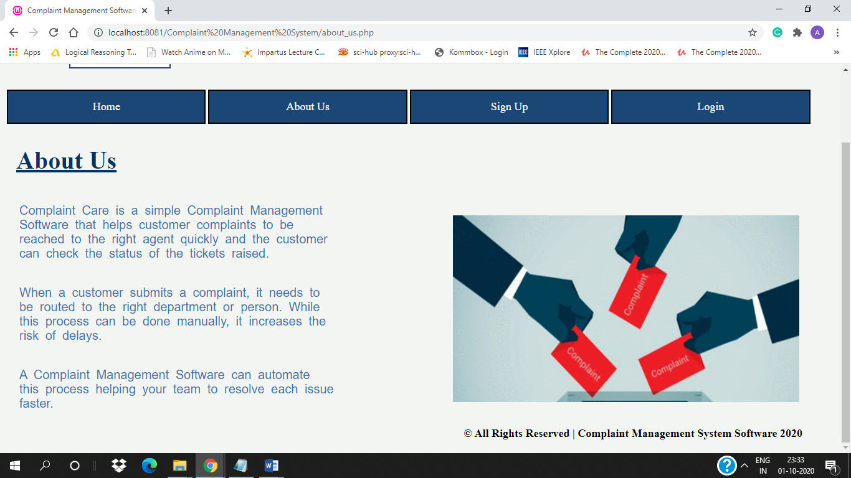

**3.** **Registration for Customer** - register.php

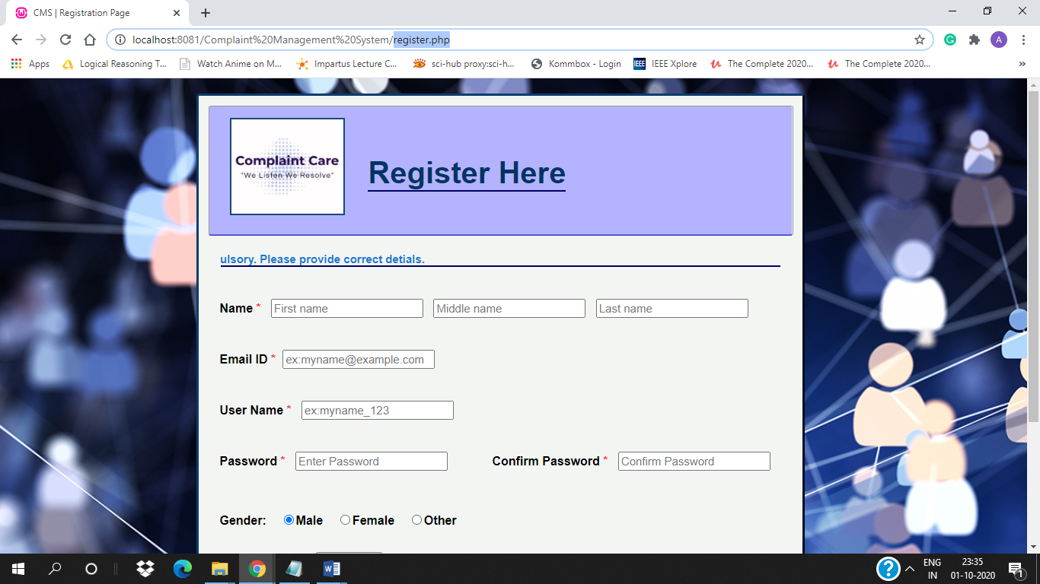

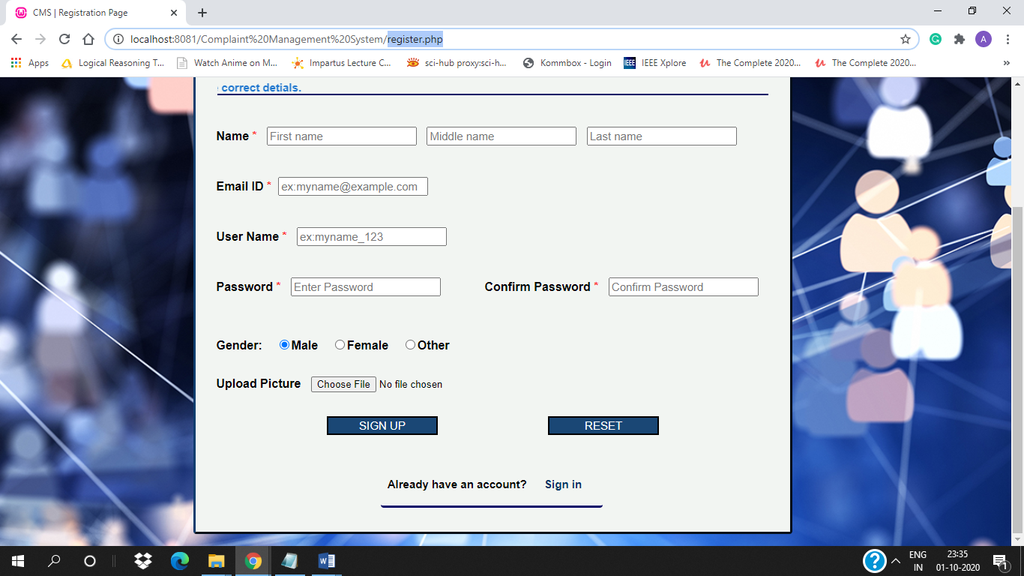

Validation of email, password and confirm password –

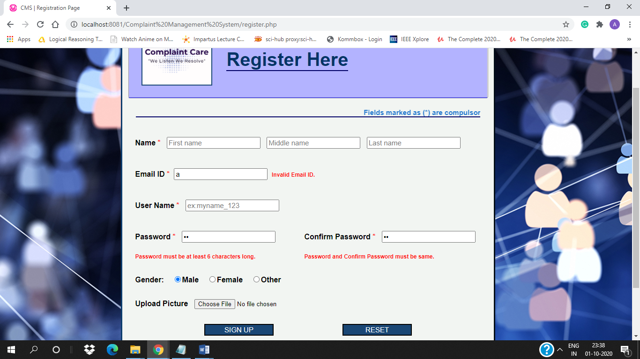

If username exists –

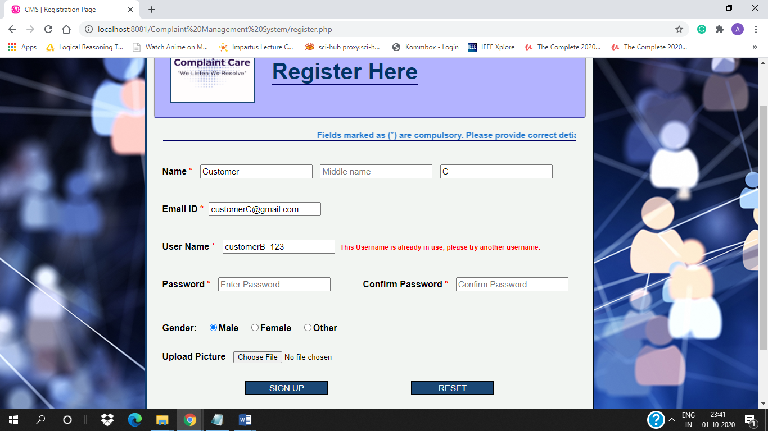

If email id already in use –

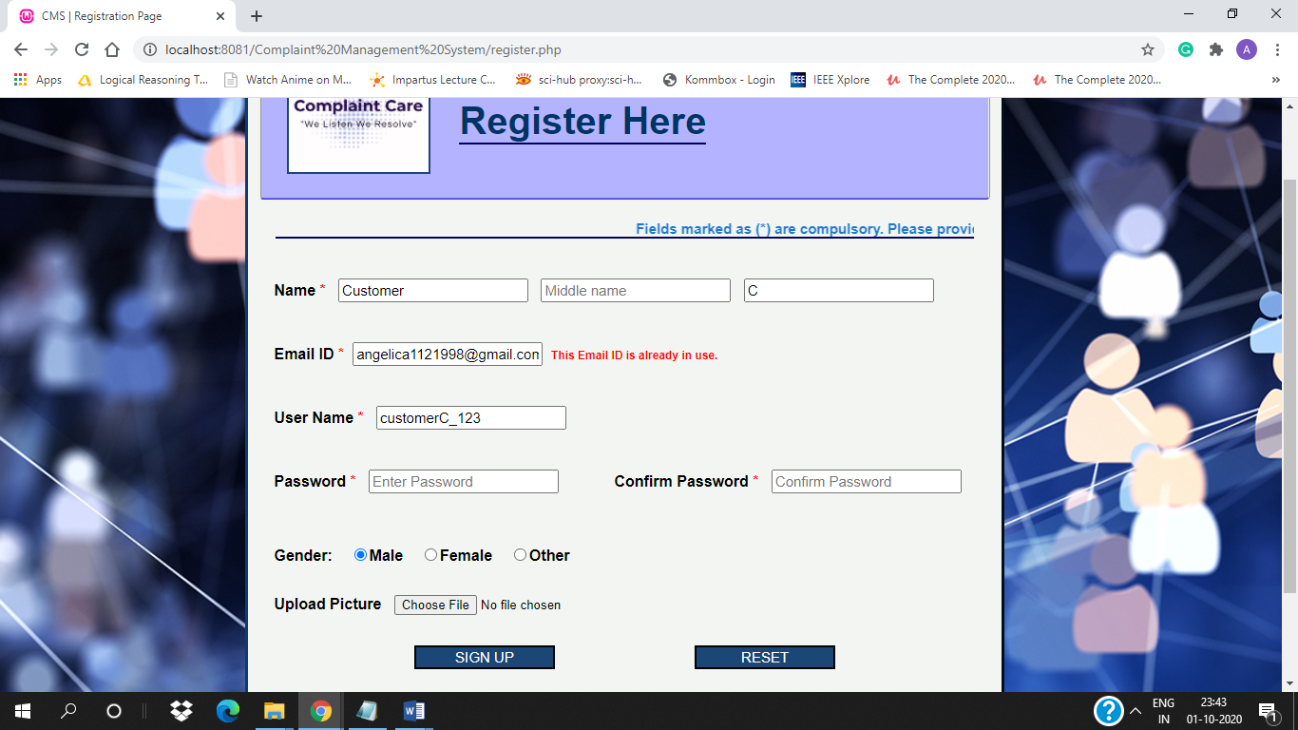

If form submitted successfully –

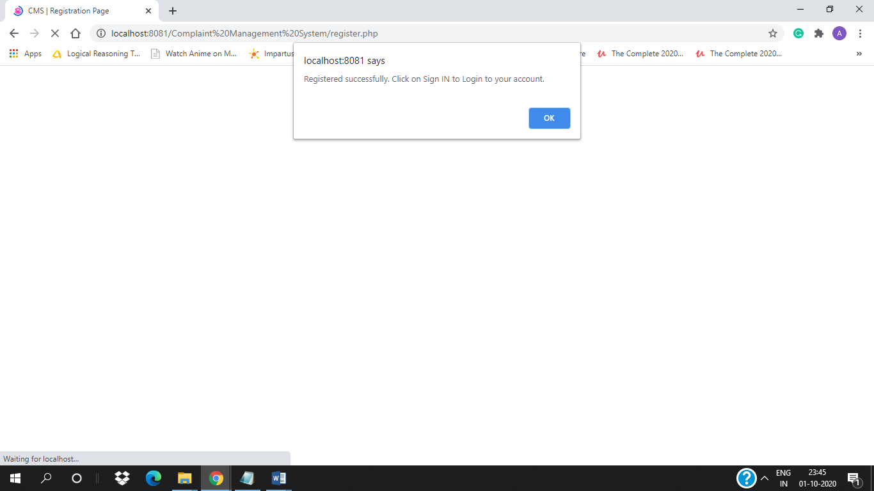

**4. Login Page for admin and customer** - login.php

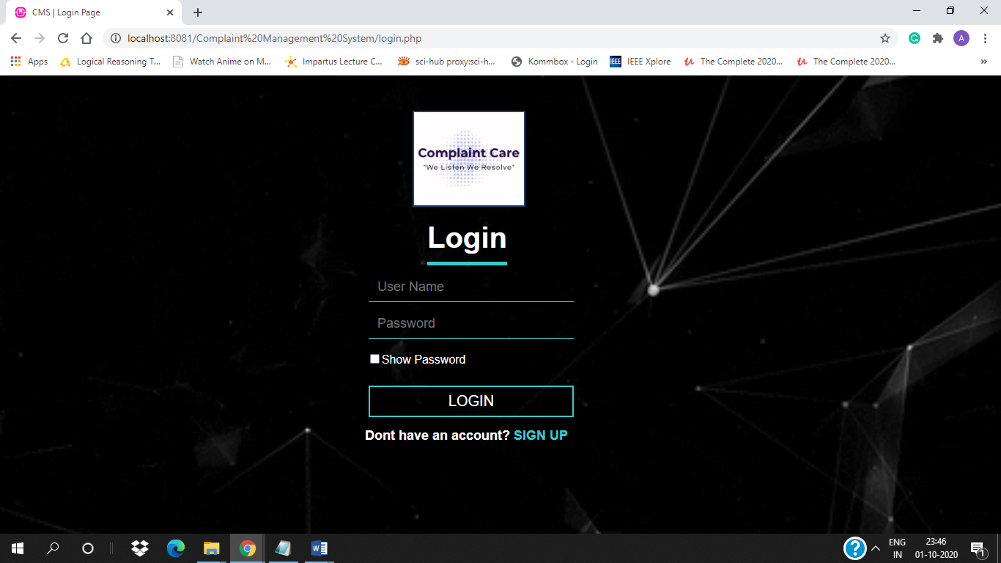

If login credentials are wrong –

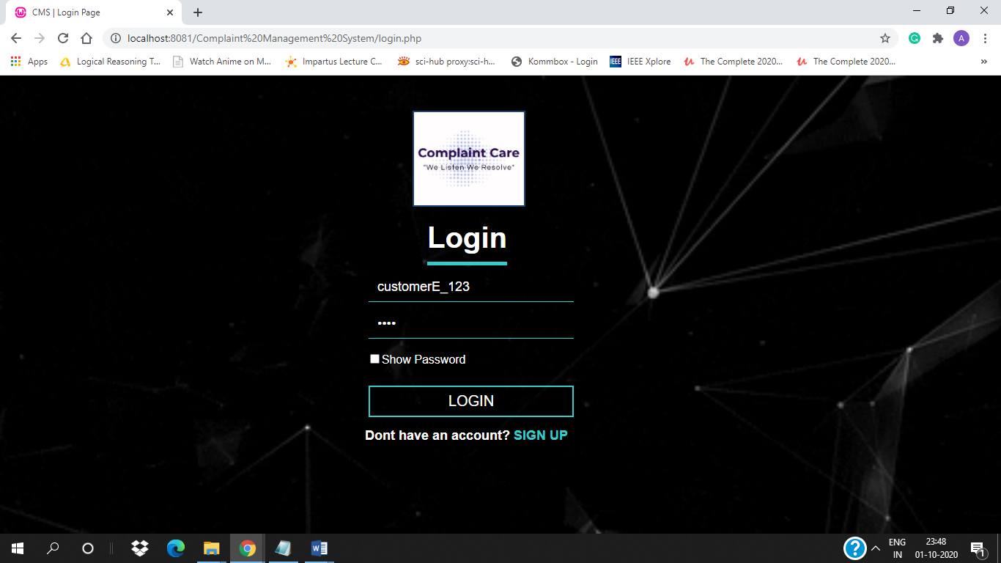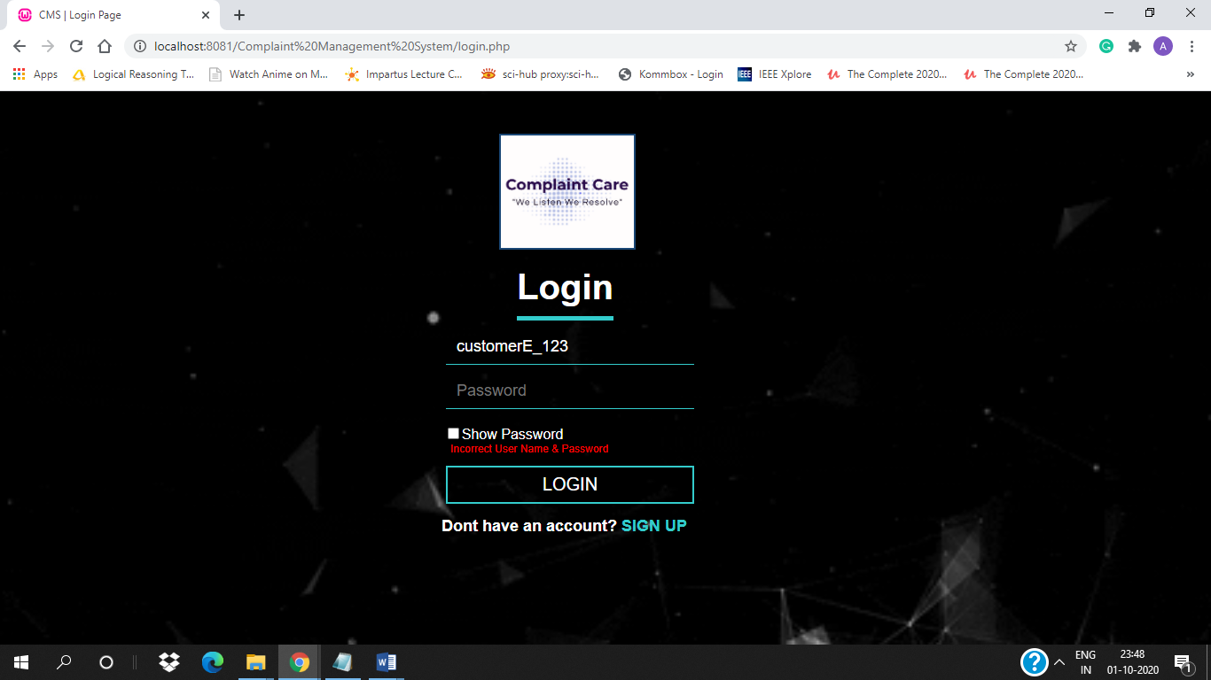

If show password is checked –

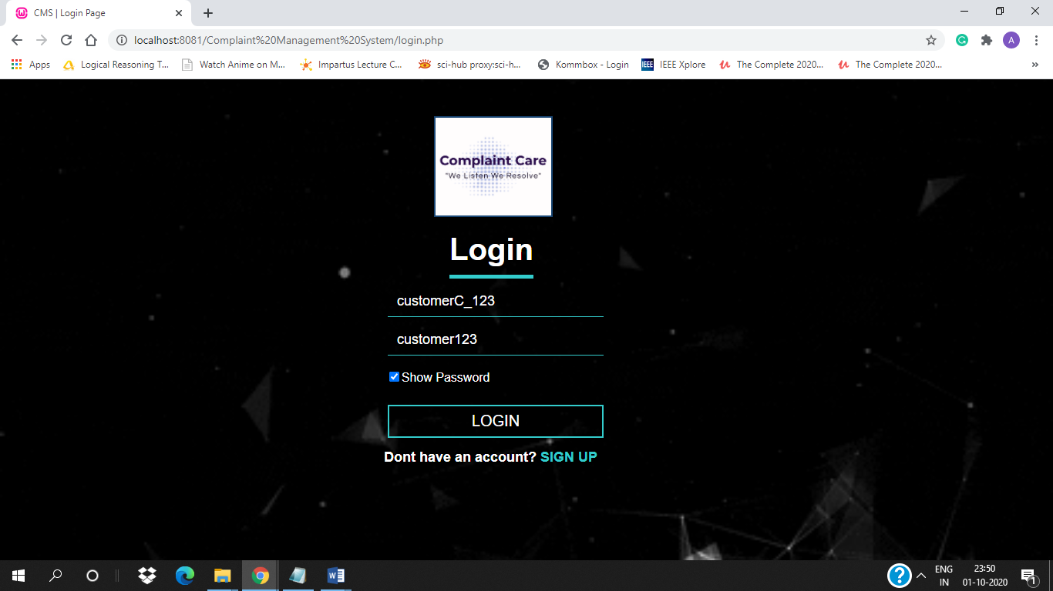

If password is wrong –

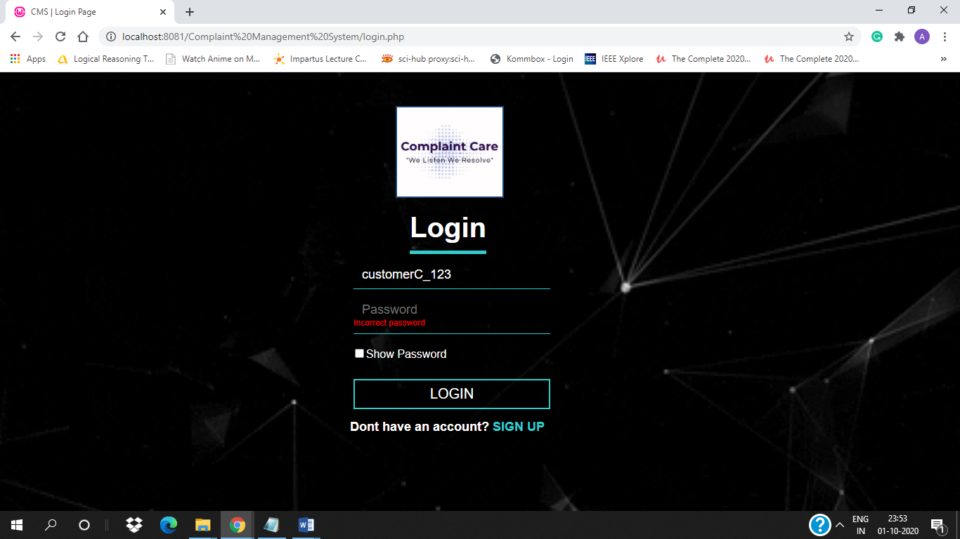

If login was successful for customer – [customer_dashboard.php]

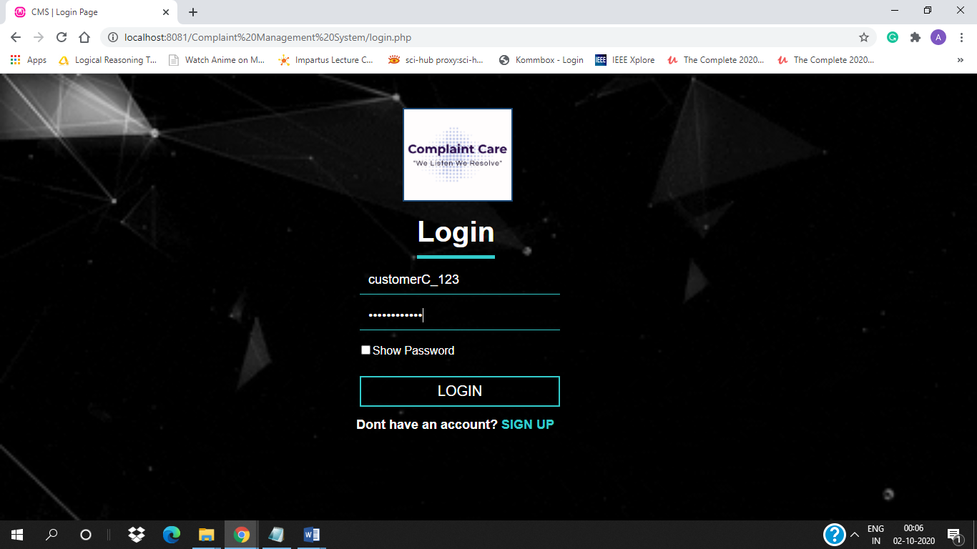

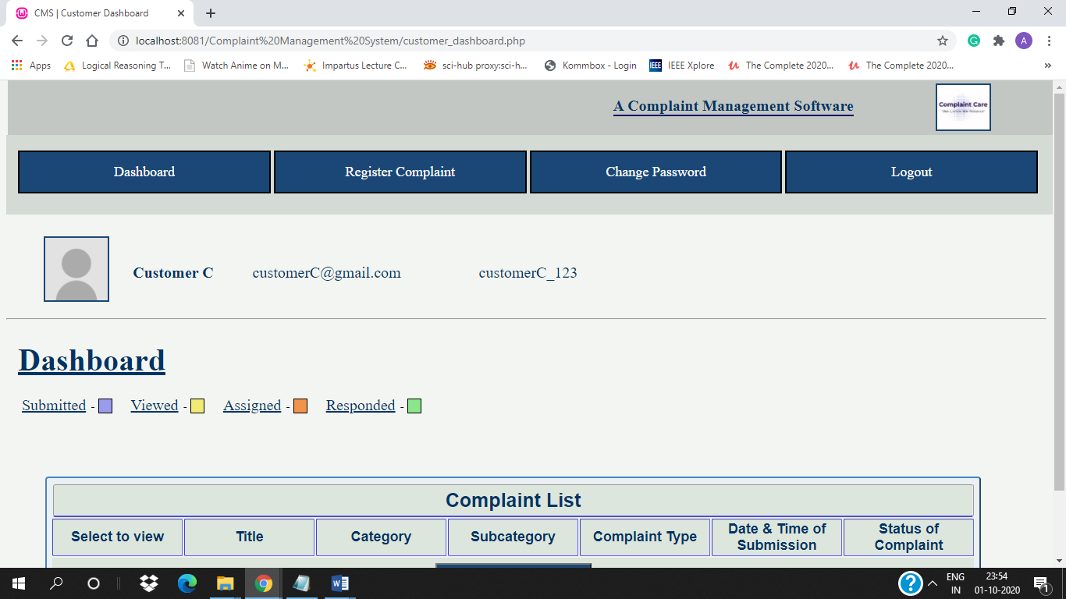

If login was successful for customer – [admin_dashboard.php]

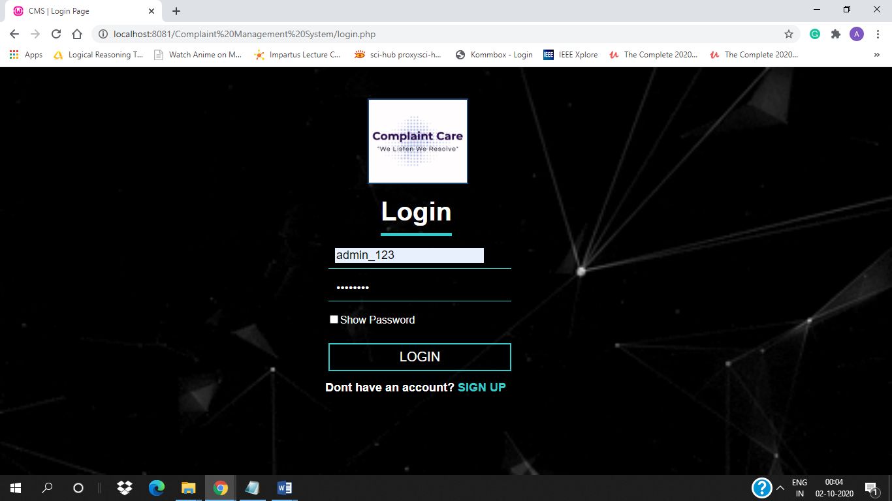

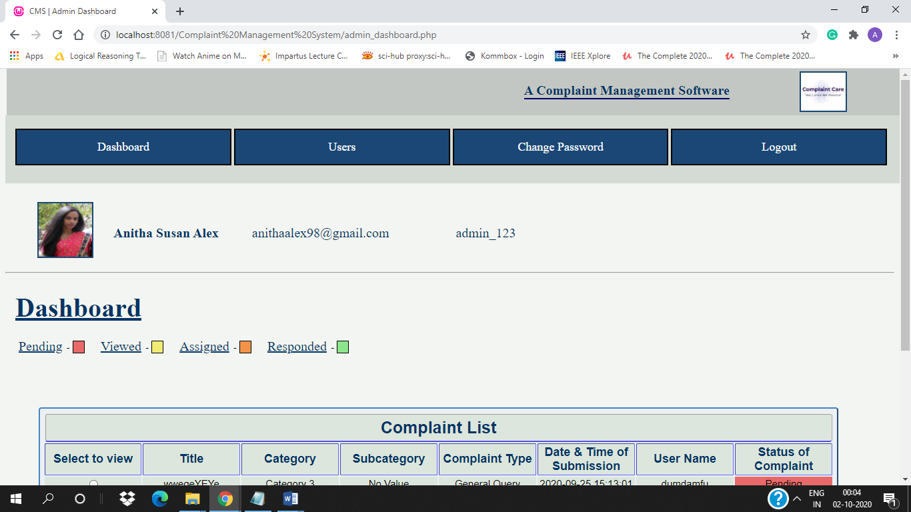

### Admin –

**1. Admin Dashboard** – [admin_dashboard.php]

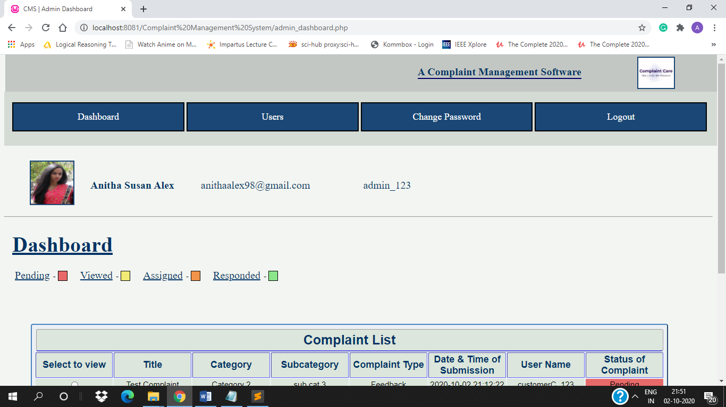

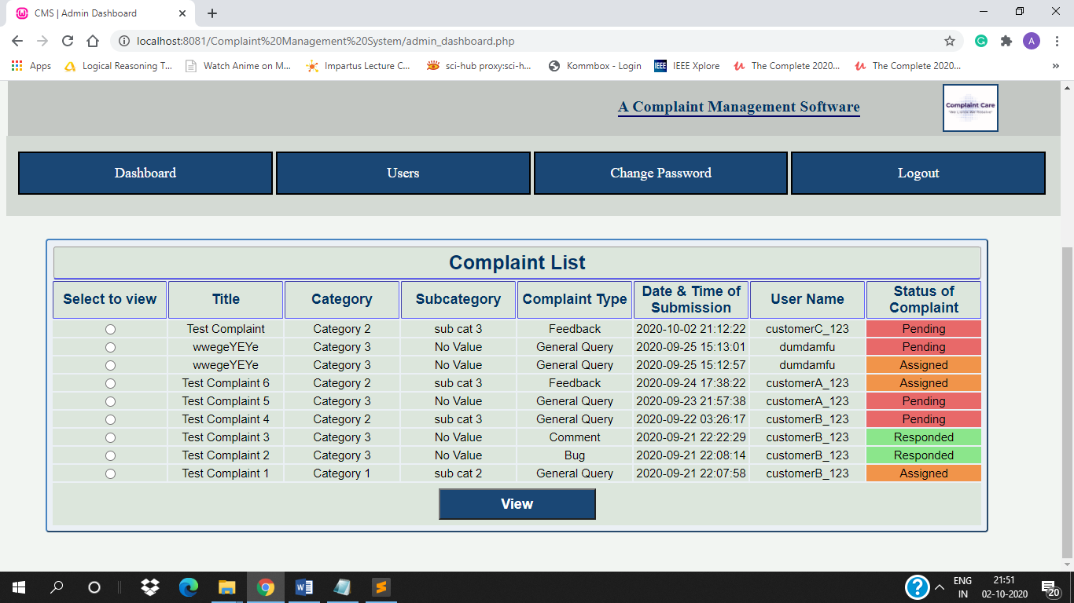

**2. View Complaint Form** – [manage_complaint.php]

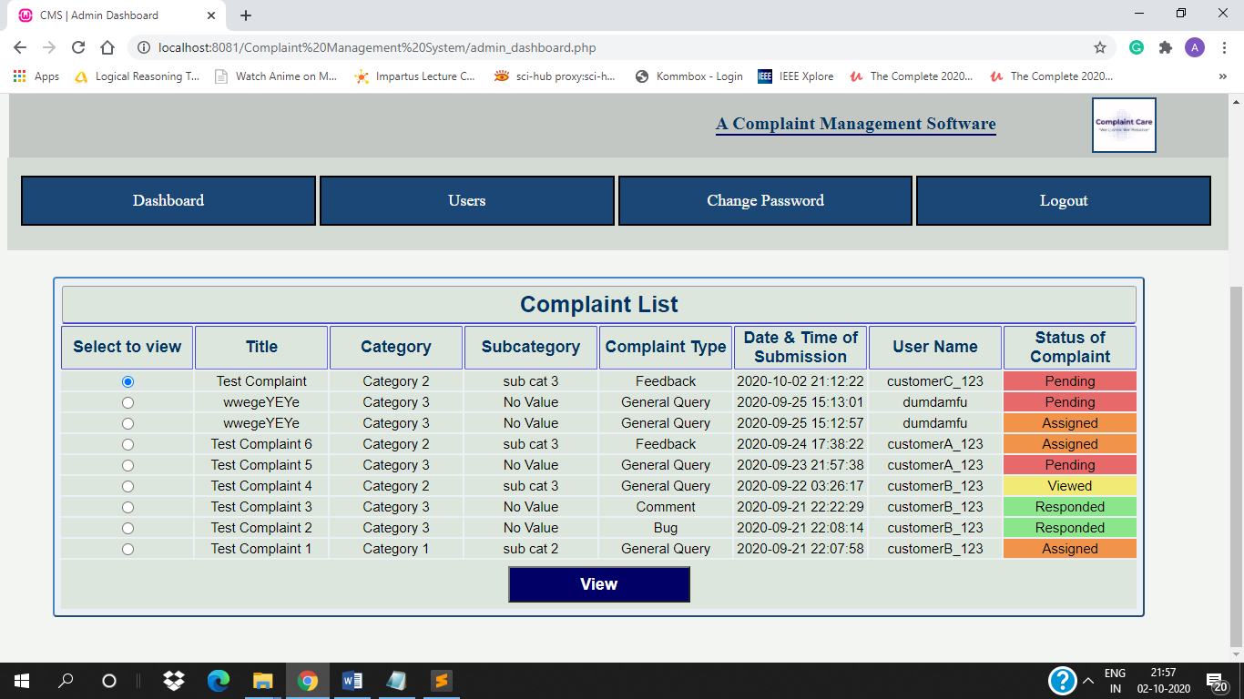

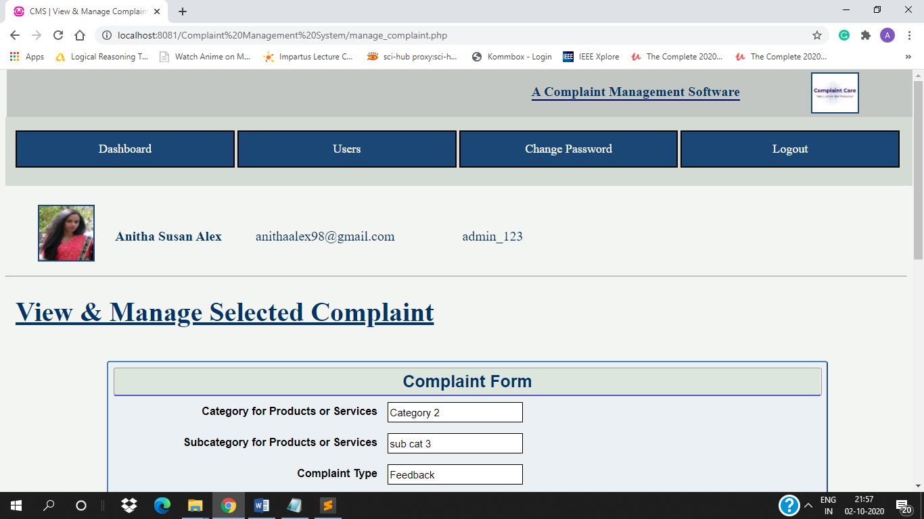

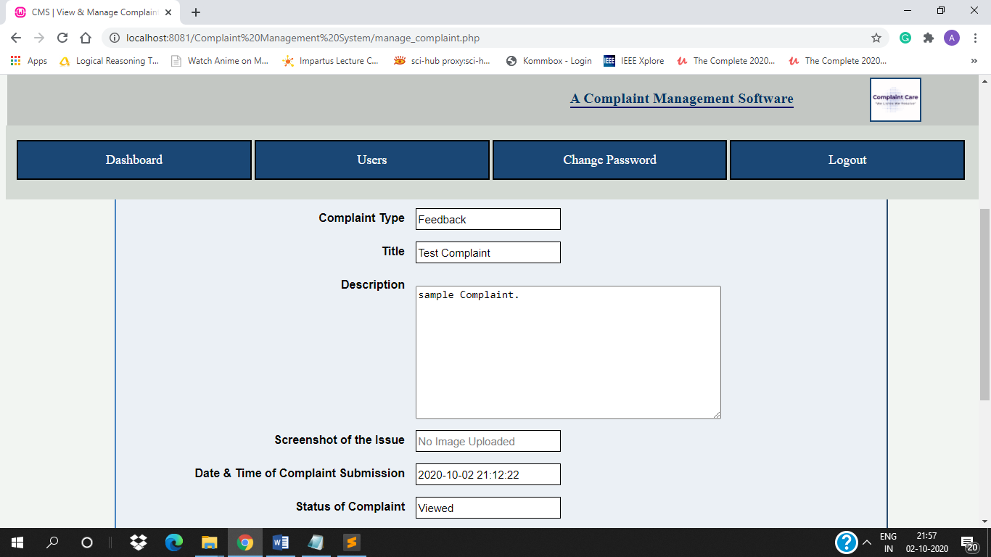

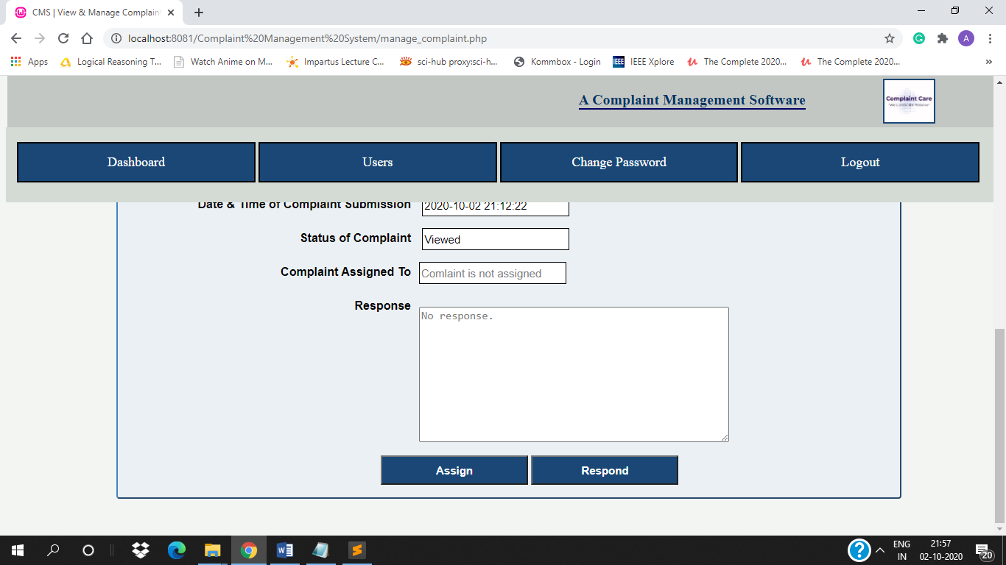

**3. Assign Complaint –** [assign_complaint.php]

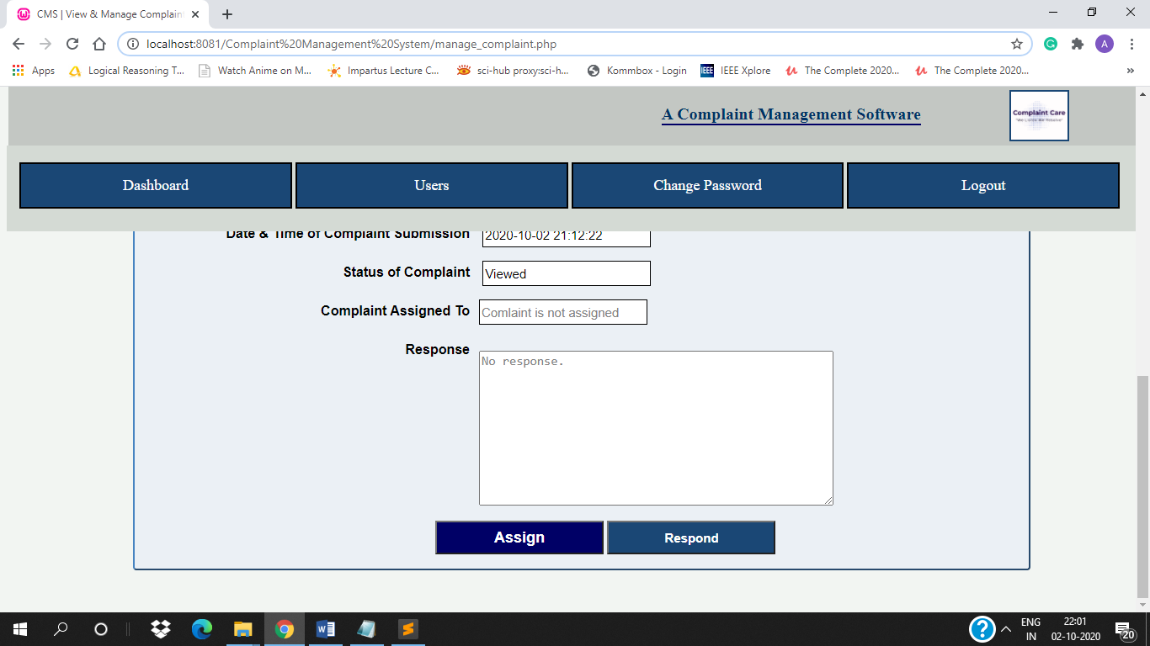

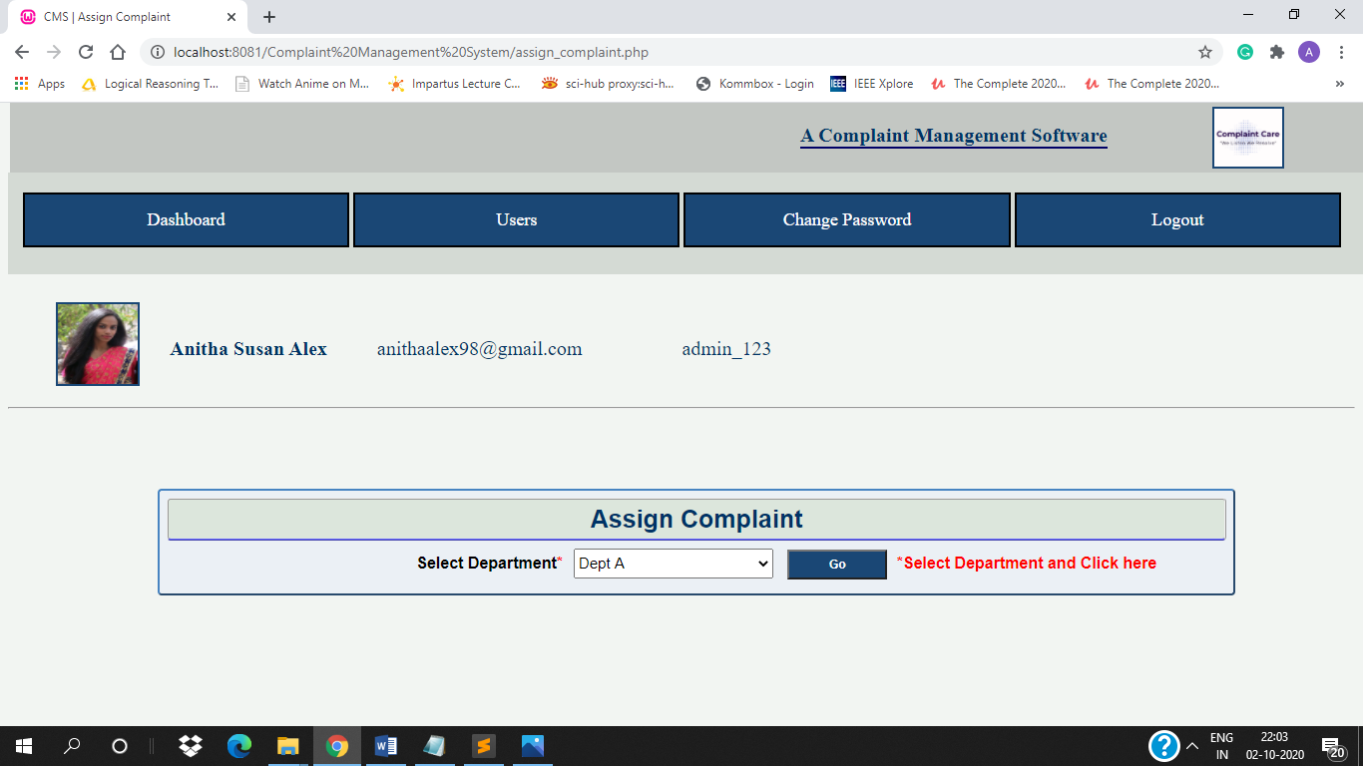

After selecting Department and clicking on button –

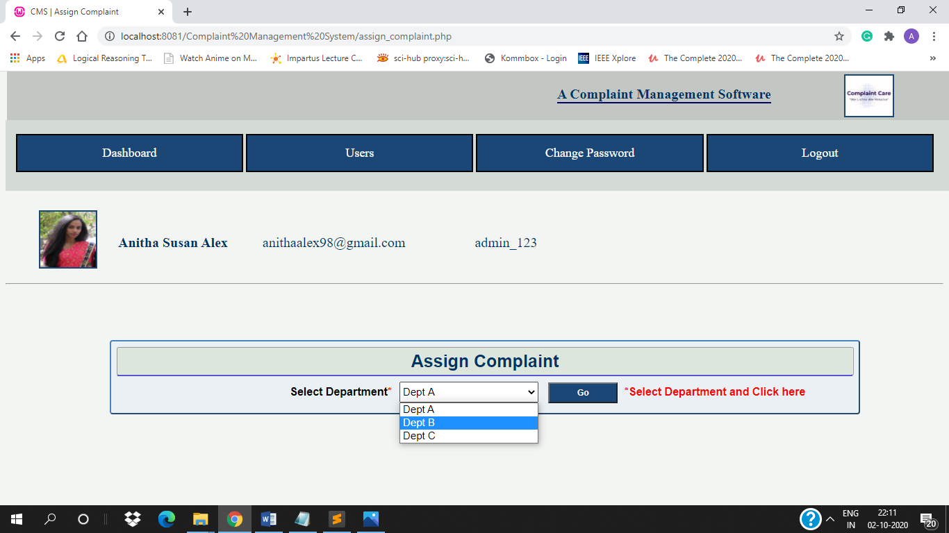

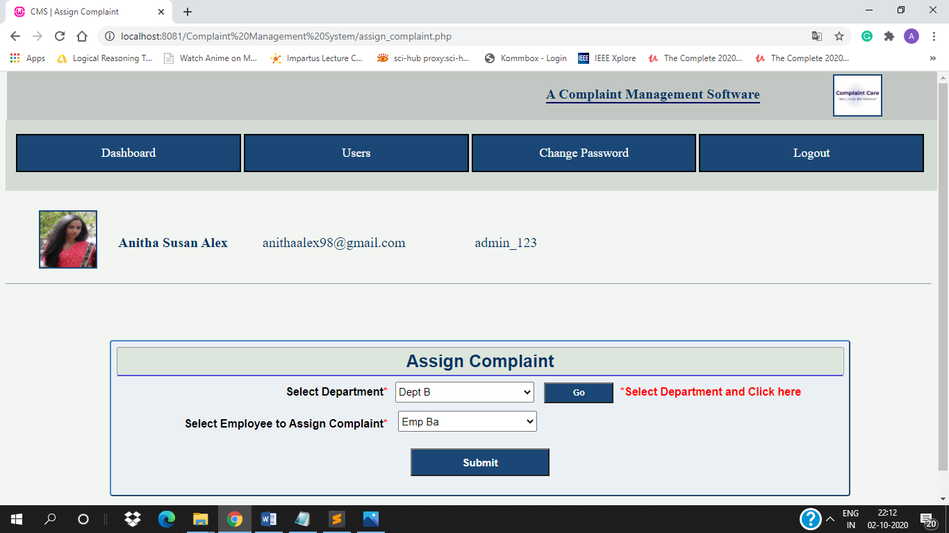

After filling form –

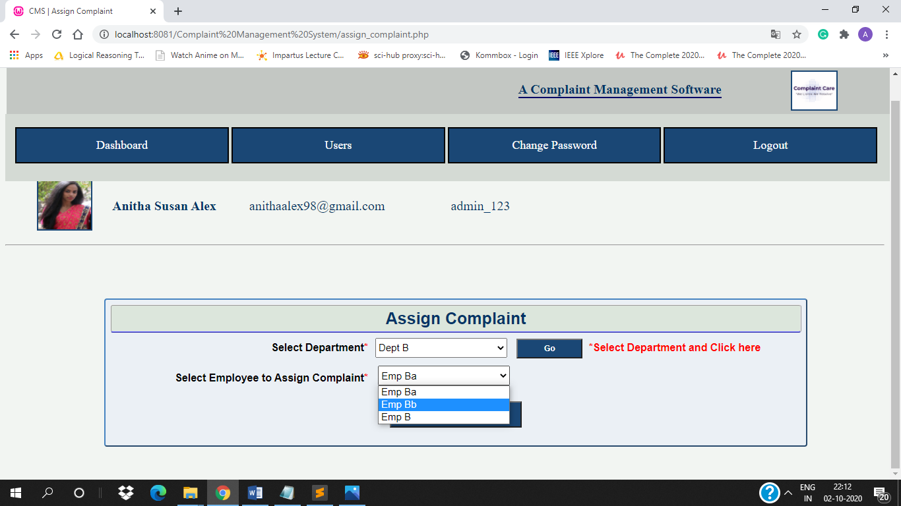

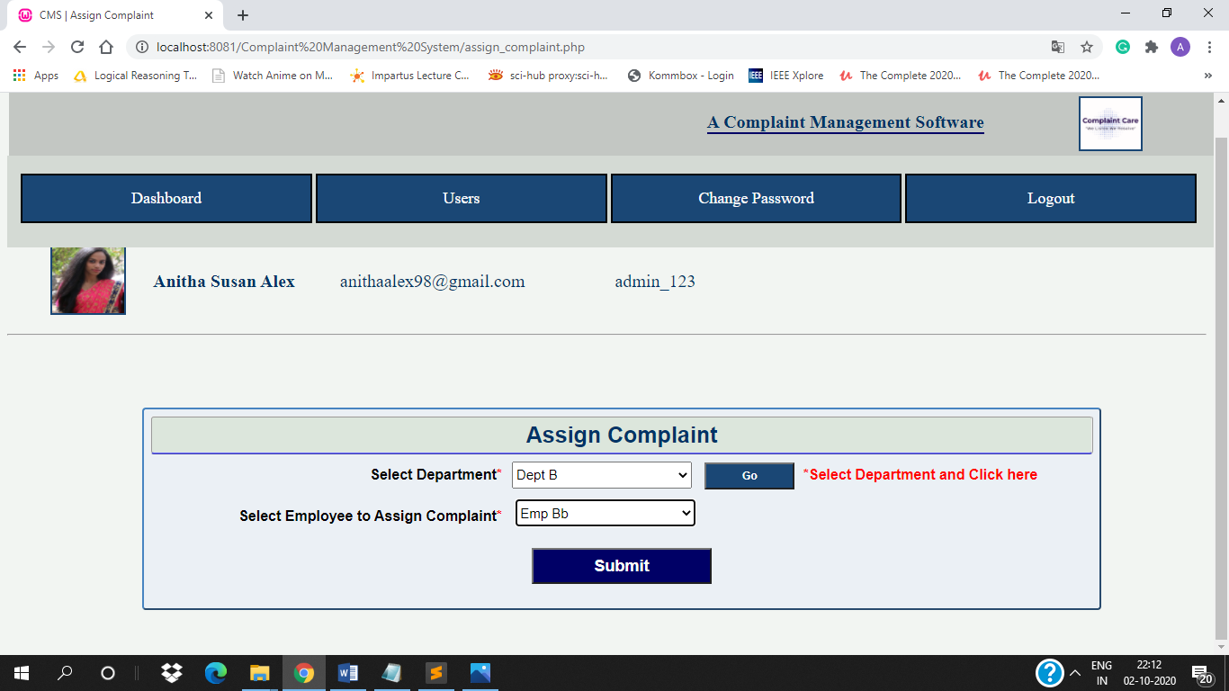

After submitting form –

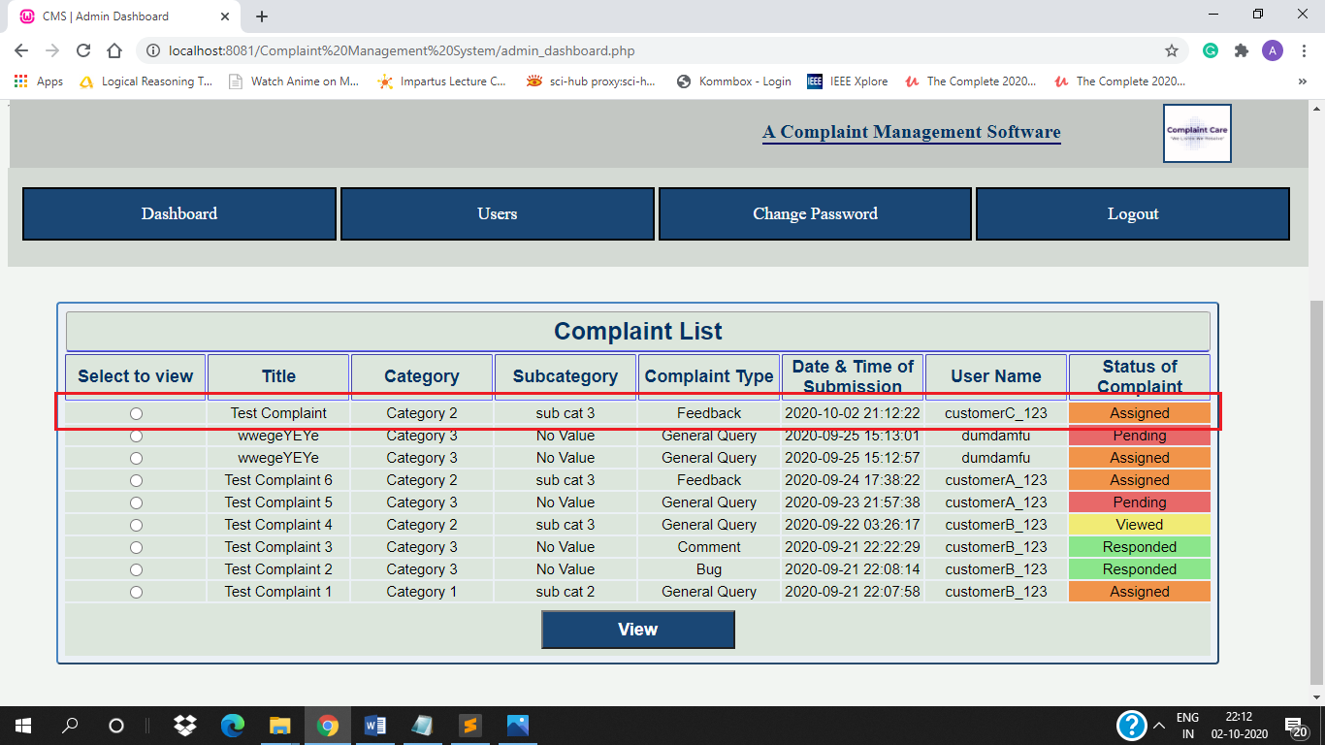

**4. Responded by Admin** – [respond_complaint.php]

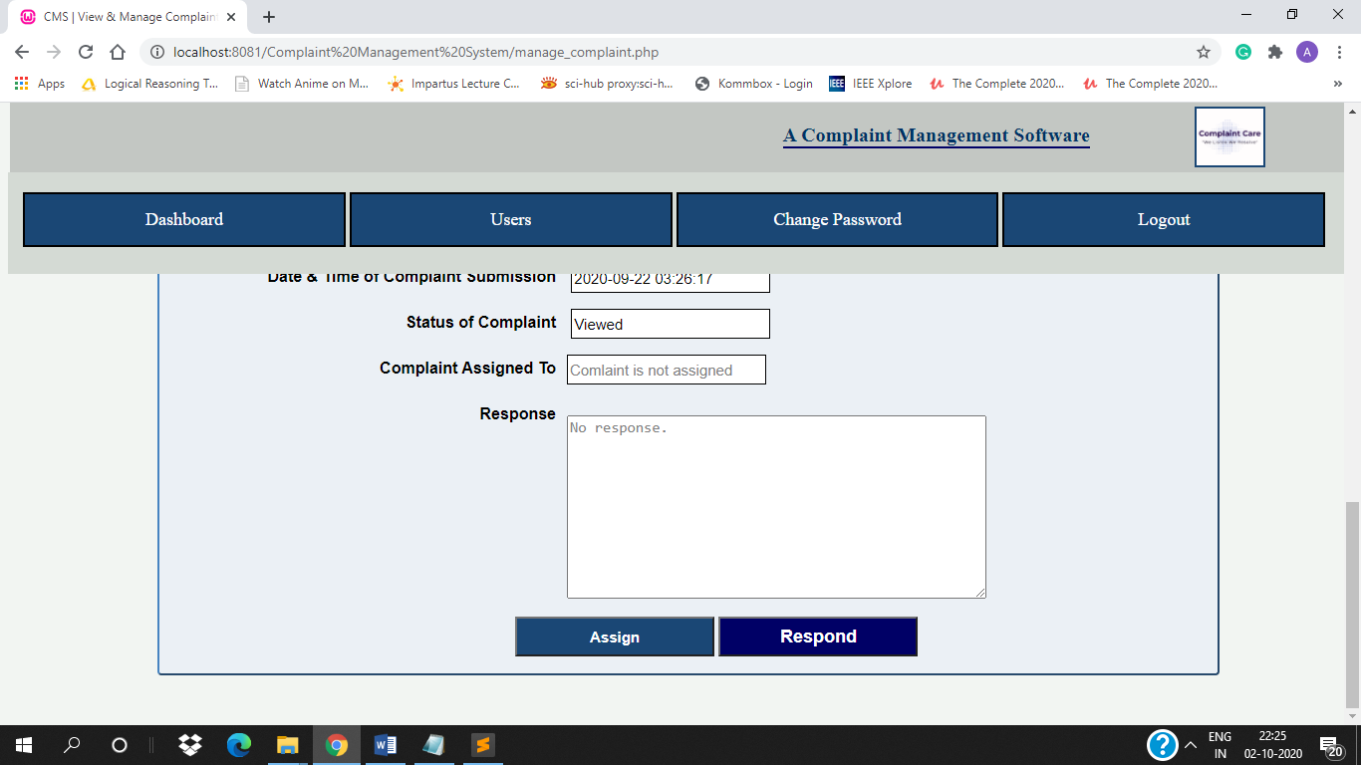

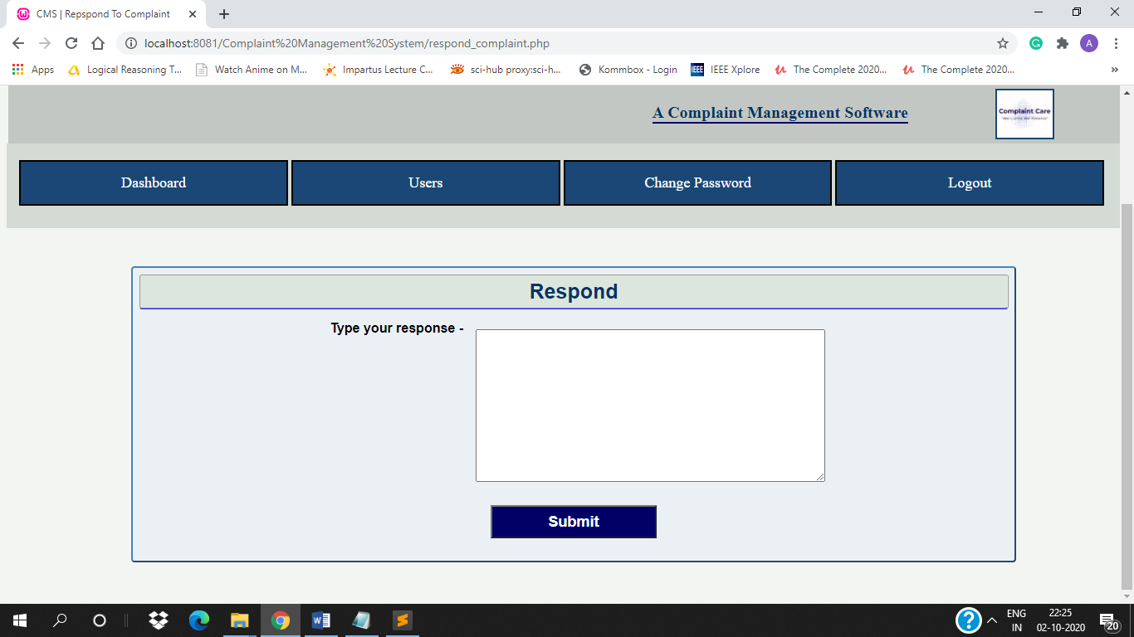

After filling and submitting form –

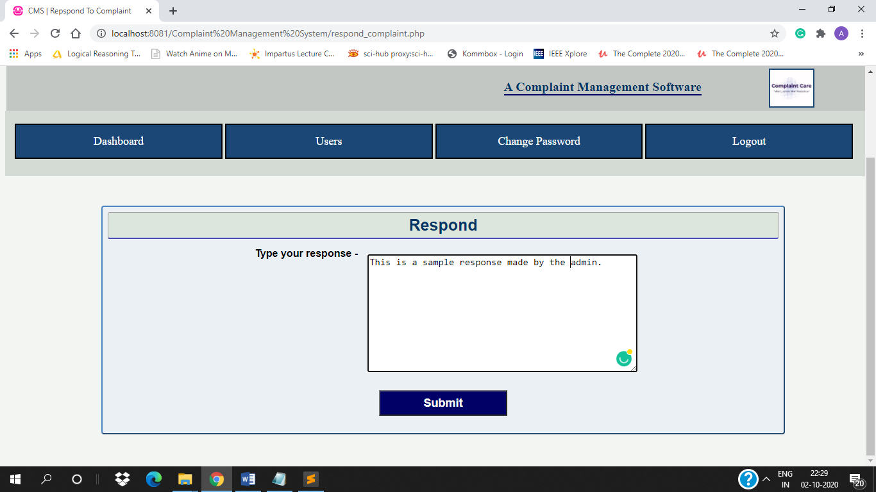

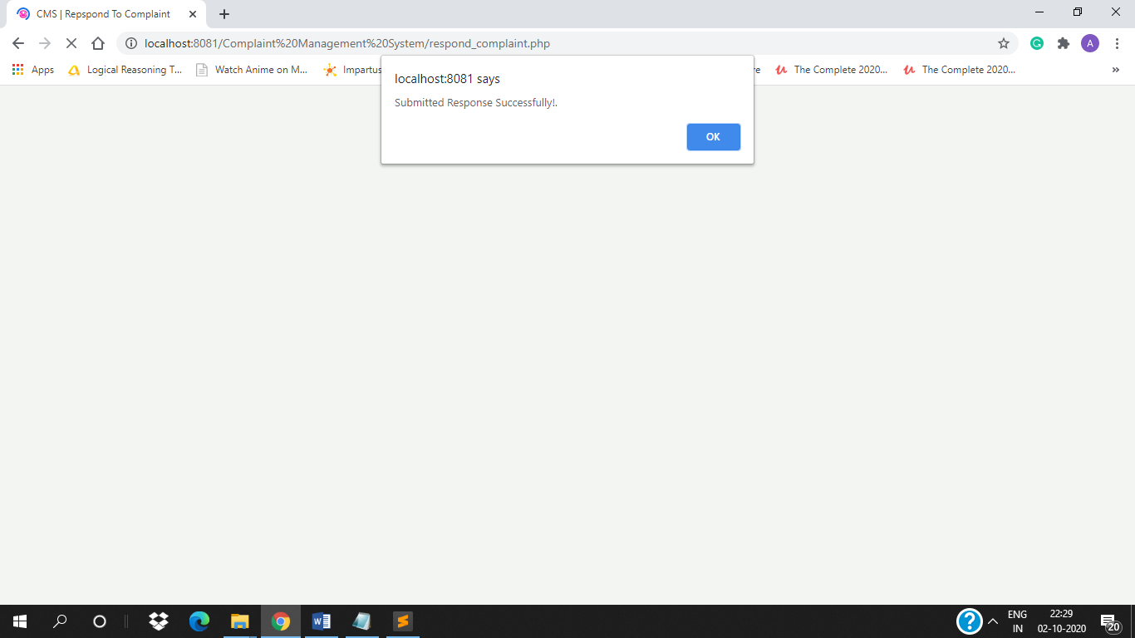

**5. User List** – [view_users.php]

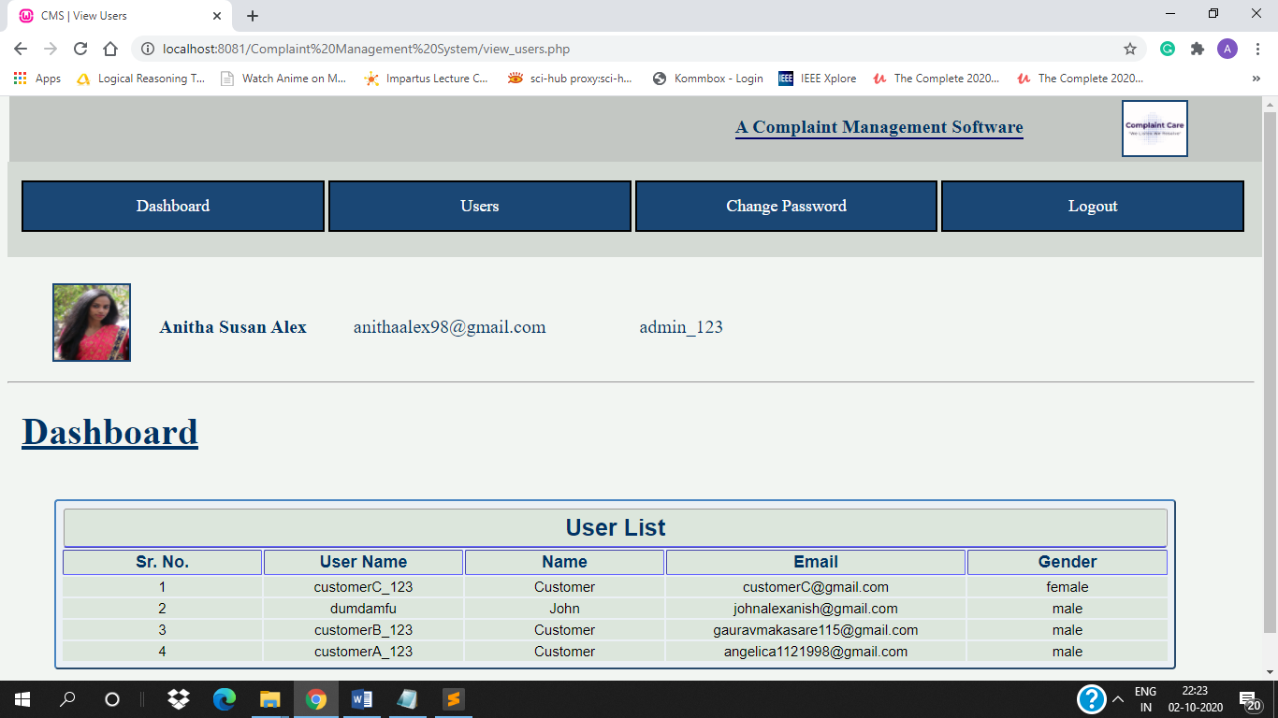

**6. Change Password** – [change_password_admin.php]

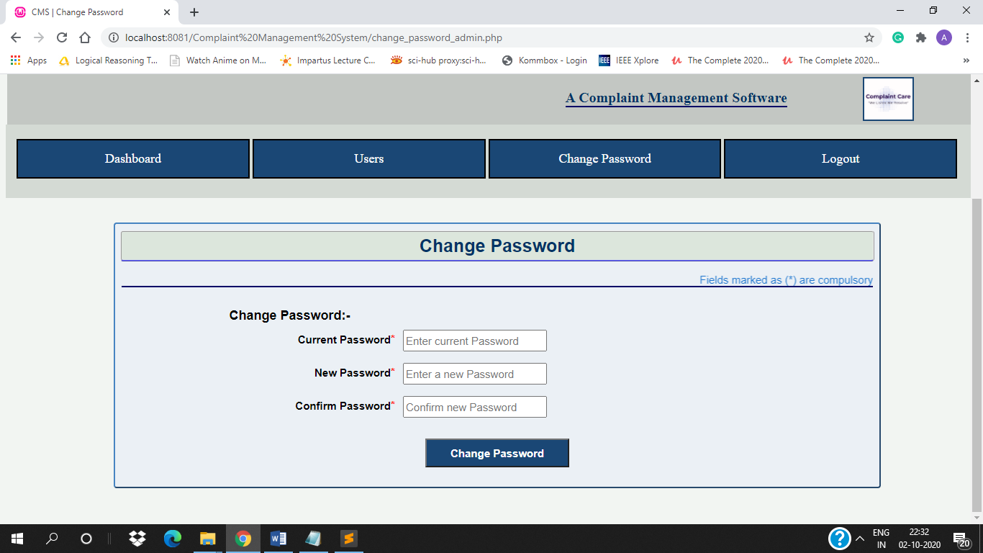

Validating password –

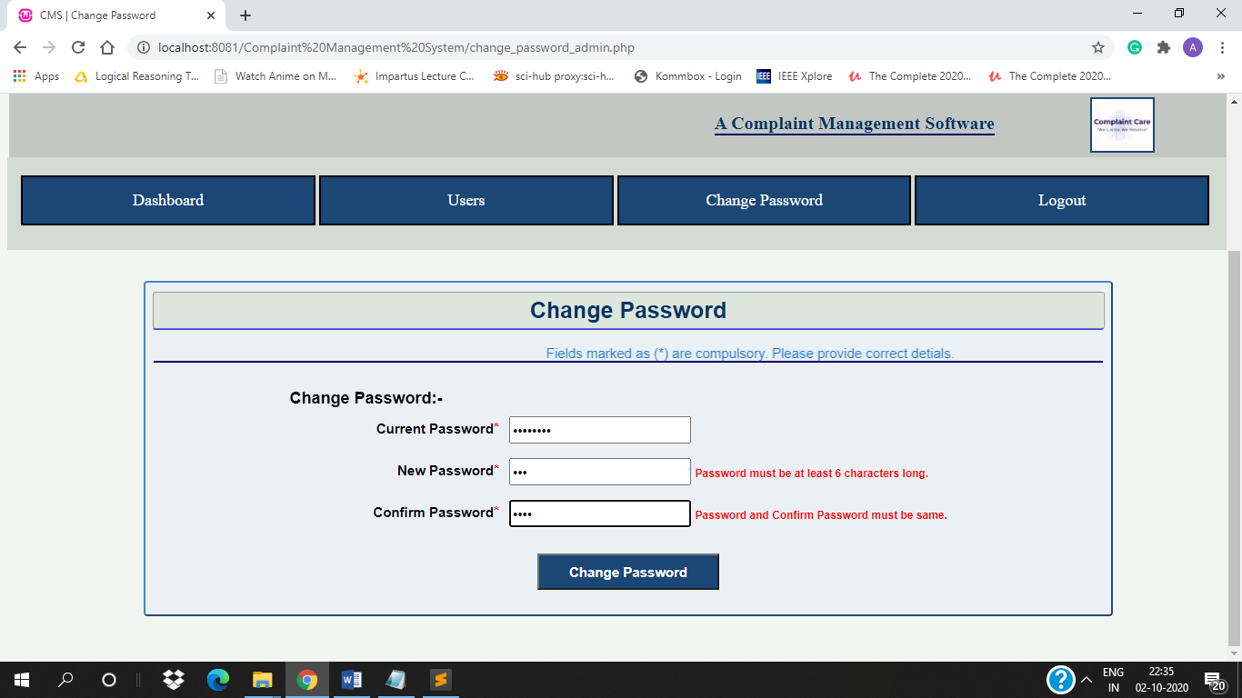

If Current Password is wrong –

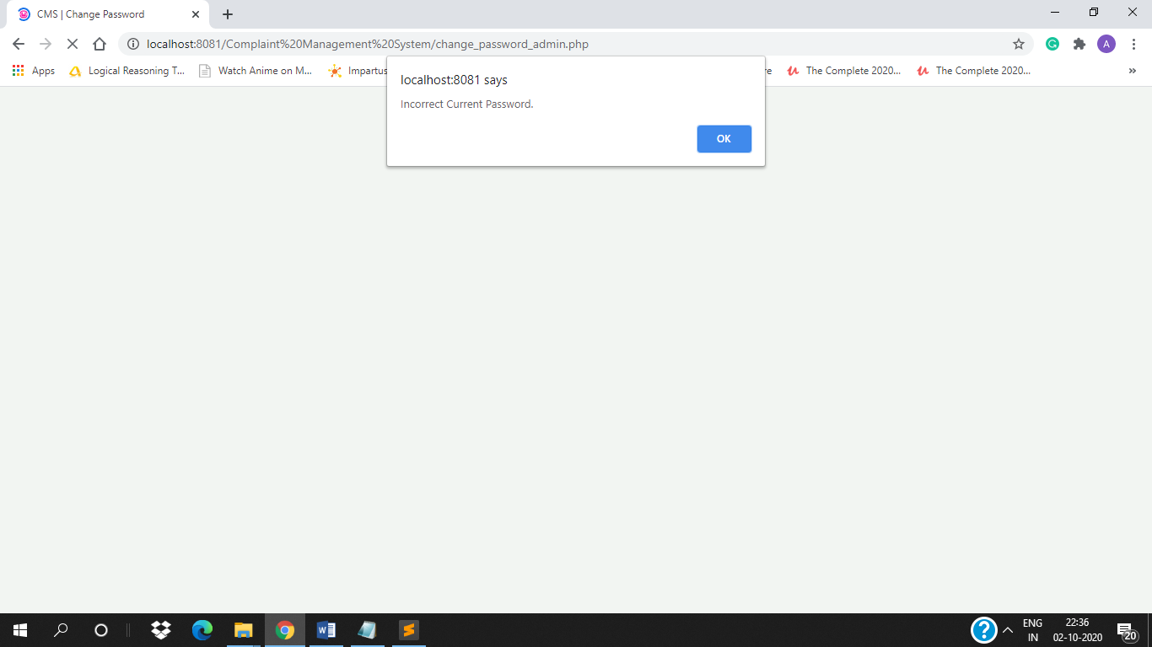

After filling form and submitting –

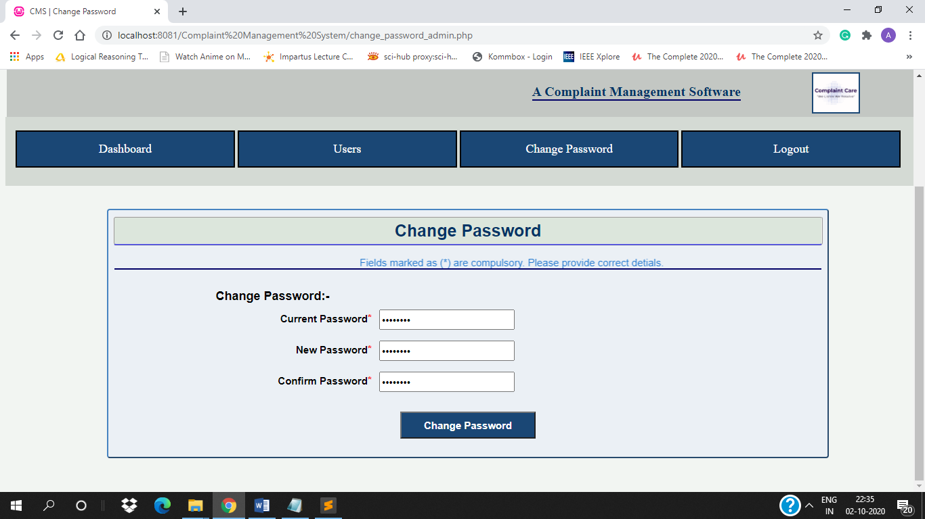

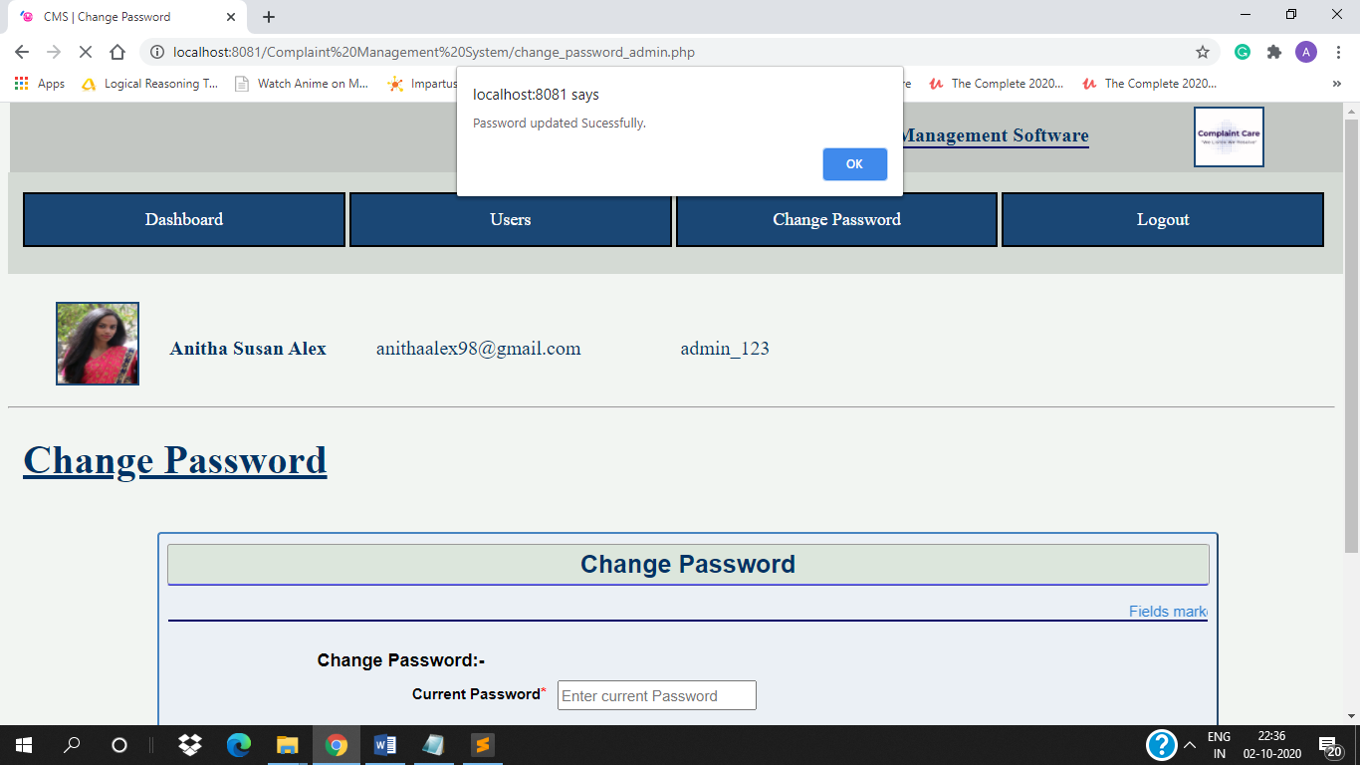

### Customer –

**1. Register Complaint** – [register_ticket.php]

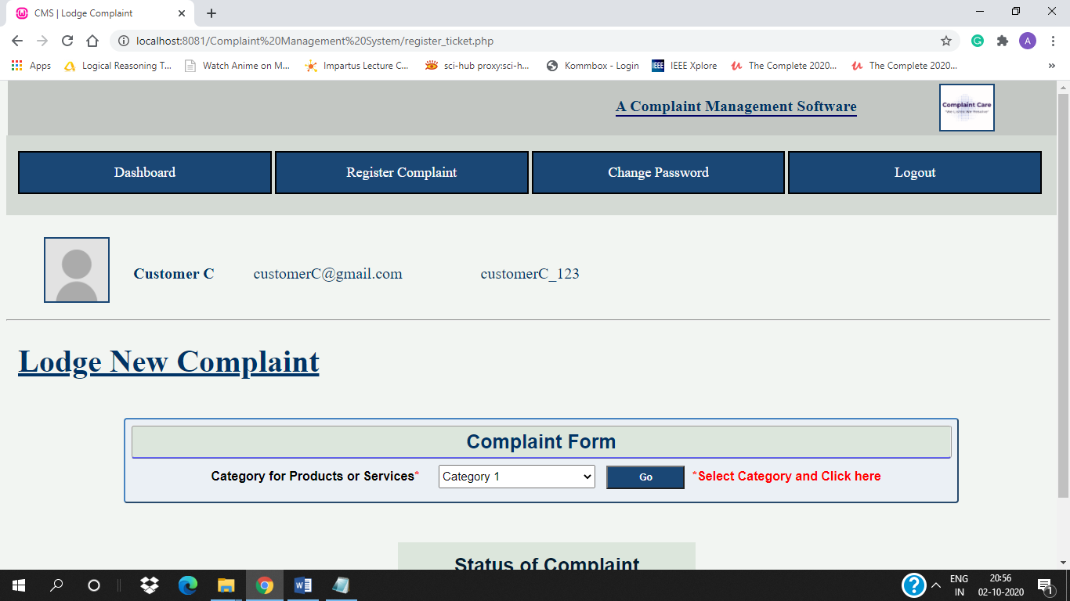

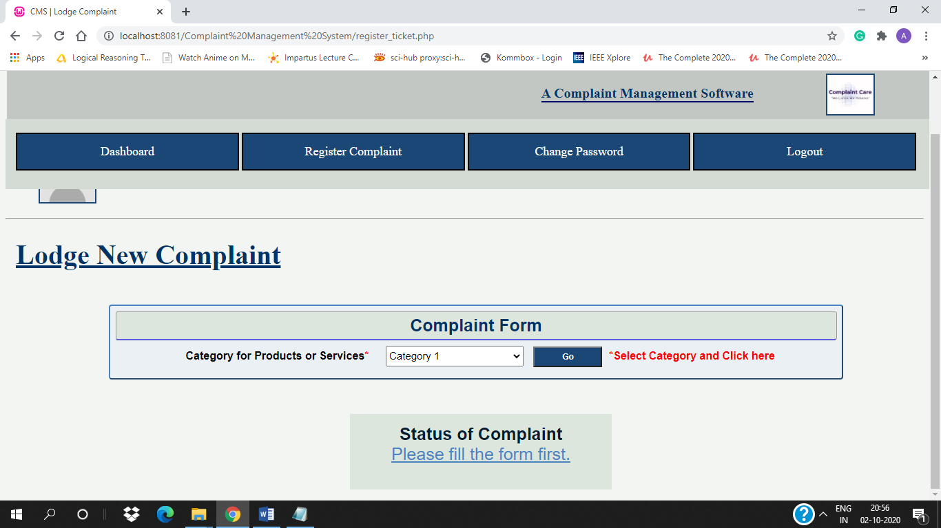

After selecting category –

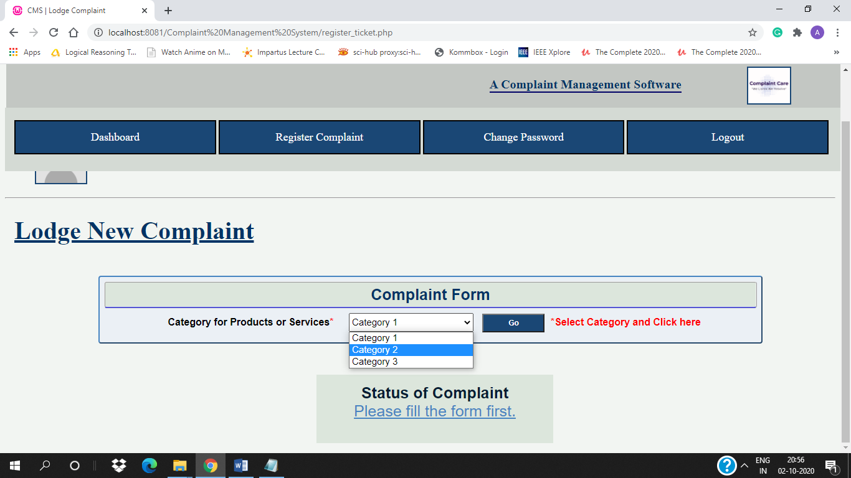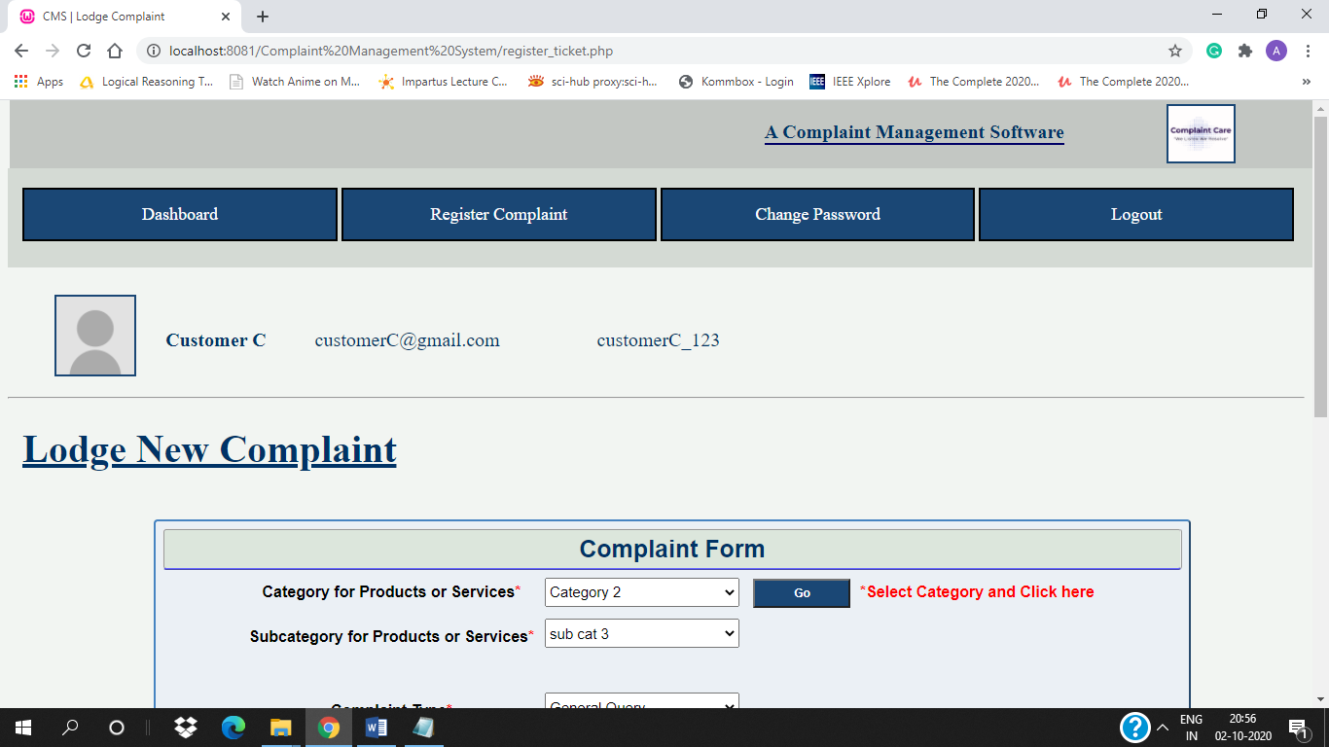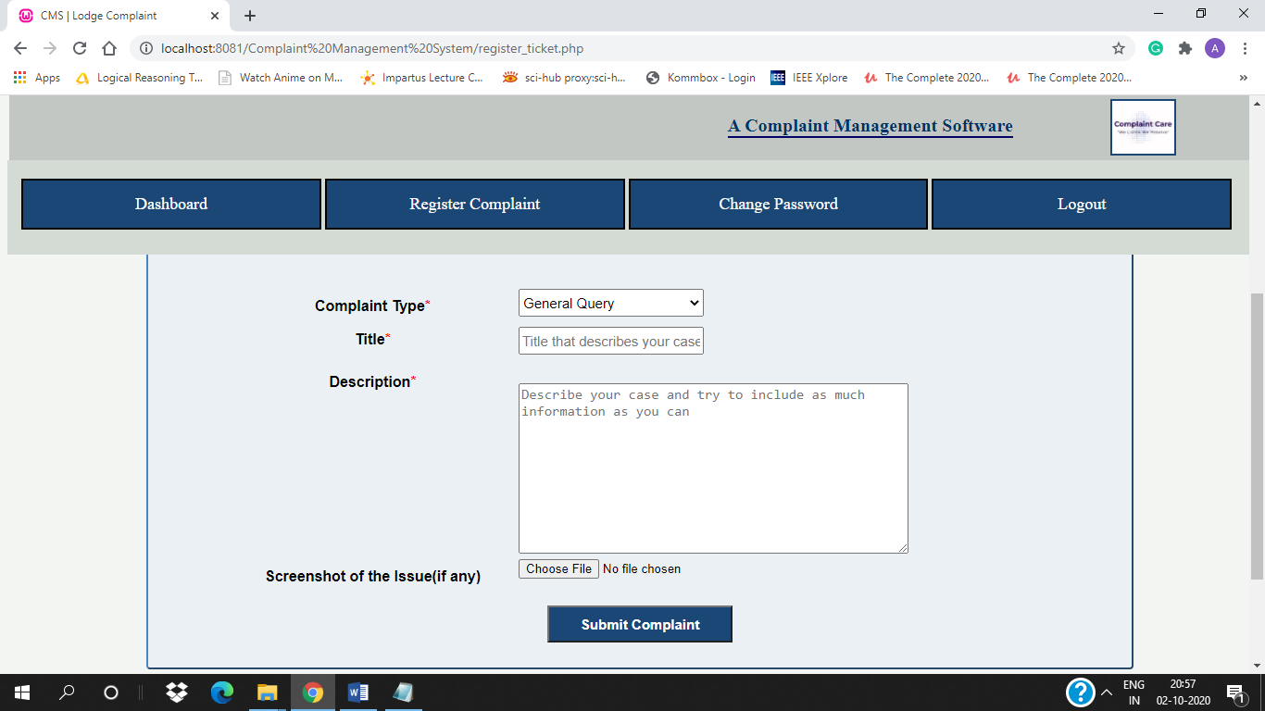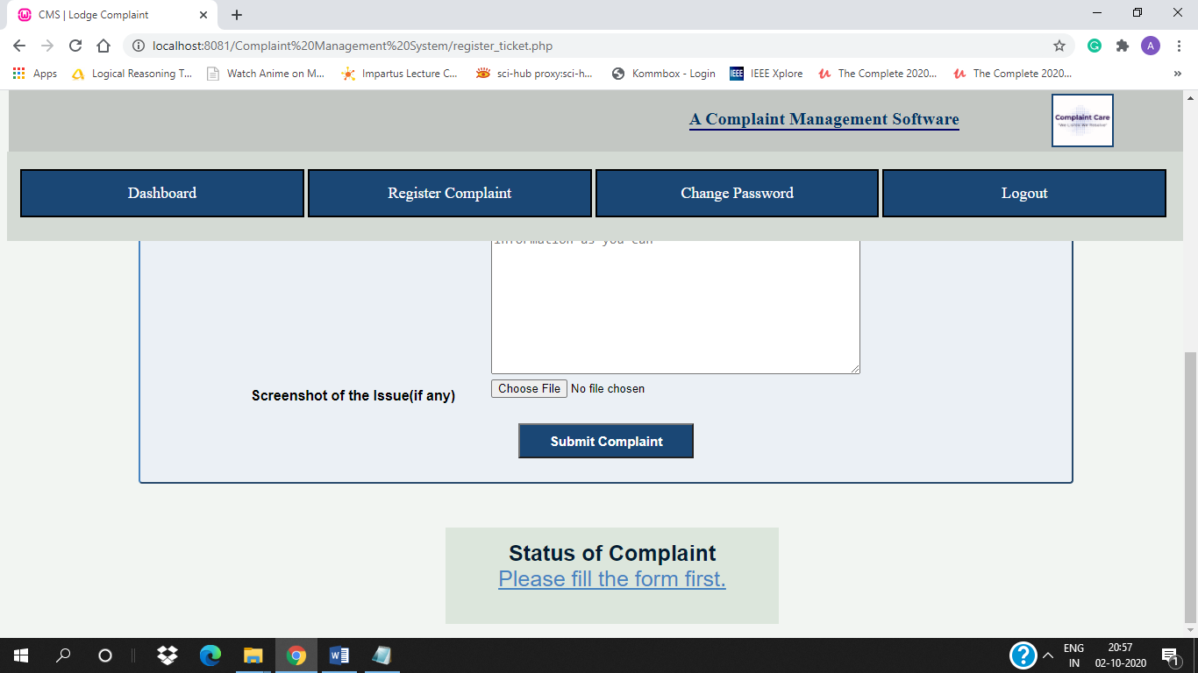

If a different category is selected –

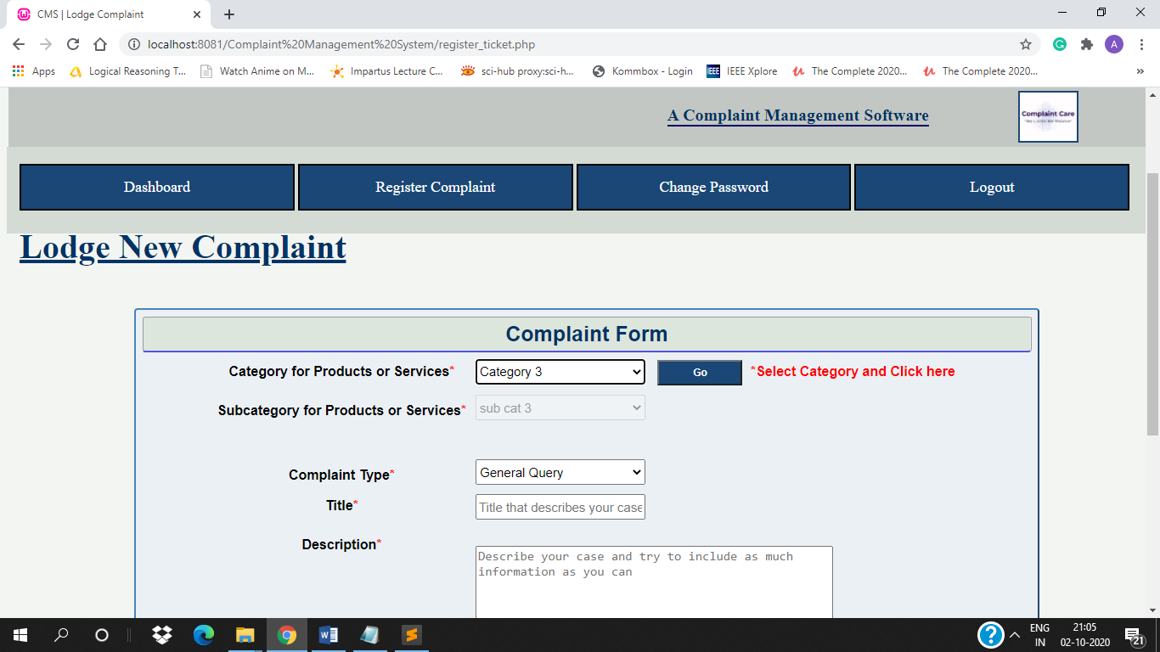

After filling and submitting form –

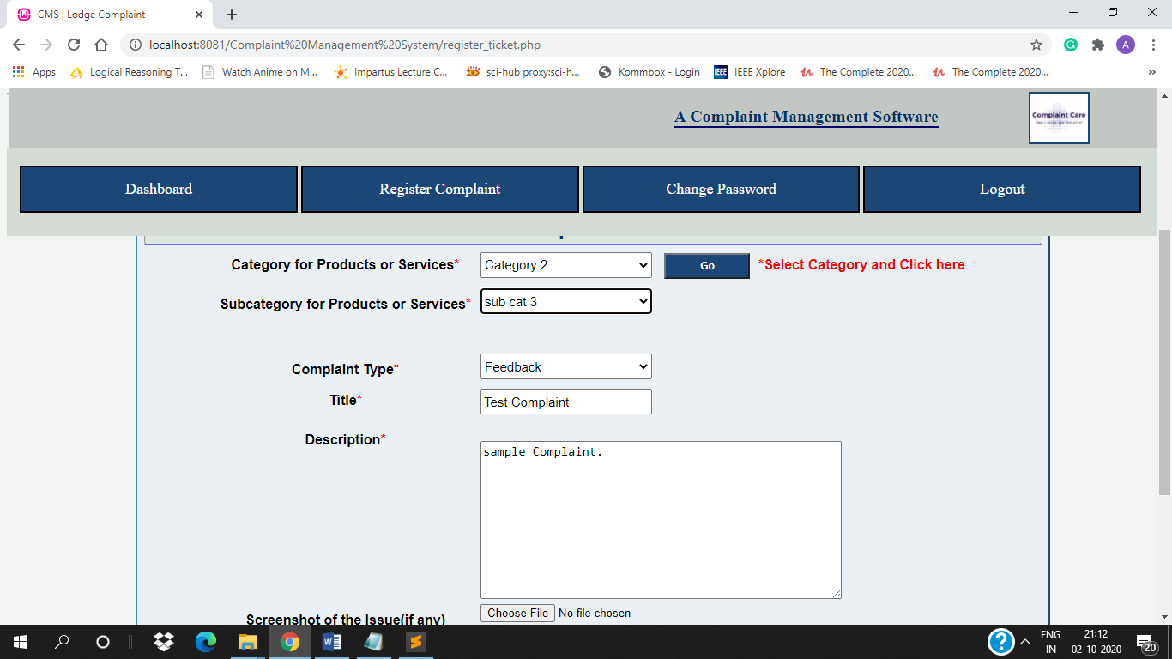

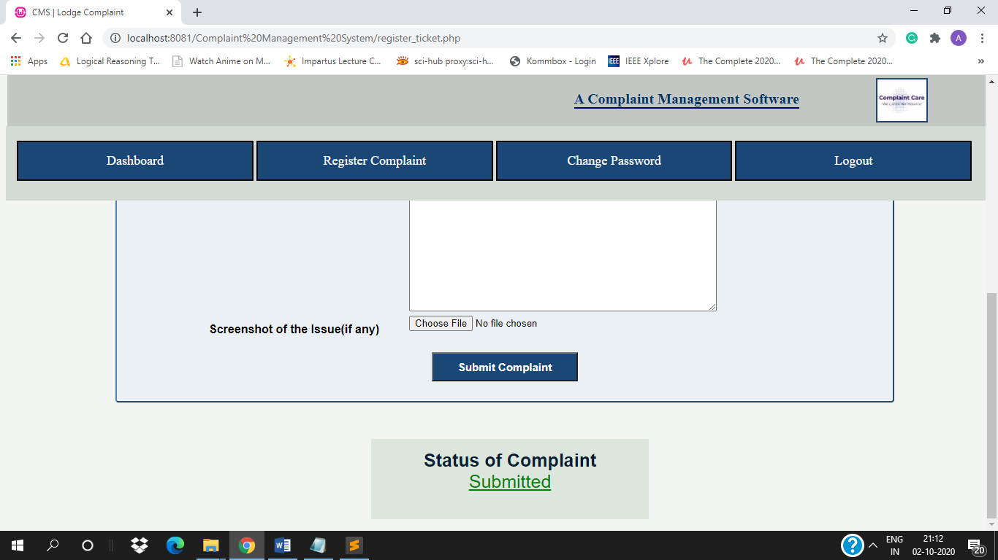

**2. Dashboard** – [customer_dashboard.php]

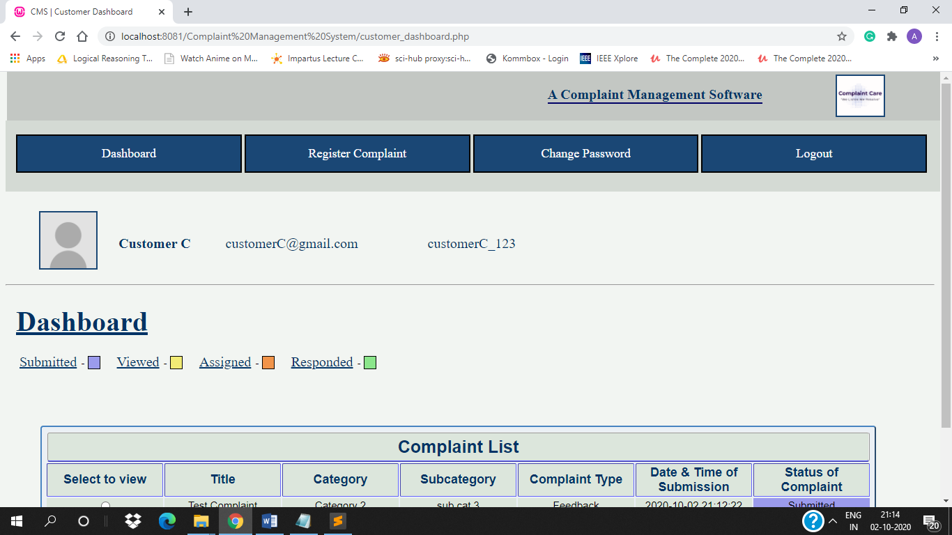

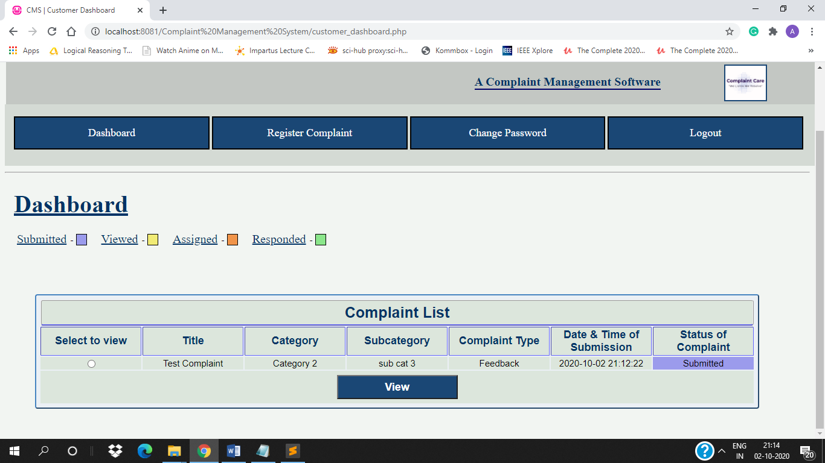

**3. View Complaint Form** – [customer_dashboard.php] [view_complaintform.php]

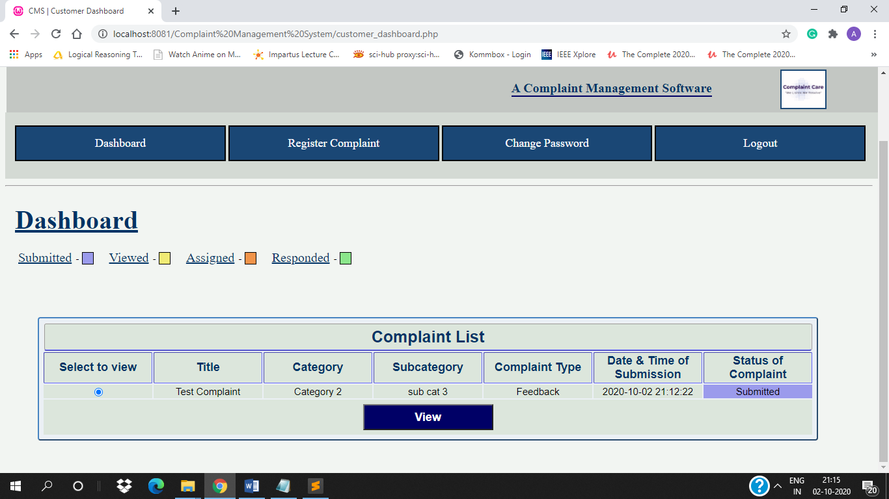

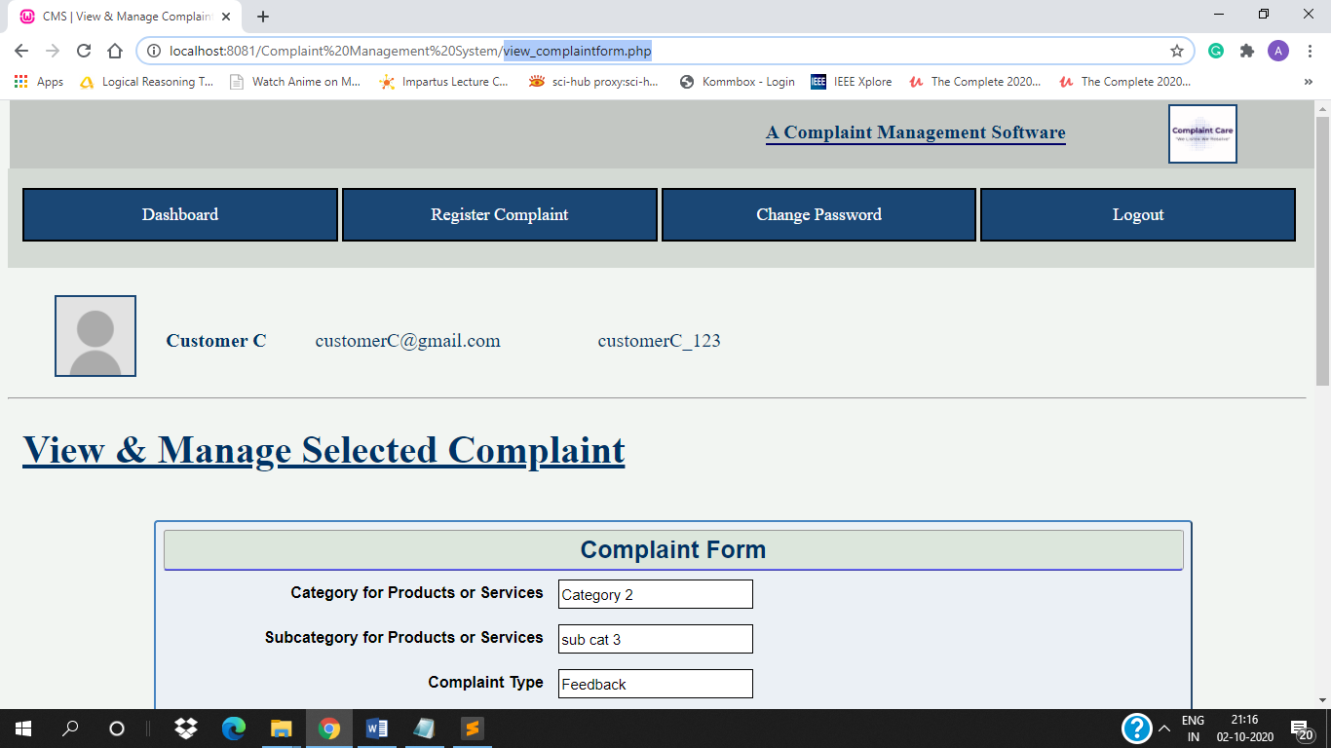

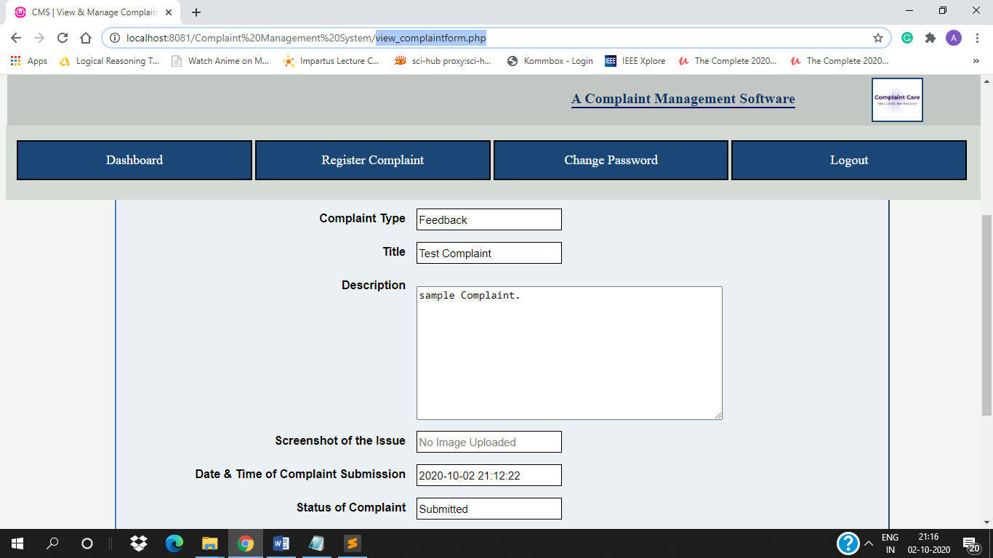

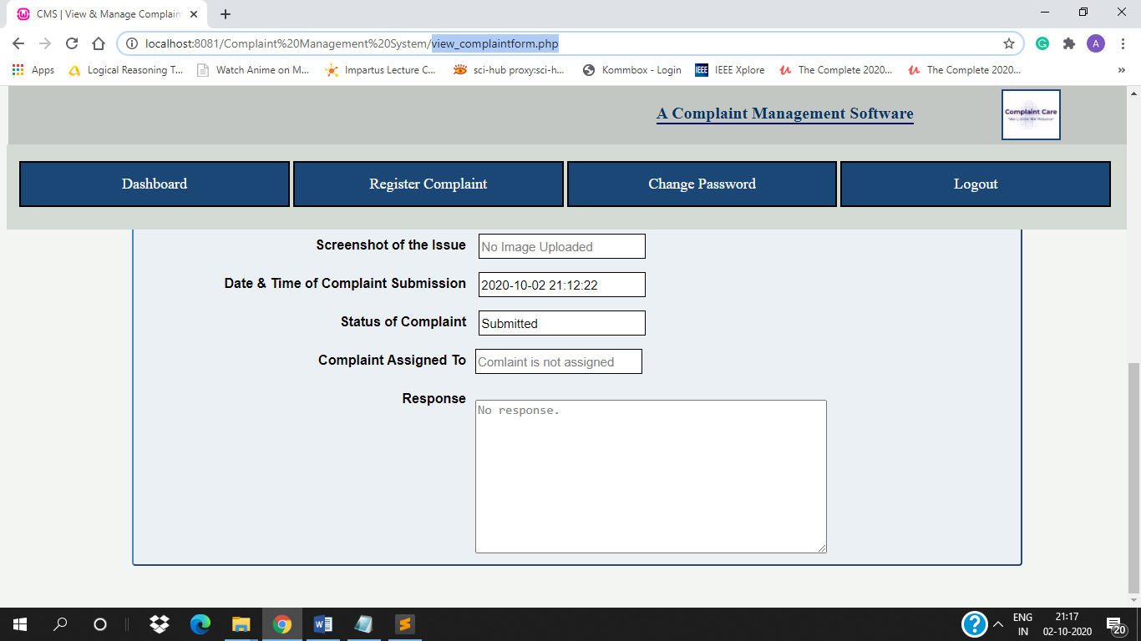

**4. Change Password** – [change_password_customer.php]

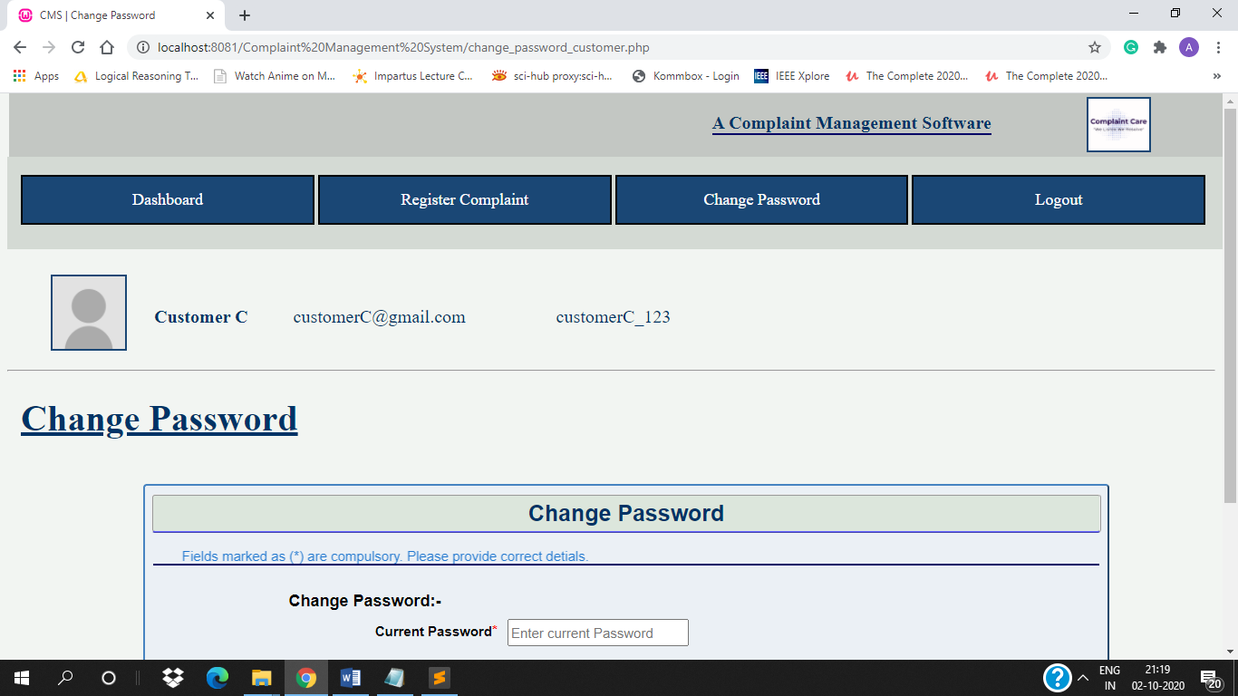

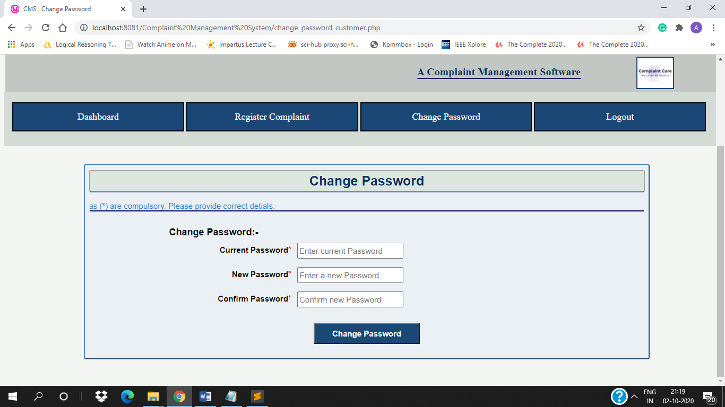

Validating password –

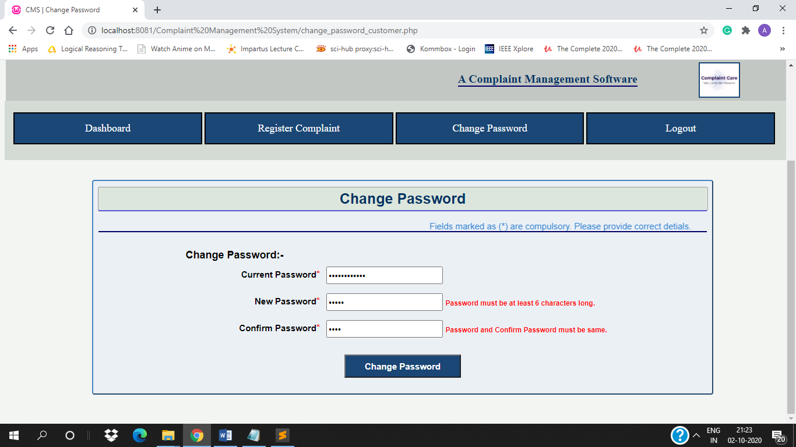

If Current Password is wrong –

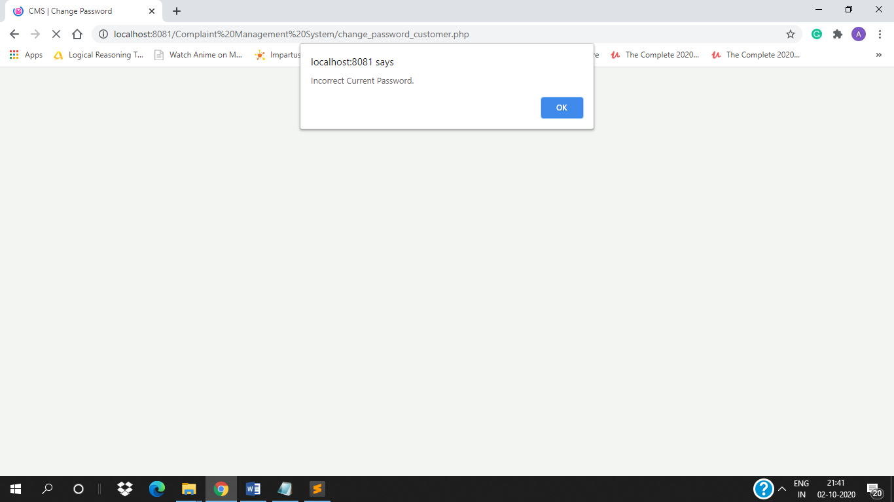

After filling form and submitting –

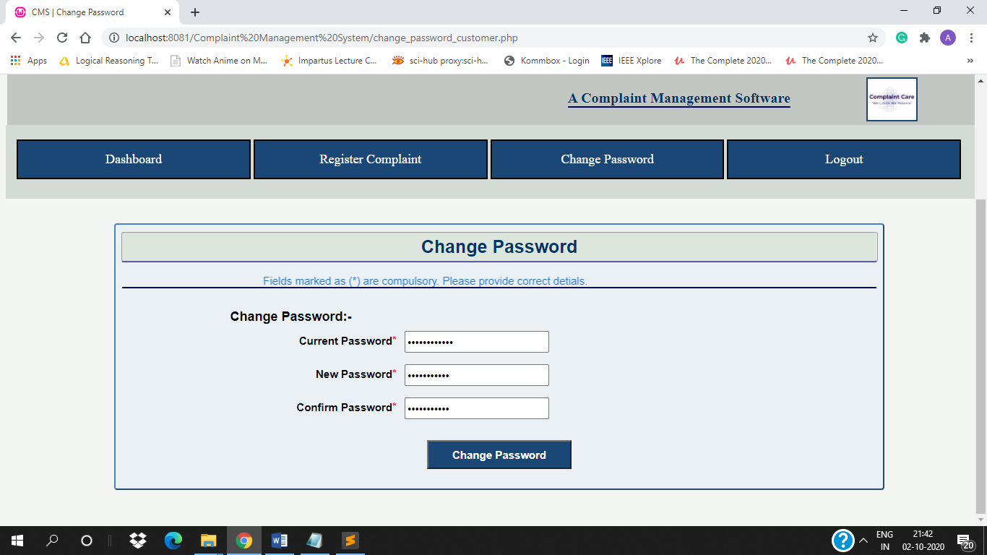

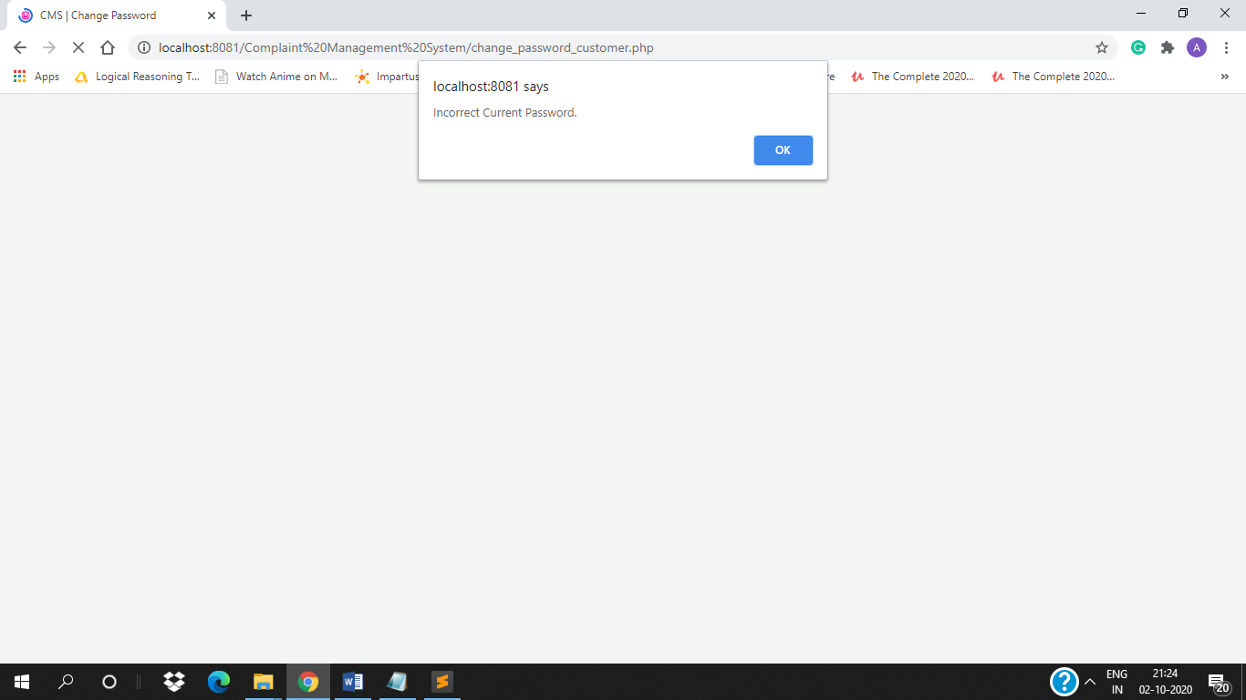

## 5. Code Snippet:

### Connectivity

1. connectivity.php

<?php

$db_server = "localhost";

$db_user = "root";

$db_password = "";

$db_name = "cms";

$conn = mysqli_connect($db_server,$db_user,$db_password,$db_name);

// Check connection

if(!$conn)

{

die("Failed to connect to MySQL: ".mysqli_connect_error());

}

?>

### Home and About Us

#### Menu –

1. index_part1.php

<html>

<head>

<meta charset="utf-8">

<title>Complaint Management Software</title>

<link rel="stylesheet" type="text/css" href="css/index_part1.css">

</head>

<body class="bg">

<table width=100%>

<tr>

<td colspan=2 width=40%><img src="css/img/heading.png" alt="logo" style="width:30%;display:inline;float:left;margin:0px 0px 30px 100px;border:2px solid #1a4775;"></td>

<td colspan=2 width=60%><h1 style="font-size:40px;color:#003366;float:left;margin:30px 0px 0px 0px;border-bottom:2px solid #000066;">A Complaint Management Software</h1></td>

</tr>

<tr>

<td colspan=4 width=40%><a href="home.php">Home</a>

<a href="about_us.php">About Us</a>

<a href="register.php">Sign Up</a>

<a href="login.php">Login</a></td>

</tr>

</table>

</body>

</html>

2. index,php

<?php

include("home.php");

?>

#### Home Page –

1. home.php

<?php

include("index_part1.php");

?>

<html>

<head>

<title>CMS | Home</title>

</head>

<body>

<form action="" method="POST">

<table width=100%>

<tr><td><img src="img/index_home_pic.gif" alt="homeGIF" style="width:90%;display:block;float:left;margin:2%;padding:2%;"></td></tr>

<tr><td><p style="float:right;font-size:18px;margin:10px 50px 10px 0px;font-weight:bold;">&copy; All Rights Reserved | Complaint Management System Software 2020</p></td></tr>

</table>

</form>

</body>

<html>

#### About Us Page –

1. about_us.php

<?php

include("index_part1.php");

?>

<html>

<head>

<title>CMS | About Us</title>

<style>

p{

color: #3a73ad;

padding: 10px 1px 10px 20px;

word-spacing: 5px;

font-size: 20px;

font-family: sans-serif;

}

</style>

</head>

<body>

<table width=100%>

<tr><th style="float:left;font-size:20px;text-decoration:underline;color:#003366;margin:2px 5px 5px 15px;"><h1>About Us</h1></th></tr>

<tr>

<td width=40%>

<p>Complaint Care is a simple Complaint Management Software that helps customer complaints to be reached to the right agent quickly and the customer can check the status of the tickets raised.</p>

<p>When a customer submits a complaint, it needs to be routed to the right department or person. While this process can be done manually, it increases the risk of delays.</p>

<p>A Complaint Management Software can automate this process helping your team to resolve each issue faster.</p>

</td>

<td>

<img src="img/index_pic.gif" alt="homeGIF" style="width:70%;height:300px;display:inline;float:right;margin:10px 55px 5px 1px;">

</td>

</tr>

</table>

<table width=100%>

<tr><td><h5 style="float:right;font-size:18px;color:black;margin:10px 50px 10px 0px;font-weight:bold;">&copy; All Rights Reserved | Complaint Management System Software 2020</h5></td></tr>

</table>

</body>

</html>

### Register User

1. register.php

<?php

include('connectivity.php');

?>

<html>

<head>

<title>CMS | Registration Page</title>

<link rel="stylesheet" type="text/css" href="css/register_page.css">

<script type="text/javascript" src="js/validate.js"></script>

<meta charset="UTF-8">

</head>

<body>

<form action="" method="POST" enctype="multipart/form-data">

<table width=60% height=100%>

<tr>

<th colspan=3><img src="css/img/heading.png" alt="logo" style="width:20%;display:inline;float:left;margin:0 20px 10px 12px;border:2px solid #1a4775;">&nbsp;&nbsp;&nbsp;

<h3 style="font-size:40px;color:#003366;float:left;margin:50px 0px 10px 10px;border-bottom:2px solid #000066;">Register Here</h3></th>

</tr>

<tr>

<td colspan=3><marquee scrollamount="3" style="font-size:15px;color:#1d75ce;float:left;margin:5px 2px 5px 2px;border-bottom:2px solid #000066;">Fields marked as (*) are compulsory. Please provide correct detials.</marquee></td>

</tr>

<tr>

<td colspan=3>Name <span style="color:red;">*</span>

&nbsp;&nbsp;<input type="text" name="userfnm" class="textbox" placeholder="First name" value="<?php if(isset($_POST['userfnm'])) echo $_POST['userfnm'];?>" required>

&nbsp;&nbsp;<input type="text" name="usermnm" class="textbox" placeholder="Middle name" value="<?php if(isset($_POST['usermnm'])) echo $_POST['usermnm'];?>">

&nbsp;&nbsp;<input type="text" name="userlnm" class="textbox" placeholder="Last name" value="<?php if(isset($_POST['userlnm'])) echo $_POST['userlnm'];?>" required></td>

</tr>

<tr>

<td colspan=3>Email ID <span style="color:red;">*</span>&nbsp;&nbsp;<input type="email" name="useremail" class="textbox" id="email" placeholder="ex:myname@example.com" onchange="return validateemail();" value="<?php if(isset($_POST['useremail'])) echo $_POST['useremail'];?>" required>&nbsp;&nbsp;<span id="emailcheck" style="font-size:12px;color:red;"></span></td>

</tr>

<tr>

<td colspan=3>User Name <span style="color:red;">*</span> &nbsp;&nbsp;<input type="text" name="usernm" class="textbox" placeholder="ex:myname_123" value="<?php if(isset($_POST['usernm'])) echo $_POST['usernm'];?>" required>&nbsp;&nbsp;<span id="usernmcheck" style="font-size:12px;color:red;"></span></td>

</tr>

<tr>

<td>Password <span style="color:red;">*</span> &nbsp;&nbsp;<input type="password" name="userpass" class="textbox" id="pass" placeholder="Enter Password" onchange="return validatepass();" required><br/><br/><span id="passcheck" style="font-size:12px;color:red;"></span></td>

<td>Confirm Password <span style="color:red;">*</span> &nbsp;&nbsp;<input type="password" name="usercpass" class="textbox" id="confirmpass" placeholder="Confirm Password" onchange="return validatecpass();" required><br/><br/><span id="cpasscheck" style="font-size:12px;color:red;"></span></td>

</tr>

<tr>

<td colspan=3>Gender:&nbsp;&nbsp;&nbsp;&nbsp;<input type="radio" name="gender" value="male" checked>Male&nbsp;&nbsp;&nbsp;&nbsp;<input type="radio" name="gender" value="female">Female&nbsp;&nbsp;&nbsp;&nbsp;<input type="radio" name="gender" value="other">Other</td>

</tr>

<tr>

<td colspan=3>Upload Picture &nbsp;&nbsp;<input type="file" accept="image/jpg, image/jpeg, image/png" name="profilepic" id="profilepic"></td>

</tr>

<tr>

<td colspan=3><input type="submit" name="submit" value="SIGN UP" class="button"><input type="reset" value="RESET" class="button"></td>

</tr>

<tr>

<td colspan=3><div class="tologin">

<h4>Already have an account? <a href="login.php">Sign in</a></h4></td>

</div></td></tr>

</table>

</form>

</body>

<html>

<?php

if(isset($_POST['submit']))

{

$firstnm = $_POST['userfnm'];

if(isset($_POST['usermnm'])){$middlenm = $_POST['usermnm'];}

else {$middlenm = null;}

$lastnm = $_POST['userlnm'];

$usernm = $_POST['usernm'];

$userpass = $_POST['userpass'];

$email = $_POST['useremail'];

$gender = $_POST['gender'];

$db_usernm = null;

$db_useremail = null;

$sql1 = "SELECT user_name, email FROM users WHERE user_name='".$usernm."' OR email='".$email."'";

$result1 = mysqli_query($conn,$sql1);

$count = mysqli_num_rows($result1);

if($count>0)

{

while($row1 = mysqli_fetch_array($result1))

{

$db_usernm = $row1["user_name"];

$db_useremail = $row1["email"];

if(strcmp($email,$db_useremail)==0)

{

echo '<script type="text/javascript">document.getElementById("emailcheck").innerHTML="This Email ID is already in use."</script>';

}

else if(strcmp($usernm,$db_usernm)==0)

{

echo '<script type="text/javascript">document.getElementById("usernmcheck").innerHTML="This Username is already in use, please try another username."</script>';

}

}

}

else

{

move_uploaded_file($_FILES['profilepic']['tmp_name'],"profile/".$_FILES['profilepic']['name']);

$profile = $_FILES['profilepic']['name'];

$sql2="INSERT INTO users(first_name, middle_name, last_name, email, user_name, password, gender, profile) VALUES ('".$firstnm."','".$middlenm."','".$lastnm."','".$email."','".$usernm."','".$userpass."','".$gender."','".$profile."')";

$result2 = mysqli_query($conn,$sql2);

if($result2)

{

echo '<script type="text/javascript">alert("Registered successfully. Click on Sign IN to Login to your account.")</script>';

}

else

{

echo '<script type="text/javascript">alert("Registration not successfull. ".mysqli_error($conn))</script>';

}

}

}

mysqli_close($conn);

?>

### Login & Logout

#### Login –

1. login.php

<?php

include('connectivity.php');

?>

<!DOCTYPE html>

<html>

<head>

<meta charset="utf-8">

<title>CMS | Login Page</title>

<link rel="stylesheet" type="text/css" href="css/login_page.css">

<script>

function showpassword()

{

var pass = document.getElementById("pass");

var chckbox = document.getElementById("chckbox");

if(chckbox.checked == true)

{

pass.type= "text";

//pass.setAttribute("type", "text");

}

else

{

pass.type= "password";

//pass.setAttribute("type", "password");

}

}

</script>

</head>

<body class="bg">

<form action="" method="POST">

<div class="logcontent">

<img src="css/img/heading.png" alt="logo" style="width:150px;display:block;float:left;margin:35px 10px 10px 80px;opacity:100%;border:2px solid #1a4775;"><br/>

<h1>Login</h1>

<div class="textbox">

<input type="text" name="username" placeholder="User Name" id="usernm" value="<?php if(isset($_POST['username'])) echo $_POST['username'];?>" required><br/>

</div>

<div class="textbox">

<input type="password" name="userpass" placeholder="Password" id="pass" required><br/><span id="passcheck" style="float:left;font-size:12px;color:red;"></span>

</div>

<br>&nbsp;&nbsp;&nbsp;&nbsp;<input type="checkbox" value="showpass" id="chckbox" onClick="showpassword();">Show Password

<br/><span id="error" style="float:left;font-size:12px;color:red;margin:0 0 0 25px;"></span>

<br/><input type="submit" name="submit" value="LOGIN" class="button"><br/>

<h4>Dont have an account? <a href="register.php">SIGN UP</a></h4>

</div>

</form>

</body>

<html>

<?php

if(isset($_POST['submit']))

{

$usernm = $_POST['username'];

$userpass = $_POST['userpass'];

$db_userid = null;

$db_usernm = null;

$db_userpass = null;

$db_usertype = null;

$sql = "SELECT user_id,user_name, password, user_type FROM users WHERE user_name='".$usernm."'";

$result = mysqli_query($conn,$sql);

$count = mysqli_num_rows($result);

if($count>0)

{

while($row = mysqli_fetch_array($result))

{

$db_usernm = $row["user_name"];

$db_userpass = $row["password"];

$db_usertype = $row["user_type"];

$db_userid = $row["user_id"];

}

if(strcmp($usernm,$db_usernm)==0 && strcmp($userpass,$db_userpass)==0)

{

session_start();

$_SESSION['uid'] = $db_userid;

$_SESSION['uname'] = $db_usernm;

$_SESSION['utype'] = $db_usertype;

if($_SESSION['utype'] == 'admin')

{

header("location:admin_dashboard.php");

}

else if($_SESSION['utype'] == 'customer')

{

header("location:customer_dashboard.php");

}

}

else

if(strcmp($usernm,$db_usernm)==0 && strcmp($userpass,$db_userpass)!==0)

{

echo '<script type="text/javascript">document.getElementById("passcheck").innerHTML="Incorrect password" </script>';

}

}

else

{

echo '<script type="text/javascript">document.getElementById("error").innerHTML="Incorrect User Name & Password" </script>';

}

}

mysqli_close($conn);

?>

#### Logout –

2. logout.php

<?php

session_start();

session_destroy();

header("location:index.php");

?>

### Change Password

1. change_password.php

<?php

session_start();

if($_SESSION['utype']=="admin")

{

header("Location:change_password_admin.php");

}

else if($_SESSION['utype']=="customer")

{

header("Location:change_password_customer.php");

}

?>

#### Admin –

1. change_password_admin.php

<?php

include('admin_dashboard_menu.php');

include('connectivity.php');

$user_id= $_SESSION['uid'];

$curr_pass = null;

$db_pass = null;

$pass = null;

?>

<html>

<head>

<title>CMS | Change Password</title>

<link rel="stylesheet" type="text/css" href="css/ticket.css">

<script type="text/javascript" src="js/validate.js"></script>

<meta charset="UTF-8">

</head>

<body>

<form action="" method="POST" enctype="multipart/form-data">

<br><h1 style="float:left;font-size:40px;text-decoration:underline;color:#003366;margin:2px 5px 5px 15px;">Change Password</h1><br>

<table width=80% class="tickettab">

<tr>

<tr>

<th colspan="2">Change Password</th>

</tr>

</tr>

<tr>

<td colspan=2><marquee scrollamount="3" style="font-size:15px;color:#1d75ce;float:left;margin:5px 2px 5px 2px;border-bottom:2px solid #000066;">Fields marked as (*) are compulsory. Please provide correct detials.</marquee></td>

</tr>

<tr>

<td class="lb">

<span style="font-size:18px;">Change Password:-</span>

</td>

</tr>

<tr>

<td class="lb" style="text-align:right;">

<span style="font-size:15px;">Current Password</span><span style="color:red;">*</span>&nbsp;&nbsp;

</td>

<td class="ct">

<input type="password" name="currpass" class="textbox" placeholder="Enter current Password" required>

</td>

</tr>

<tr>

<td class="lb" style="text-align:right;">

<span style="font-size:15px;">New Password</span><span style="color:red;">*</span>&nbsp;&nbsp;

</td>

<td class="ct">

<input type="password" name="userpass" class="textbox" id="pass" placeholder="Enter a new Password" onchange="return validatepass();" required>

<span id="passcheck" style="font-size:12px;color:red;"></span>

</td>

</tr>

<tr>

<td class="lb" style="text-align:right;">

<span style="font-size:15px;">Confirm Password</span><span style="color:red;">*</span>&nbsp;&nbsp;

</td>

<td class="ct">

<input type="password" name="usercpass" class="textbox" id="confirmpass" placeholder="Confirm new Password" onchange="return validatecpass();" required>

<span id="cpasscheck" style="font-size:12px;color:red;"></span>

</td>

</tr>

<tr>

<td colspan=2 class="buttons"><input type="submit" name="changepass" value="Change Password" class="button"></td>

</tr>

</table>

</form>

</body>

<html>

<?php

if(isset($_POST['changepass']))

{

if(isset($_POST['currpass']))

{

$curr_pass = $_POST['currpass'];

$sql1 = "SELECT password FROM users WHERE user_id='".$user_id."'";

$result1 = mysqli_query($conn,$sql1);

$count = mysqli_num_rows($result1);

if($count>0)

{

while($row1 = mysqli_fetch_array($result1))

{

$db_pass = $row1['password'];

}

}

else

{

echo '<script type="text/javascript">alert("Failed to get current password from database. ".mysqli_error($conn))</script>';

}

if($curr_pass!=$db_pass)

{

echo '<script type="text/javascript">alert("Incorrect Current Password.")</script>';

}

else

{

$pass = $_POST['userpass'];

$sql1a = "UPDATE users SET password ='".$pass."' WHERE user_id='".$user_id."'";

$result1a = mysqli_query($conn,$sql1a);

if($result1a)

{

echo '<script type="text/javascript">alert("Password updated Sucessfully.")</script>';

}

else

{

echo '<script type="text/javascript">alert("Password could not be updated Sucessfully.")</script>';

}

}

}

}

?>

#### Customer –

1. change_password_customer.php

<?php

include('customer_dashboard_menu.php');

include('connectivity.php');

$user_id= $_SESSION['uid'];

$curr_pass = null;

$db_pass = null;

$pass = null;

?>

<html>

<head>

<title>CMS | Change Password</title>

<link rel="stylesheet" type="text/css" href="css/ticket.css">

<script type="text/javascript" src="js/validate.js"></script>

<meta charset="UTF-8">

</head>

<body>

<form action="" method="POST" enctype="multipart/form-data">

<br><h1 style="float:left;font-size:40px;text-decoration:underline;color:#003366;margin:2px 5px 5px 15px;">Change Password</h1><br>

<table width=80% class="tickettab">

<tr>

<tr>

<th colspan="2">Change Password</th>

</tr>

</tr>

<tr>

<td colspan=2><marquee scrollamount="3" style="font-size:15px;color:#1d75ce;float:left;margin:5px 2px 5px 2px;border-bottom:2px solid #000066;">Fields marked as (*) are compulsory. Please provide correct detials.</marquee></td>

</tr>

<tr>

<td class="lb">

<span style="font-size:18px;">Change Password:-</span>

</td>

</tr>

<tr>

<td class="lb" style="text-align:right;">

<span style="font-size:15px;">Current Password</span><span style="color:red;">*</span>&nbsp;&nbsp;

</td>

<td class="ct">

<input type="password" name="currpass" class="textbox" placeholder="Enter current Password" required>

</td>

</tr>

<tr>

<td class="lb" style="text-align:right;">

<span style="font-size:15px;">New Password</span><span style="color:red;">*</span>&nbsp;&nbsp;

</td>

<td class="ct">

<input type="password" name="userpass" class="textbox" id="pass" placeholder="Enter a new Password" onchange="return validatepass();" required>

<span id="passcheck" style="font-size:12px;color:red;"></span>

</td>

</tr>

<tr>

<td class="lb" style="text-align:right;">

<span style="font-size:15px;">Confirm Password</span><span style="color:red;">*</span>&nbsp;&nbsp;

</td>

<td class="ct">

<input type="password" name="usercpass" class="textbox" id="confirmpass" placeholder="Confirm new Password" onchange="return validatecpass();" required>

<span id="cpasscheck" style="font-size:12px;color:red;"></span>

</td>

</tr>

<tr>

<td colspan=2 class="buttons"><input type="submit" name="changepass" value="Change Password" class="button"></td>

</tr>

</table>

</form>

</body>

<html>

<?php

if(isset($_POST['changepass']))

{

if(isset($_POST['currpass']))

{

$curr_pass = $_POST['currpass'];

$sql1 = "SELECT password FROM users WHERE user_id='".$user_id."'";

$result1 = mysqli_query($conn,$sql1);

$count = mysqli_num_rows($result1);

if($count>0)

{

while($row1 = mysqli_fetch_array($result1))

{

$db_pass = $row1['password'];

}

}

else

{

echo '<script type="text/javascript">alert("Failed to get current password from database. ".mysqli_error($conn))</script>';

}

if($curr_pass!=$db_pass)

{

echo '<script type="text/javascript">alert("Incorrect Current Password.")</script>';

}

else

{

$pass = $_POST['userpass'];

$sql1a = "UPDATE users SET password ='".$pass."' WHERE user_id='".$user_id."'";

$result1a = mysqli_query($conn,$sql1a);

if($result1a)

{

echo '<script type="text/javascript">alert("Password updated Sucessfully.")</script>';

}

else

{

echo '<script type="text/javascript">alert("Password could not be updated Sucessfully.")</script>';

}

}

}

}

?>

### Admin

#### Admin Menu –

1. admin_dashboard_menu.php

<?php

ob_start();

include('connectivity.php');

?>

<html>

<head>

<meta charset="utf-8">

<link rel="stylesheet" type="text/css" href="css/customer_dashboard.css">

<script type="text/javascript">

function imgError(image)

{

image.onerror = "";

image.src = "profile/default.jpg";

return true;

}

</script>

<style>

.menu

{

position: fixed;

top: 70px;

width: 100%;

height: 80px;

background-color: #d4dad4;

border-width: 2px;

padding: 20px 10px 2px 15px;

}

</style>

</head>

<body class="bg">

<table width=100%>

<tr>

<td colspan=2 width=100% style="top:0;border-bottom:1px solid #000066;position:fixed;background-color:#c3c7c3;"><img src="css/img/heading.png" alt="logo" style="width:5%;display:inline;float:right;margin:3px 90px 5px 100px;border:2px solid #1a4775;">

<h1 style="font-size:20px;color:#003366;float:right;margin:20px 5px 0px 400px;border-bottom:2px solid #000066;">A Complaint Management Software</h1>

</td>

</tr>

</table>

<table width=100% style="margin:180px 5px 5px 5px;">

<tr>

<td>

<?php

session_start();

$sql1 = "SELECT first_name, middle_name, last_name, profile, email, user_name FROM users WHERE user_name='".$_SESSION['uname']."' AND user_id='".$_SESSION['uid']."'";

$result1 = mysqli_query($conn,$sql1);

$row1 = mysqli_fetch_array($result1);

echo '<div id="profilediv">';

echo '<img src="profile/'.$row1['profile'].'"alt="profile pic" onerror="imgError(this);" style="width:80px;height:80px;display:block;float:left;margin:5px 30px 10px 40px;border:2px solid #1a4775;">';

echo '<p style="font-weight:bolder;font-size:20px;color:#003366;float:left;margin:40px 0px 0px 0px;">'.$row1['first_name'].' '.$row1['middle_name'].' '.$row1['last_name'].'</p>';

echo '<p style="font-size:20px;color:#003366;float:left;margin:40px 0px 0px 50px;">'.$row1['email'].'</p>';

echo '<p style="font-size:20px;color:#003366;float:left;margin:40px 0px 0px 100px;">'.$row1['user_name'].'</p>';

echo '</div>';

ob_end_flush();

?>

</td>

</tr>

</table>

<hr>

<div class="menu">

<td colspan=4 width=40%><a href="admin_dashboard.php">Dashboard</a>

<a href="view_users.php">Users</a>

<a href="change_password.php">Change Password</a>

<a href="logout.php">Logout</a></td>

</div>

</body>

</html>

#### Admin Dashboard –

1. admin_dashboard.php

<?php

ob_start();

include('admin_dashboard_menu.php');

include('connectivity.php');

$comp_id = null;

$user_id = null;

$user_name = null;

$title = null;

$cat_id = null;

$cat_nm =null;

$subcat_id = null;

$subcat_nm = null;

$comptype_id = null;

$comptype_nm = null;

$date = null;

$status = null;

?>

<html>

<head>

<title>CMS | Admin Dashboard</title>

<link rel="stylesheet" type="text/css" href="css/c_dashboard.css">

</head>

<body>

<form action="" method="POST">

<br><h1 style="float:left;font-size:40px;text-decoration:underline;color:#003366;margin:2px 5px 5px 15px;">Dashboard</h1><br><br><br><br>

<span style="font-size:20px;text-decoration:underline;color:#003366;margin:2px 2px 2px 20px;">Pending</span> - <span style="background-color:#e86969;width:20px;border-style:ridge;border-color:black;border-width:1px;">&nbsp;&nbsp;&nbsp;&nbsp;</span>

<span style="font-size:20px;text-decoration:underline;color:#003366;margin:2px 2px 2px 20px;">Viewed</span> - <span style="background-color:#f1eb75;width:20px;border-style:ridge;border-color:black;border-width:1px;">&nbsp;&nbsp;&nbsp;&nbsp;</span>

<span style="font-size:20px;text-decoration:underline;color:#003366;margin:2px 2px 2px 20px;">Assigned</span> - <span style="background-color:#f1944a;width:20px;border-style:ridge;border-color:black;border-width:1px;">&nbsp;&nbsp;&nbsp;&nbsp;</span>

<span style="font-size:20px;text-decoration:underline;color:#003366;margin:2px 2px 2px 20px;">Responded</span> - <span style="background-color:#8be68b;width:20px;border-style:ridge;border-color:black;border-width:1px;">&nbsp;&nbsp;&nbsp;&nbsp;</span>

<table width=90% class="complist">

<tr>

<th colspan="8">Complaint List</th>

</tr>

<tr>

<th class="lb">Select to view</th>

<th class="lb">Title</th>

<th class="lb">Category</th>

<th class="lb">Subcategory</th>

<th class="lb">Complaint Type</th>

<th class="lb">Date & Time of Submission</th>

<th class="lb">User Name</th>

<th class="lb">Status of Complaint</th>

</tr>

<?php

$sql1 = "SELECT * FROM complaint order by date desc";

$result1 = mysqli_query($conn,$sql1);

$count1 = mysqli_num_rows($result1);

if($count1>0)

{

while($row1 = mysqli_fetch_array($result1))

{

$comp_id = $row1['comp_id'];

$user_id = $row1['user_id'];

$title = $row1['complaint_title'];

$cat_id = $row1['cat_id'];

$subcat_id = $row1['sub_cat_id'];

$comptype_id = $row1['comp_type_id'];

$date = $row1['date'];

$status = $row1['status'];

$sql2 = "SELECT category.cat_name FROM category,complaint WHERE category.cat_id=complaint.cat_id AND complaint.comp_id ='".$comp_id."'";

$result2 = mysqli_query($conn,$sql2);

$count2 = mysqli_num_rows($result2);

if($count2>0)

{

while($row2 = mysqli_fetch_array($result2))

{

$cat_nm = $row2['cat_name'];

}

}

$sql3 = "SELECT sub_category.sub_cat_name FROM sub_category,complaint WHERE sub_category.sub_cat_id='".$subcat_id."' AND complaint.comp_id ='".$comp_id."' AND complaint.sub_cat_id IS NOT NULL";

if($subcat_id=="")

{

$subcat_nm = "No Value";

}

else

{

$result3 = mysqli_query($conn,$sql3);

$count3 = mysqli_num_rows($result3);

if($count3>0)

{

while($row3 = mysqli_fetch_array($result3))

{

$subcat_nm = $row3['sub_cat_name'];

}

}

}

$sql4 = "SELECT complaint_type.comp_type_title FROM complaint_type,complaint WHERE complaint_type.comp_type_id=complaint.comp_type_id AND complaint.comp_id ='".$comp_id."'";

$result4 = mysqli_query($conn,$sql4);

$count4 = mysqli_num_rows($result4);

if($count4>0)

{

while($row4 = mysqli_fetch_array($result4))

{

$comptype_nm = $row4['comp_type_title'];

}

}

$sql5 = "SELECT user_name FROM users WHERE user_id ='".$user_id."'";

$result5 = mysqli_query($conn,$sql5);

$count5 = mysqli_num_rows($result5);

if($count5>0)

{

while($row5 = mysqli_fetch_array($result5))

{

$user_name = $row5['user_name'];

}

}

echo '<tr>';

echo '<td><input type="radio" id="complaint" name="complaint" value='.$comp_id.'></td>';

echo '<td><span id="ctitle">'.$title.'</span></td>';

echo '<td><span id="ccat">'.$cat_nm.'</span></td>';

echo '<td><span id="csubcat">'.$subcat_nm.'</span></td>';

echo '<td><span id="ctype">'.$comptype_nm.'</span></td>';

echo '<td><span id="cdate">'.$date.'</span></td>';

echo '<td><span id="cdate">'.$user_name.'</span></td>';

if($status=="Viewed")

{

echo '<td style="background-color:#f1eb75;"><span id="cstatus">'.$status.'</span></td>';

}

else if($status=="Assigned")

{

echo '<td style="background-color:#f1944a;"><span id="cstatus">'.$status.'</span></td>';

}

else if($status=="Responded")

{

echo '<td style="background-color:#8be68b;"><span id="cstatus">'.$status.'</span></td>';

}

else

{

echo '<td style="background-color:#e86969;"><span id="cstatus" >Pending</span></td>';

}

echo '</tr>';

}

}

else

{

echo '<script type="text/javascript">alert("Could not load data. ".mysqli_error($conn))</script>';

}

?>

<tr>

<td colspan="8">

<input type="submit" name="view" id="view" value="View" class="button">

</td>

</tr>

</table>

</form>

</body>

</html>

<?php

if(isset($_POST['view']))

{

if(isset($_POST['complaint']))

{

$_SESSION['complaint_id'] = $_POST['complaint'];

$sql7 = "SELECT status FROM complaint WHERE comp_id='".$_SESSION['complaint_id']."'";

$result7 = mysqli_query($conn,$sql7);

$count7 = mysqli_num_rows($result7);

if($count7>0)

{

while ($row7 = mysqli_fetch_array($result7))

{

$status = $row7['status'];

}

}

if(isset($_POST['view']))

{

if($status=="Submitted")

{

$sql6 = "UPDATE complaint SET status ='Viewed' WHERE comp_id='".$_SESSION['complaint_id']."'";

$result6 = mysqli_query($conn,$sql6);

}

header("Location:manage_complaint.php");

}

}

else

{

echo '<script type="text/javascript">alert("Select a Complaint first.")</script>';

}

}

ob_end_flush();

?>

#### View Complaint –

1. manage_complaint.php

<?php

ob_start();

include('admin_dashboard_menu.php');

include('connectivity.php');

$comp_id = $_SESSION['complaint_id'];

$title = null;

$description = null;

$cat_id = null;

$cat_nm =null;

$subcat_id = null;

$subcat_nm = null;

$comptype_id = null;

$comptype_nm = null;

$date = null;

$status = null;

$emp_id = null;

$emp_name = null;

$emp_email = null;

$dept_id = null;

$dept_name = null;

$response = null;

$sql1 = "SELECT * FROM complaint WHERE complaint.comp_id='".$comp_id."'";

$result1 = mysqli_query($conn,$sql1);

$count1 = mysqli_num_rows($result1);

if($count1>0)

{

while($row1 = mysqli_fetch_array($result1))

{

$title = $row1['complaint_title'];

$description = $row1['description'];

$cat_id = $row1['cat_id'];

$subcat_id = $row1['sub_cat_id'];

$comptype_id = $row1['comp_type_id'];

$date = $row1['date'];

$status = $row1['status'];

$emp_id = $row1['emp_id'];

$response = $row1['response'];

if($row1["screenshot"]==null)

{

$screenshot = "";

}

else

{

$screenshot = "img/complaint_screenshots/".$row1["screenshot"];

}

}

$sql2 = "SELECT category.cat_name FROM category,complaint WHERE category.cat_id=complaint.cat_id AND complaint.comp_id ='".$comp_id."'";

$result2 = mysqli_query($conn,$sql2);

$count2 = mysqli_num_rows($result2);

if($count2>0)

{

while($row2 = mysqli_fetch_array($result2))

{

$cat_nm = $row2['cat_name'];

}

}

$sql3 = "SELECT sub_category.sub_cat_name FROM sub_category,complaint WHERE sub_category.sub_cat_id='".$subcat_id."' AND complaint.comp_id ='".$comp_id."' AND complaint.sub_cat_id IS NOT NULL";

if($subcat_id=="")

{

$subcat_nm = "No Value";

}

else

{

$result3 = mysqli_query($conn,$sql3);

$count3 = mysqli_num_rows($result3);

if($count3>0)

{

while($row3 = mysqli_fetch_array($result3))

{

$subcat_nm = $row3['sub_cat_name'];

}

}

}

$sql4 = "SELECT complaint_type.comp_type_title FROM complaint_type,complaint WHERE complaint_type.comp_type_id=complaint.comp_type_id AND complaint.comp_id ='".$comp_id."'";

$result4 = mysqli_query($conn,$sql4);

$count4 = mysqli_num_rows($result4);

if($count4>0)

{

while($row4 = mysqli_fetch_array($result4))

{

$comptype_nm = $row4['comp_type_title'];

}

}

if($response==null && $emp_id!=null)

{

$sql5 = "SELECT * FROM employee WHERE emp_id ='".$emp_id."'";

$result5 = mysqli_query($conn,$sql5);

$count5 = mysqli_num_rows($result5);

if($count5>0)

{

while($row5 = mysqli_fetch_array($result5))

{

$emp_name = $row5['emp_name'];

$emp_email = $row5['emp_email'];

$dept_id = $row5['dept_id'];

$sql5a = "SELECT * FROM department WHERE dept_id ='".$dept_id."'";

$result5a = mysqli_query($conn,$sql5a);

$count5a = mysqli_num_rows($result5a);

if($count5a>0)

{

while($row5a = mysqli_fetch_array($result5a))

{

$dept_name = $row5a['dept_name'];

}

}

}

}

}

}

else

{

echo '<script type="text/javascript">alert("Error fetching form. ".mysqli_error($conn))</script>';

}

?>

<html>

<head>

<title>CMS | View & Manage Complaints</title>

<link rel="stylesheet" type="text/css" href="css/ticket.css">

</head>

<body>

<form action="" method="POST" enctype="multipart/form-data">

<br><h1 style="float:left;font-size:40px;text-decoration:underline;color:#003366;margin:2px 5px 5px 15px;">View & Manage Selected Complaint</h1><br>

<table width=80% class="tickettab">

<tr>

<th colspan="2">Complaint Form</th>

</tr>

<tr>

<td style="text-align:right;" class="lb">Category for Products or Services</td>

<td class="ct">&nbsp;&nbsp;

<input style="background-color:white;border-color:black;border-width:1px;color:black;" type="text" name="ctitle" value="<?php echo $cat_nm; ?>" class="textbox" id="title" disabled>

</td>

</tr>

<tr>

<td style="text-align:right;" class="lb">Subcategory for Products or Services</td>

<td class="ct">&nbsp;&nbsp;

<input style="background-color:white;border-color:black;border-width:1px;color:black;" type="text" name="ctitle" value="<?php echo $subcat_nm; ?>" class="textbox" id="title" disabled>

</td>

</tr>

<tr>

<td style="text-align:right;" class="lb">Complaint Type</td>

<td class="ct">&nbsp;&nbsp;

<input style="background-color:white;border-color:black;border-width:1px;color:black;" type="text" name="ctitle" value="<?php echo $comptype_nm; ?>" class="textbox" id="title" disabled>

</td>

</tr>

<tr>

<td style="text-align:right;" class="lb">Title</td>

<td class="ct">&nbsp;&nbsp;

<input style="background-color:white;border-color:black;border-width:1px;color:black;" type="text" name="ctitle" value="<?php echo $title; ?>" class="textbox" id="title" disabled>

</td>

</tr>

<tr>

<td style="text-align:right;" class="lb">Description</td>

<td class="ct">&nbsp;&nbsp;

<textarea style="font-size: 15px;" name="description" cols="50" rows="10" id="desc" readonly><?php echo $description; ?></textarea>

</td>

</tr>

<tr>

<td style="text-align:right;" class="lb">Screenshot of the Issue</td>

<td class="ct">&nbsp;&nbsp;

<?php

if($screenshot=="")

{

echo '<input style="background-color:white;border-color:black;border-width:1px;color:grey;" type="text" name="ctitle" value="No Image Uploaded" class="textbox" id="title" disabled>';

}

else

{

echo '<img src="'.$screenshot.'"alt="screenshot of complaint" style="width:400px;height:400px;display:block;float:left;margin:10px 10px 10px 10px;border:2px solid #1a4775;">';

}

?>

</td>

</tr>

<tr>

<td style="text-align:right;" class="lb">Date & Time of Complaint Submission</td>

<td class="ct">&nbsp;&nbsp;

<input style="background-color:white;border-color:black;border-width:1px;color:black;" type="text" name="ctitle" value="<?php echo $date; ?>" class="textbox" id="title" disabled>

</td>

<tr>

<td style="text-align:right;" class="lb">Status of Complaint</td>

<td class="ct">&nbsp;&nbsp;

<input style="background-color:white;border-color:black;border-width:1px;color:black;" type="text" name="ctitle" value="<?php echo $status; ?>" class="textbox" id="title" disabled>

</td>

</tr>

<?php

if($emp_id=="")

{

echo '<tr>';

echo '<td style="text-align:right;" class="lb">Complaint Assigned To</td>

<td class="ct">&nbsp;&nbsp;';

echo '<input style="background-color:white;border-color:black;border-width:1px;color:grey;" type="text" name="ctitle" value="Comlaint is not assigned" class="textbox" id="title" disabled>';

echo '</td>';

echo '</tr>';

}

else

{

echo '<tr>';

echo '<td style="text-align:right;" class="lb">Complaint Assigned To:-</td><td></td>';

echo '<tr>';

echo '<td style="text-align:right;" class="lb">Department</td>

<td class="ct">&nbsp;&nbsp;';

echo '<input style="background-color:white;border-color:black;border-width:1px;color:black;" type="text" name="ctitle" value="'.$dept_name.'" class="textbox" id="title" disabled>';

echo '</td>';

echo '</tr>';

echo '</tr><tr>';

echo '<td style="text-align:right;" class="lb">Employee Name</td>

<td class="ct">&nbsp;&nbsp;';

echo '<input style="background-color:white;border-color:black;border-width:1px;color:black;" type="text" name="ctitle" value="'.$emp_name.'" class="textbox" id="title" disabled>';

echo '</td>';

echo '</tr>';

echo '<tr>';

echo '<td style="text-align:right;" class="lb">Employee Email ID</td>

<td class="ct">&nbsp;&nbsp;';

echo '<input style="background-color:white;border-color:black;border-width:1px;color:black;" type="text" name="ctitle" value="'.$emp_email.'" class="textbox" id="title" disabled>';

echo '</td>';

echo '</tr>';

}

if($response=="")

{

echo '<tr>';

echo '<td style="text-align:right;" class="lb">Response</td>

<td class="ct">&nbsp;&nbsp;';

echo '<textarea style="font-size:15px;color:grey;" name="description" cols="50" rows="10" id="desc" readonly>No response.</textarea>';

echo '</td>';

echo '</tr>';

}

else

{

echo '<tr>';

echo '<td style="text-align:right;" class="lb">Response</td>

<td class="ct">&nbsp;&nbsp;';

echo '<textarea style="font-size: 15px;color:black;" name="description" cols="50" rows="10" id="desc" readonly>'.$response.'</textarea>';

echo '</td>';

echo '</tr>';

}

?>

<tr>

<td colspan="2"><input type="submit" name="assign" id="assign" value="Assign" class="button" style="margin:0px 0px 0px 350px;">

<input type="submit" name="respond" id="respond" value="Respond" class="button" style="margin:0px 0px 0px 0px;">

</td>

</tr>

</table>

</form>

</body>

</html>

<?php

if(isset($_POST['assign']) && $status!="Responded")

{

if($status=="Assigned")

{

echo '<script type="text/javascript">alert("You have already assigned this complaint to a department/employee.");</script>';

}

else

header("Location:assign_complaint.php");

}

else if(isset($_POST['assign']) && $status=="Responded")

{

echo '<script type="text/javascript">alert("You have already responded to this complaint, so you cannot assign this complaint to a department/employee.");</script>';

}

if(isset($_POST['respond']) && $status!="Assigned")

{

if($status=="Responded")

{

echo '<script type="text/javascript">alert("You have already responded to this complaint.");</script>';

}

else

header("Location:respond_complaint.php");

}

else if(isset($_POST['respond']) && $status=="Assigned")

{

echo '<script type="text/javascript">alert("You have already assigned this complaint to a department/employee, so you cannot respond.");</script>';

}

ob_end_flush();

?>

#### Respond to Complaint –

1. respond_complaint.php

<?php

include('admin_dashboard_menu.php');

include('connectivity.php');

$response = null;

$status = null;

?>

<html>

<head>

<title>CMS | Repspond To Complaint</title>

<link rel="stylesheet" type="text/css" href="css/ticket.css">

<script type="text/javascript">

function checksub()

{

var x = document.getElementById("subcat").disabled = true;

//var y = document.getElementById("subcatd").disabled = true;

}

</script>

</head>

<body>

<form action="" method="POST">

<table table width=80% class="tickettab">

<tr>

<th colspan="2">Respond</th>

</tr>

<tr>

<td class="lb" style="text-align:right;">Type your response -</td>

<td class="ct">&nbsp;&nbsp;

<textarea style="font-size: 15px;" name="response" cols="50" rows="10" id="desc" required=""><?php if(isset($_POST['response'])) echo $_POST['response']; ?></textarea>

</td>

</tr>

<tr>

<td colspan="2" class="buttons">

<input type="submit" name="submit" value="Submit" class="button">

</td>

</tr>

</table>

</form>

</body>

</html>

<?php

if(isset($_POST['submit']))

{

if(isset($_POST['response']))

{

$sql7 = "SELECT status FROM complaint WHERE comp_id='".$_SESSION['complaint_id']."'";

$result7 = mysqli_query($conn,$sql7);

$count7 = mysqli_num_rows($result7);

if($count7>0)

{

while ($row7 = mysqli_fetch_array($result7))

{

$status = $row7['status'];

}

}

if($status=="Responded")

{

echo '<script type="text/javascript">alert("Response for this complaint is already submitted. Please, return to the Dashboard.")</script>';

}

else

{

$response = $_POST['response'];

$sql = "UPDATE complaint SET response ='".$response."', status='Responded' WHERE comp_id='".$_SESSION['complaint_id']."'";

$result = mysqli_query($conn,$sql);

if($result)

{

echo '<script type="text/javascript">alert("Submitted Response Successfully!.")</script>';

}

else

{

echo '<script type="text/javascript">alert("Failed to submit.")</script>';

}

}

}

}

?>

#### Assign Complaint –

1. assign_complaint.php

<?php

include('admin_dashboard_menu.php');

include('connectivity.php');

$dept_id = null;

$dept_name = null;

$emp_id = null;

$emp_name = null;

?>

<html>

<head>

<title>CMS | Assign Complaint</title>

<link rel="stylesheet" type="text/css" href="css/ticket.css">

<script type="text/javascript">

function checksub()

{

var x = document.getElementById("subcat").disabled = true;

//var y = document.getElementById("subcatd").disabled = true;

}

</script>

</head>

<body>

<form action="" method="POST">

<table table width=80% class="tickettab">

<tr>

<th colspan="2">Assign Complaint</th>

</tr>

<tr>

<td class="lb" style="text-align:right;">Select Department<span style="color:red;">*</span></td>

<td class="ct">&nbsp;&nbsp;<select name="dept" id="cat" onChange="checksub();">

<?php

$sql2a = "SELECT * FROM department";

$result2a = mysqli_query($conn,$sql2a);

$count2a = mysqli_num_rows($result2a);

if($count2a>0)

{

while($row2a = mysqli_fetch_array($result2a))

{

$dept_id = $row2a['dept_id'];

$dept_name = $row2a['dept_name'];

echo '<option value="'.$dept_id.'">'.$dept_name.'</option>';

}

}

else

{

echo '<option value="default" selected>No Value</option>';

echo '<script type="text/javascript">alert("Failed to update complaint status. ".mysqli_error($conn))</script>';

}

?>

</select>

<input type="submit" value="Go" name="Go" class="buttona"> <span style="color:red;">*Select Department and Click here</span>

</td>

<script type="text/javascript">

document.getElementById('cat').value = "<?php echo $_POST['dept'];?>";

</script>

</tr>

<?php

if(isset($_POST['Go']) || isset($_POST['submit']))

{

?>

<tr>

<td class="lb" style="text-align:right;">Select Employee to Assign Complaint<span style="color:red;">*</span></td>

<td class="ct">&nbsp;&nbsp;

<?php

$dept_id = $_POST['dept'];

$sql3a = "SELECT emp_id, emp_name FROM employee WHERE dept_id='".$dept_id."'";

$result3a = mysqli_query($conn,$sql3a);

$count3a = mysqli_num_rows($result3a);

if($count3a>0)

{

echo '<select name="emp" id="subcat" required>';

while($row3a = mysqli_fetch_array($result3a))

{

$emp_id = $row3a['emp_id'];

$emp_name = $row3a['emp_name'];

echo '<option value="'.$emp_id.'">'.$emp_name.'</option>';

}

echo "</select>";

}

else

{

echo '<select name="subcat" id="subcat">';

echo '<option value="empty" selected>No Value</option>';

echo '</select>';

echo '<script type="text/javascript">alert("Failed to update complaint status. ".mysqli_error($conn))</script>';

}

?>

</td>

<script type="text/javascript">

document.getElementById('subcat').value = "<?php echo $_POST['emp'];?>";

</script>

</tr>

<tr>

<td colspan="2" class="buttons">

<input type="submit" name="submit" value="Submit" class="button">

</td>

</tr>

<?php

}

?>

</table>

</form>

</body>

</html>

<?php

if(isset($_POST['submit']))

{

if(isset($_POST['emp']))

{

$sql6a = "UPDATE complaint SET emp_id ='".$_POST['emp']."' WHERE comp_id='".$_SESSION['complaint_id']."'";

$result6a = mysqli_query($conn,$sql6a);

if($result6a)

{

$sql6b = "UPDATE complaint SET status ='Assigned' WHERE comp_id='".$_SESSION['complaint_id']."'";

$result6b = mysqli_query($conn,$sql6b);

if($result6b)

{

header("Location:admin_dashboard.php");

}

}

else

{

echo '<script type="text/javascript">alert("Failed to submit.Select Department and Employee details properly.")</script>';

}

}

else

{

echo '<script type="text/javascript">alert("Failed to submit.Select Department and Employee details properly.")</script>';

}

}

?>

#### User List –

1. view_users.php

<?php

ob_start();

include('admin_dashboard_menu.php');

include('connectivity.php');

$sr_no = 1;

$user_name = null;

$first_name = null;

$middle_name = null;

$last_name = null;

$name = null;

$email = null;

$gender = null;

?>

<html>

<head>

<title>CMS | View Users</title>

<link rel="stylesheet" type="text/css" href="css/c_dashboard.css">

</head>

<body>

<form action="" method="POST">

<br><h1 style="float:left;font-size:40px;text-decoration:underline;color:#003366;margin:2px 5px 5px 15px;">Dashboard</h1><br>

<table width=90% class="complist">

<tr>

<th colspan="5">User List</th>

</tr>

<tr>

<th class="lb">Sr. No.</th>

<th class="lb">User Name</th>

<th class="lb">Name</th>

<th class="lb">Email</th>

<th class="lb">Gender</th>

</tr>

<?php

$sql = "SELECT * FROM users WHERE user_type='customer' order by user_id desc";

$result = mysqli_query($conn,$sql);

$count = mysqli_num_rows($result);

if($count>0)

{

while($row = mysqli_fetch_array($result))

{

$user_name = $row['user_name'];

$first_name = $row['first_name'];

$middle_name = $row['middle_name'];

$last_name = $row['last_name'];

$email = $row['email'];

$gender = $row['gender'];

$name = $first_name." ".$middle_name." ".$last_name;

echo '<tr>';

echo '<td><span>'.$sr_no.'</span></td>';

echo '<td><span>'.$user_name.'</span></td>';

echo '<td><span>'.$first_name.'</span></td>';

echo '<td><span>'.$email.'</span></td>';

echo '<td><span>'.$gender.'</span></td>';

echo '</tr>';

$sr_no=$sr_no+1;

}

}

else

{

echo '<script type="text/javascript">alert("Could not load data. ".mysqli_error($conn))</script>';

}

?>

</table>

</form>

</body>

</html>

<?php

ob_end_flush();

?>

### Customer

#### Customer Menu –

1. customer_dashboard_menu.php

<?php

include('connectivity.php');

?>

<html>

<head>

<meta charset="utf-8">

<link rel="stylesheet" type="text/css" href="css/customer_dashboard.css">

<script type="text/javascript">

function imgError(image)

{

image.onerror = "";

image.src = "profile/default.jpg";

return true;

}

</script>

<style>

.menu

{

position: fixed;

top: 70px;

width: 100%;

height: 80px;

background-color: #d4dad4;

border-width: 2px;

padding: 20px 10px 2px 15px;

}

</style>

</head>

<body class="bg">

<table width=100%>

<tr>

<td colspan=2 width=100% style="top:0;border-bottom:1px solid #000066;position:fixed;background-color:#c3c7c3;"><img src="css/img/heading.png" alt="logo" style="width:5%;display:inline;float:right;margin:3px 90px 5px 100px;border:2px solid #1a4775;">

<h1 style="font-size:20px;color:#003366;float:right;margin:20px 5px 0px 400px;border-bottom:2px solid #000066;">A Complaint Management Software</h1>

</td>

</tr>

</table>

<table width=100% style="margin:180px 5px 5px 5px;">

<tr>

<td>

<?php

session_start();

$sql1 = "SELECT first_name, middle_name, last_name, profile, email, user_name FROM users WHERE user_name='".$_SESSION['uname']."'";

$result1 = mysqli_query($conn,$sql1);

$row1 = mysqli_fetch_array($result1);

echo '<div id="profilediv">';

echo '<img src="profile/'.$row1['profile'].'"alt="profile pic" onerror="imgError(this);" style="width:80px;height:80px;display:block;float:left;margin:5px 30px 10px 40px;border:2px solid #1a4775;">';

echo '<p style="font-weight:bolder;font-size:20px;color:#003366;float:left;margin:40px 0px 0px 0px;">'.$row1['first_name'].' '.$row1['middle_name'].' '.$row1['last_name'].'</p>';

echo '<p style="font-size:20px;color:#003366;float:left;margin:40px 0px 0px 50px;">'.$row1['email'].'</p>';

echo '<p style="font-size:20px;color:#003366;float:left;margin:40px 0px 0px 100px;">'.$row1['user_name'].'</p>';

echo '</div>';

?>

</td>

</tr>

</table>

<hr>

<div class="menu">

<td colspan=4 width=40%><a href="customer_dashboard.php">Dashboard</a>

<a href="register_ticket.php">Register Complaint</a>

<a href="change_password.php">Change Password</a>

<a href="logout.php">Logout</a></td>

</div>

</body>

</html>

#### Customer Dashboard –

1. customer_dashboard.php

<?php

ob_start();

include('customer_dashboard_menu.php');

include('connectivity.php');

$comp_id = null;

$title = null;

$cat_id = null;

$cat_nm =null;

$subcat_id = null;

$subcat_nm = null;

$comptype_id = null;

$comptype_nm = null;

$date = null;

$status = null;

?>

<html>

<head>

<title>CMS | Customer Dashboard</title>

<link rel="stylesheet" type="text/css" href="css/c_dashboard.css">

</head>

<body>

<form action="" method="POST">

<br><h1 style="float:left;font-size:40px;text-decoration:underline;color:#003366;margin:2px 5px 5px 15px;">Dashboard</h1><br><br><br><br>

<span style="font-size:20px;text-decoration:underline;color:#003366;margin:2px 2px 2px 20px;">Submitted</span> - <span style="background-color:#9b9bec;width:20px;border-style:ridge;border-color:black;border-width:1px;">&nbsp;&nbsp;&nbsp;&nbsp;</span>

<span style="font-size:20px;text-decoration:underline;color:#003366;margin:2px 2px 2px 20px;">Viewed</span> - <span style="background-color:#f1eb75;width:20px;border-style:ridge;border-color:black;border-width:1px;">&nbsp;&nbsp;&nbsp;&nbsp;</span>

<span style="font-size:20px;text-decoration:underline;color:#003366;margin:2px 2px 2px 20px;">Assigned</span> - <span style="background-color:#f1944a;width:20px;border-style:ridge;border-color:black;border-width:1px;">&nbsp;&nbsp;&nbsp;&nbsp;</span>

<span style="font-size:20px;text-decoration:underline;color:#003366;margin:2px 2px 2px 20px;">Responded</span> - <span style="background-color:#8be68b;width:20px;border-style:ridge;border-color:black;border-width:1px;">&nbsp;&nbsp;&nbsp;&nbsp;</span>

<table width=90% class="complist">

<tr>

<th colspan="7">Complaint List</th>

</tr>

<tr>

<th class="lb">Select to view</th>

<th class="lb">Title</th>

<th class="lb">Category</th>

<th class="lb">Subcategory</th>

<th class="lb">Complaint Type</th>

<th class="lb">Date & Time of Submission</th>

<th class="lb">Status of Complaint</th>

</tr>

<?php

$sql1 = "SELECT comp_id,complaint_title,cat_id,sub_cat_id,comp_type_id,date,status FROM complaint WHERE complaint.user_id='".$_SESSION['uid']."'";

$result1 = mysqli_query($conn,$sql1);

$count1 = mysqli_num_rows($result1);

if($count1>0)

{

while($row1 = mysqli_fetch_array($result1))

{

$comp_id = $row1['comp_id'];

$title = $row1['complaint_title'];

$cat_id = $row1['cat_id'];

$subcat_id = $row1['sub_cat_id'];

$comptype_id = $row1['comp_type_id'];

$date = $row1['date'];

$status = $row1['status'];

$sql2 = "SELECT category.cat_name FROM category,complaint WHERE category.cat_id=complaint.cat_id AND complaint.comp_id ='".$comp_id."'";

$result2 = mysqli_query($conn,$sql2);

$count2 = mysqli_num_rows($result2);

if($count2>0)

{

while($row2 = mysqli_fetch_array($result2))

{

$cat_nm = $row2['cat_name'];

}

}

$sql3 = "SELECT sub_category.sub_cat_name FROM sub_category,complaint WHERE sub_category.sub_cat_id='".$subcat_id."' AND complaint.comp_id ='".$comp_id."' AND complaint.sub_cat_id IS NOT NULL";

if($subcat_id=="")

{

$subcat_nm = "No Value";

}

else

{

$result3 = mysqli_query($conn,$sql3);

$count3 = mysqli_num_rows($result3);

if($count3>0)

{

while($row3 = mysqli_fetch_array($result3))

{

$subcat_nm = $row3['sub_cat_name'];

}

}

}

$sql4 = "SELECT complaint_type.comp_type_title FROM complaint_type,complaint WHERE complaint_type.comp_type_id=complaint.comp_type_id AND complaint.comp_id ='".$comp_id."'";

$result4 = mysqli_query($conn,$sql4);

$count4 = mysqli_num_rows($result4);

if($count4>0)

{

while($row4 = mysqli_fetch_array($result4))

{

$comptype_nm = $row4['comp_type_title'];

}

}

echo '<tr>';

echo '<td><input type="radio" id="complaint" name="complaint" value='.$comp_id.'></td>';

echo '<td><span id="ctitle">'.$title.'</span></td>';

echo '<td><span id="ccat">'.$cat_nm.'</span></td>';

echo '<td><span id="csubcat">'.$subcat_nm.'</span></td>';

echo '<td><span id="ctype">'.$comptype_nm.'</span></td>';

echo '<td><span id="cdate">'.$date.'</span></td>';

if($status=="Viewed")

{

echo '<td style="background-color:#f1eb75;"><span id="cstatus">'.$status.'</span></td>';

}

else if($status=="Assigned")

{

echo '<td style="background-color:#f1944a;"><span id="cstatus">'.$status.'</span></td>';

}

else if($status=="Responded")

{

echo '<td style="background-color:#8be68b;"><span id="cstatus">'.$status.'</span></td>';

}

else

{

echo '<td style="background-color:#9b9bec;"><span id="cstatus" >'.$status.'</span></td>';

}

echo '</tr>';

}

}

echo '<tr><td colspan="7"><input type="submit" name="submit" value="View" class="button"></td></tr>';

?>

</table>

</form>

</body>

</html>

<?php

if(isset($_POST['submit']))

{

if(isset($_POST['complaint']))

{

$_SESSION['complaint_id'] = $_POST['complaint'];

header("Location:view_complaintform.php");

}

}

ob_end_flush();

?>

#### View Complaint –

1. view_complaintform.php

<?php

ob_start();

include('customer_dashboard_menu.php');

include('connectivity.php');

$comp_id = $_SESSION['complaint_id'];

$title = null;

$description = null;

$cat_id = null;

$cat_nm =null;

$subcat_id = null;

$subcat_nm = null;

$comptype_id = null;

$comptype_nm = null;

$date = null;

$status = null;

$emp_id = null;

$emp_name = null;

$dept_id = null;

$dept_name = null;

$response = null;

$sql1 = "SELECT * FROM complaint WHERE complaint.comp_id='".$comp_id."'";

$result1 = mysqli_query($conn,$sql1);

$count1 = mysqli_num_rows($result1);

if($count1>0)

{

while($row1 = mysqli_fetch_array($result1))

{

$title = $row1['complaint_title'];

$description = $row1['description'];

$cat_id = $row1['cat_id'];

$subcat_id = $row1['sub_cat_id'];

$comptype_id = $row1['comp_type_id'];

$date = $row1['date'];

$status = $row1['status'];

$emp_id = $row1['emp_id'];

$response = $row1['response'];

if($row1["screenshot"]==null)

{

$screenshot = "";

}

else

{

$screenshot = "img/complaint_screenshots/".$row1["screenshot"];

}

}

$sql2 = "SELECT category.cat_name FROM category,complaint WHERE category.cat_id=complaint.cat_id AND complaint.comp_id ='".$comp_id."'";

$result2 = mysqli_query($conn,$sql2);

$count2 = mysqli_num_rows($result2);

if($count2>0)

{

while($row2 = mysqli_fetch_array($result2))

{

$cat_nm = $row2['cat_name'];

}

}

$sql3 = "SELECT sub_category.sub_cat_name FROM sub_category,complaint WHERE sub_category.sub_cat_id='".$subcat_id."' AND complaint.comp_id ='".$comp_id."' AND complaint.sub_cat_id IS NOT NULL";

if($subcat_id=="")

{

$subcat_nm = "No Value";

}

else

{

$result3 = mysqli_query($conn,$sql3);

$count3 = mysqli_num_rows($result3);

if($count3>0)

{

while($row3 = mysqli_fetch_array($result3))

{

$subcat_nm = $row3['sub_cat_name'];

}

}

}

$sql4 = "SELECT complaint_type.comp_type_title FROM complaint_type,complaint WHERE complaint_type.comp_type_id=complaint.comp_type_id AND complaint.comp_id ='".$comp_id."'";

$result4 = mysqli_query($conn,$sql4);

$count4 = mysqli_num_rows($result4);

if($count4>0)

{

while($row4 = mysqli_fetch_array($result4))

{

$comptype_nm = $row4['comp_type_title'];

}

}

if($response==null && $emp_id!=null)

{

$sql5 = "SELECT * FROM employee WHERE emp_id ='".$emp_id."'";

$result5 = mysqli_query($conn,$sql5);

$count5 = mysqli_num_rows($result5);

if($count5>0)

{

while($row5 = mysqli_fetch_array($result5))

{

$emp_name = $row5['emp_name'];

$dept_id = $row5['dept_id'];

$sql5a = "SELECT * FROM department WHERE dept_id ='".$dept_id."'";

$result5a = mysqli_query($conn,$sql5a);

$count5a = mysqli_num_rows($result5a);

if($count5a>0)

{

while($row5a = mysqli_fetch_array($result5a))

{

$dept_name = $row5a['dept_name'];

}

}

}

}

}

}

else

{

echo '<script type="text/javascript">alert("Error fetching form. ".mysqli_error($conn))</script>';

}

?>

<html>

<head>

<title>CMS | View & Manage Complaints</title>

<link rel="stylesheet" type="text/css" href="css/ticket.css">

</head>

<body>

<form action="" method="POST" enctype="multipart/form-data">

<br><h1 style="float:left;font-size:40px;text-decoration:underline;color:#003366;margin:2px 5px 5px 15px;">View & Manage Selected Complaint</h1><br>

<table width=80% class="tickettab">

<tr>

<th colspan="2">Complaint Form</th>

</tr>

<tr>

<td style="text-align:right;" class="lb">Category for Products or Services</td>

<td class="ct">&nbsp;&nbsp;

<input style="background-color:white;border-color:black;border-width:1px;color:black;" type="text" name="ctitle" value="<?php echo $cat_nm; ?>" class="textbox" id="title" disabled>

</td>

</tr>

<tr>

<td style="text-align:right;" class="lb">Subcategory for Products or Services</td>

<td class="ct">&nbsp;&nbsp;

<input style="background-color:white;border-color:black;border-width:1px;color:black;" type="text" name="ctitle" value="<?php echo $subcat_nm; ?>" class="textbox" id="title" disabled>

</td>

</tr>

<tr>

<td style="text-align:right;" class="lb">Complaint Type</td>

<td class="ct">&nbsp;&nbsp;

<input style="background-color:white;border-color:black;border-width:1px;color:black;" type="text" name="ctitle" value="<?php echo $comptype_nm; ?>" class="textbox" id="title" disabled>

</td>

</tr>

<tr>

<td style="text-align:right;" class="lb">Title</td>

<td class="ct">&nbsp;&nbsp;

<input style="background-color:white;border-color:black;border-width:1px;color:black;" type="text" name="ctitle" value="<?php echo $title; ?>" class="textbox" id="title" disabled>

</td>

</tr>

<tr>

<td style="text-align:right;" class="lb">Description</td>

<td class="ct">&nbsp;&nbsp;

<textarea style="font-size: 15px;" name="description" cols="50" rows="10" id="desc" readonly><?php echo $description; ?></textarea>

</td>

</tr>

<tr>

<td style="text-align:right;" class="lb">Screenshot of the Issue</td>

<td class="ct">&nbsp;&nbsp;

<?php

if($screenshot=="")

{

echo '<input style="background-color:white;border-color:black;border-width:1px;color:grey;" type="text" name="ctitle" value="No Image Uploaded" class="textbox" id="title" disabled>';

}

else

{

echo '<img src="'.$screenshot.'"alt="screenshot of complaint" style="width:400px;height:400px;display:block;float:left;margin:10px 10px 10px 10px;border:2px solid #1a4775;">';

}

?>

</td>

</tr>

<tr>

<td style="text-align:right;" class="lb">Date & Time of Complaint Submission</td>

<td class="ct">&nbsp;&nbsp;

<input style="background-color:white;border-color:black;border-width:1px;color:black;" type="text" name="ctitle" value="<?php echo $date; ?>" class="textbox" id="title" disabled>

</td>

<tr>

<td style="text-align:right;" class="lb">Status of Complaint</td>

<td class="ct">&nbsp;&nbsp;

<input style="background-color:white;border-color:black;border-width:1px;color:black;" type="text" name="ctitle" value="<?php echo $status; ?>" class="textbox" id="title" disabled>

</td>

</tr>

<?php

if($emp_id=="")

{

echo '<tr>';

echo '<td style="text-align:right;" class="lb">Complaint Assigned To</td>

<td class="ct">&nbsp;&nbsp;';

echo '<input style="background-color:white;border-color:black;border-width:1px;color:grey;" type="text" name="ctitle" value="Comlaint is not assigned" class="textbox" id="title" disabled>';

echo '</td>';

echo '</tr>';

}

else

{

echo '<tr>';

echo '<td style="text-align:right;" class="lb">Complaint Assigned To:-</td><td></td>';

echo '<tr>';

echo '<td style="text-align:right;" class="lb">Department</td>

<td class="ct">&nbsp;&nbsp;';

echo '<input style="background-color:white;border-color:black;border-width:1px;color:black;" type="text" name="ctitle" value="'.$dept_name.'" class="textbox" id="title" disabled>';

echo '</td>';

echo '</tr>';

echo '</tr><tr>';

echo '<td style="text-align:right;" class="lb">Employee Name</td>

<td class="ct">&nbsp;&nbsp;';

echo '<input style="background-color:white;border-color:black;border-width:1px;color:black;" type="text" name="ctitle" value="'.$emp_name.'" class="textbox" id="title" disabled>';

echo '</td>';

echo '</tr>';

}

if($response=="")

{

echo '<tr>';

echo '<td style="text-align:right;" class="lb">Response</td>

<td class="ct">&nbsp;&nbsp;';

echo '<textarea style="font-size:15px;color:grey;" name="description" cols="50" rows="10" id="desc" readonly>No response.</textarea>';

echo '</td>';

echo '</tr>';

}

else

{

echo '<tr>';

echo '<td style="text-align:right;" class="lb">Response</td>

<td class="ct">&nbsp;&nbsp;';

echo '<textarea style="font-size: 15px;color:black;" name="description" cols="50" rows="10" id="desc" readonly>'.$response.'</textarea>';

echo '</td>';

echo '</tr>';

}

?>

</table>

</form>

</body>

</html>

<?php

ob_end_flush();

?>

#### Register a Complaint –

1. view_complaintform.php

<?php

include('customer_dashboard_menu.php');

include('connectivity.php');

$cat_id = null;

$sub_cat_id = null;

?>

<html>

<head>

<title>CMS | Lodge Complaint</title>

<link rel="stylesheet" type="text/css" href="css/ticket.css">

<script type="text/javascript">

function checkcomp()

{

var title = document.getElementById("title").value;

var desc = document.getElementById("desc").value;

if(title.length>20)

{

document.getElementById("statusval").style.color = "red";

document.getElementById("statusval").innerHTML = "Title is too long.";

return false;

}

else

{

return true;

}

}

function checksub()

{

var x = document.getElementById("subcat").disabled = true;

//var y = document.getElementById("subcatd").disabled = true;

}

</script>

</head>

<body>

<form action="" method="POST" enctype="multipart/form-data">

<br><h1 style="float:left;font-size:40px;text-decoration:underline;color:#003366;margin:2px 5px 5px 15px;">Lodge New Complaint</h1><br>

<table width=80% class="tickettab">

<tr>

<th colspan="2">Complaint Form</th>

</tr>

<tr>

<td class="lb">Category for Products or Services<span style="color:red;">*</span></td>

<td class="ct"><select name="cat" id="cat" onChange="checksub();">

<?php

$sql2 = "SELECT cat_id, cat_name FROM category";

$result2 = mysqli_query($conn,$sql2);

$count2 = mysqli_num_rows($result2);

if($count2>0)

{

while($row2 = mysqli_fetch_array($result2))

{

$cat_id = $row2['cat_id'];

echo '<option value="'.$cat_id.'">'.$row2['cat_name'].'</option>';

}

}

else

{

echo '<option value="default" selected>No Value</option>';

}

?>

</select>

<input type="submit" value="Go" name="Go_Category" class="buttona"> <span style="color:red;">*Select Category and Click here</span>

</td>

<script type="text/javascript">

document.getElementById('cat').value = "<?php echo $_POST['cat'];?>";

</script>

</tr>

<tr>

<?php

if(isset($_POST['Go_Category']) || isset($_POST['submit']))

{

?>

<td class="lb">Subcategory for Products or Services<span style="color:red;">*</span></td>

<td class="ct">

<?php

$cat_id = $_POST['cat'];

$sql3 = "SELECT sub_cat_id, sub_cat_name FROM category, sub_category WHERE sub_category.cat_id='".$cat_id."' AND category.cat_id=sub_category.cat_id";

$result3 = mysqli_query($conn,$sql3);

$count3 = mysqli_num_rows($result3);

if($count3>0)

{

echo '<select name="subcat" id="subcat" required>';

while($row3 = mysqli_fetch_array($result3))

{

$sub_cat_id = $row3['sub_cat_id'];

echo '<option value="'.$sub_cat_id.'">'.$row3['sub_cat_name'].'</option>';

}

echo "</select>";

}

else

{

echo '<select name="subcat" id="subcat">';

echo '<option value="empty" selected>No Value</option>';

echo '</select>';

}

?>

</td>

<script type="text/javascript">

document.getElementById('subcat').value = "<?php echo $_POST['subcat'];?>";

</script>

</tr>

<tr><td><br><td></tr>

<tr>

<td class="lb">Complaint Type<span style="color:red;">*</span></td>

<td class="ct"><select name="ctype" id="ctype">

<?php

$sql4 = "SELECT comp_type_id, comp_type_title FROM complaint_type";

$result4 = mysqli_query($conn,$sql4);

$count4 = mysqli_num_rows($result4);

if($count4>0)

{

while($row4 = mysqli_fetch_array($result4))

{

echo '<option value="'.$row4['comp_type_id'].'">'.$row4['comp_type_title'].'</option>';

}

}

else

{

echo '<option value="default" selected>No Value</option>';

}

?>

</select>

</td>

<script type="text/javascript">

document.getElementById('ctype').value = "<?php echo $_POST['ctype'];?>";

</script>

</tr>

<tr>

<td class="lb">Title<span style="color:red;">*</span></td>

<td class="ct">

<input type="text" name="ctitle" value="<?php if(isset($_POST['ctitle'])) echo $_POST['ctitle']; ?>" placeholder="Title that describes your case" class="textbox" id="title" required>

</td>

</tr>

<tr>

<td class="lb">Description<span style="color:red;">*</span></td>

<td class="ct">

<textarea style="font-size: 15px;" name="description" cols="50" rows="10" placeholder="Describe your case and try to include as much information as you can" id="desc" required><?php if(isset($_POST['description'])) echo $_POST['description']; ?></textarea>

</td>

</tr>

<tr>

<td class="lb">Screenshot of the Issue(if any)</td>

<td class="ct">

<input type="file" accept="image/jpg, image/jpeg, image/png" name="screenshot" id="screenshot">

</td>

</tr>

<tr>

<td colspan="2" class="buttons">

<input type="submit" name="submit" value="Submit Complaint" class="button" onClick="return checkcomp();">

</td>

</tr>

<?php

}

?>

</table>

<div class="cstatus">

<label style="font-weight:bold;">Status of Complaint</label> <br>

<span style="text-decoration:underline;" id="statusval"></span>

<span style="text-decoration:underline;color:red;" id="statuserr"></span>

<span style="text-decoration:underline;color:#ffa600;" id="statusw"></span>

</div>

</form>

</body>

</html>

<?php

echo '<script type="text/javascript">document.getElementById("statusval").style.color = "#4784c1"</script>';

echo '<script type="text/javascript">document.getElementById("statusval").innerHTML="Please fill the form first."</script>';

if(isset($_POST['submit']))

{

$cat_id = $_POST['cat'];

$comp_type = $_POST['ctype'];

$uid = $_SESSION['uid'];

$ctitle = $_POST['ctitle'];

$description = $_POST['description'];

$screenshot = null;

$sql5 = null;

move_uploaded_file($_FILES['screenshot']['tmp_name'],"img/complaint_screenshots/".$_FILES['screenshot']['name']);

$screenshot = $_FILES['screenshot']['name'];

echo '<script type="text/javascript">document.getElementById("statusval").style.color = "#ffa600"</script>';

echo '<script type="text/javascript">document.getElementById("statusval").innerHTML="Waiting"</script>';

if(isset($_POST['subcat']) && $_POST['subcat']!="empty")

{

$sub_cat_id = $_POST['subcat'];

$sql5 = "INSERT INTO complaint(user_id, cat_id, sub_cat_id, comp_type_id, complaint_title, description, screenshot, status) VALUES('".$uid."','".$cat_id."','".$sub_cat_id."','".$comp_type."','".$ctitle."','".$description."','".$screenshot."','Submitted')";

}

else if($_POST['subcat']=="empty")

{

$sql5 = "INSERT INTO complaint(user_id, cat_id, sub_cat_id, comp_type_id, complaint_title, description, screenshot, status) VALUES('".$uid."','".$cat_id."',NULL,'".$comp_type."','".$ctitle."','".$description."','".$screenshot."','Submitted')";

}

$result5 = mysqli_query($conn,$sql5);

if($result5)

{

echo '<script type="text/javascript">document.getElementById("statusval").style.color = "green"</script>';

echo '<script type="text/javascript">document.getElementById("statusval").innerHTML="Submitted"</script>';

}

else

{

echo '<script type="text/javascript">document.getElementById("statusval").style.color = "red"</script>';

echo '<script type="text/javascript">document.getElementById("statusval").innerHTML="Failed to Submit'.mysqli_error($conn).'"</script>';

}

}

?>

### External Javascript

1. validate.jsp

function validatepass()

{ var pass = document.getElementById("pass").value;

if(pass.length<6)

{

document.getElementById("passcheck").innerHTML = "Password must be at least 6 characters long.";

return false;

}

else

{

document.getElementById("passcheck").innerHTML = "";

return true;

}

}

function validatecpass()

{

var pass = document.getElementById("pass").value;

var cpass = document.getElementById("confirmpass").value;

if(pass != cpass)

{

document.getElementById("cpasscheck").innerHTML = "Password and Confirm Password must be same.";

return false;

}

else

{

document.getElementById("cpasscheck").innerHTML = "";

return true;

}

}

function validateemail()

{

var email_id = document.getElementById("email").value;

var pattern= /^[a-zA-Z0-9._-]+@[a-zA-Z0-9.-]+\.[a-zA-Z]{2,4}$/;

if(email_id.match(pattern))

{

document.getElementById("emailcheck").innerHTML = "";

return true;

}

else

{

document.getElementById("emailcheck").innerHTML = "Invalid Email ID.";

return false;

}

}

### External CSS

1. c_dashboard.css

.complist

{

border-style: outset;

border-width: 2px;

border-color: #4784c1;

border-radius: 4px;

background-color: #ebf0f5;

font-family: sans-serif;

margin: 80px 50px 50px 50px;

padding: 5px 5px 5px 5px;

}

.complist td

{

text-align: center;

font-size: 15px;

width: 10%;

padding: 2px 2px 2px 2px;

margin: 2px 2px 2px 2px;

background-color: #dce6dc;

border-width: 1px;

border-color: #6666ff;

}

.complist th

{

font-size: 25px;

color: #003366;

width: 10%;

text-align: center;

padding: 5px 5px 5px 5px;

margin: 5px 5px 5px 5px;

background-color: #dce6dc;

border-style: ridge;

border-bottom-color: #6666ff;

border-width: 2px;

border-radius: 4px;

}

.complist .lb

{

font-size: 18px;

text-align: center;

padding: 2px 2px 2px 2px;

margin: 10px 10px 10px 10px;

background-color: #dce6dc;

border-style: ridge;

border-width: 1px;

border-color: #6666ff;

border-radius: 2px;

}

#ctitle,#ccat,#csubcat,#ctype,#cdate,#cstatus

{

font-size: 15px;

}

.button

{

width: 200px;

height: 40px;

font-size: 18px;

background-color: #1a4775;

color: white;

font-weight: bold;

margin: 5px 5px 5px 5px;

padding: 5px 5px 5px 5px;

}

.button:hover

{

background-color: #000066;

color: white;

font-weight: bold;

font-size: 18px;

width: 200px;

height: 40px;

margin: 5px 5px 5px 5px;

padding: 5px 5px 5px 5px;

}

.button:active

{

background: #219954;

color: black;

font-weight: bold;

font-size: 18px;

width: 200px;

height: 40px;

margin: 5px 5px 5px 5px;

padding: 5px 5px 5px 5px;

}

2. customer_dashboard.css

a:link,a:visited

{

background-color: #1a4775;

border: 2px solid black;

color: white;

padding: 15px 25px 15px 25px;

text-align: center;

text-decoration: none;

display: inline-block;

font-size:18px;

width: 20%;

}

a:hover

{

background-color: #000066;

}

a:active

{

background-color: #219954;

}

.bg

{

background-color: #f2f5f2;

}

3. dashboard_tab.css

.complist

{

border-style: outset;

border-width: 2px;

border-color: #4784c1;

border-radius: 4px;

background-color: #ebf0f5;

font-family: sans-serif;

margin: 10px 50px 50px 50px;

padding: 5px 5px 5px 5px;

}

.complist td

{

text-align: center;

font-size: 15px;

width: 10%;

padding: 2px 2px 2px 2px;

margin: 2px 2px 2px 2px;

background-color: #dce6dc;

border-width: 1px;

border-color: #6666ff;

}

.complist th

{

font-size: 25px;

color: #003366;

width: 10%;

text-align: center;

padding: 5px 5px 5px 5px;

margin: 5px 5px 5px 5px;

background-color: #dce6dc;

border-style: ridge;

border-bottom-color: #6666ff;

border-width: 2px;

border-radius: 4px;

}

.complist .lb

{

font-size: 18px;

text-align: center;

padding: 2px 2px 2px 2px;

margin: 10px 10px 10px 10px;

background-color: #dce6dc;

border-style: ridge;

border-width: 1px;

border-color: #6666ff;

border-radius: 2px;

}

#ctitle,#ccat,#csubcat,#ctype,#cdate,#cstatus

{

font-size: 15px;

}

.button

{

width: 200px;

height: 40px;

font-size: 18px;

background-color: #1a4775;

color: white;

font-weight: bold;

margin: 5px 5px 5px 5px;

padding: 5px 5px 5px 5px;

}

.button:hover

{

background-color: #000066;

color: white;

font-weight: bold;

font-size: 18px;

width: 200px;

height: 40px;

margin: 5px 5px 5px 5px;

padding: 5px 5px 5px 5px;

}

.button:active

{

background: #219954;

color: black;

font-weight: bold;

font-size: 18px;

width: 200px;

height: 40px;

margin: 5px 5px 5px 5px;

padding: 5px 5px 5px 5px;

}

4. index_part1.css

a:link,a:visited

{

background-color: #1a4775;

border: 2px solid black;

color: white;

padding: 15px 25px 15px 25px;

text-align: center;

text-decoration: none;

display: inline-block;

font-size:18px;

width: 20%;

}

a:hover

{

background-color: #000066;

}

a:active

{

background-color: #219954;

}

.bg

{

background-color: #f2f5f2;

}

5. login_page.css

.bg

{

margin: 0;

padding: 0;

font-family: sans-serif;

background-image: url("img/login.gif");

background-size: cover;

}

.logcontent

{

height: 600px;

width: 400px;

position: absolute;

top: 50%;

left: 50%;

transform: translate(-50%,-50%);

color: white;

}

.logcontent h1

{

float: left;

font-size: 40px;

border-bottom: 5px solid #33cccc;

margin: 0px 0px 10px 100px;

padding: 10px 0;

}

.logcontent h4

{

float: left;

font-size: 18px;

margin: 15px 0px 0px 15px;

}

.logcontent h5

{

float: left;

font-size: 18px;

margin: 3px 0px 5px 85px;

}

.textbox

{

width: 70%;

overflow: hidden;

font-size: 18px;

padding: 8px 0;

margin: 10px 0 0 20px;

border-bottom: 1px solid #33cccc;

}

.textbox input

{

border: none;

outline: none;

background: none;

color: white;

font-size: 18px;

width: 80%;

float: left;

margin: 0 10px;

}

.button

{

width: 70%;

background: none;

border: 2px solid #33cccc;

color: white;

padding: 8px 0;

margin: 8px 0 0 20px;

font-size: 20px;

cursor: pointer;

}

.button:active

{

background: #0d3d6e;

}

a:link, a:visited

{

color: #33cccc;

text-decoration: none;

}

a:hover

{

color: #338ccc;

text-decoration: underline;

}

a:active

{

color: #29e06c;

text-decoration: underline;

}

6. loginchange.css

#logcontent

{

height: 300px;

width: 400px;

text-align: center;

color: #000033;

background-color: #e6f3ff;

border-style: outset;

border-width: 5px;

border-color: #80b3ff;

border-radius: 4px;

font-size: 18px;

font-family: times new roman;

font-weight: bold;

padding: 3px 3px 2px;

margin: 10px 400px 1px 450px;

opacity: 0.9;

overflow: hidden;

}

#logcontent:hover

{

height: 300px;

width: 400px;

text-align: center;

color: #000033;

background-color: #e6f3ff;

border-style: outset;

border-width: 5px;

border-color: #80b3ff;

border-radius: 4px;

font-size: 18px;

font-family: times new roman;

font-weight: bold;

padding: 3px 3px 2px;

margin: 10px 400px 1px 450px;

opacity: 15;

overflow: hidden;

}

.bg

{

background-image: url("img/login.jpg") no-repeat;

background-size: cover;

}

h3

{

height: 8px;

width: 400px;

text-align: center;

text-decoration: underline;

font-size: 35px;

font-family: times new roman;

}

.textbox

{

height: 40px;

width: 350px;

text-align: center;

color: #595959;

border-style: solid;

border-radius: 4px;

background-color: #f2f2f2;

font-size: 15px;

font-family: sans-serif;

margin: 10px 400px 10px 30px;

opacity: 15;

}

.textbox:hover

{

height: 50px;

width: 350px;

text-align: center;

color: #404040;

border-style: solid;

border-radius: 4px;

background-color: #ffffff;

font-size: 18px;

font-family: sans-serif;

font-weight: bold;

margin: 10px 400px 10px 30px;

opacity: 20;

}

.button

{

height: 40px;

width: 350px;

text-align: center;

border-radius: 10px;

background-color: #ccd9ff;

font-size: 15px;

font-family: sans-serif;

font-weight: bold;

margin: 2px 400px 10px 30px;

opacity: 15;

}

.button:hover

{

height: 50px;

width: 350px;

text-align: center;

border-radius: 10px;

background-color: #3366ff;

font-size: 18px;

font-family: sans-serif;

font-weight: bold;

margin: 2px 400px 10px 30px;

opacity: 20;

}

.signup

{

height: 40px;

width: 400px;

text-align: center;

border-style: outset;

border-width: 5px;

border-color: #80b3ff;

background-color: #e6f3ff;

font-size: 18px;

font-family: times new roman;

font-weight: bold;

padding: 5px 3px 2px;

margin: 5px 400px 5px 450px;

opacity: 0.9;

}

.signup:hover

{

height: 40px;

width: 400px;

text-align: center;

border-style: outset;

border-width: 5px;

border-color: #80b3ff;

background-color: #e6f3ff;

font-size: 20px;

font-family: times new roman;

font-weight: bold;

padding: 5px 3px 2px;

margin: 5px 400px 5px 450px;

opacity: 20;

}

7. register_page.css

body

{

background-image: url("img/registerbg.jpg");

background-size: cover;

}

.textbox

{

overflow: hidden;

font-size: 15px;

padding: 2px 2px 2px 2px;

margin: 5px 0px 5px 0px;

}

.button

{

width: 20%;

text-align: center;

background: #1a4775;

border: 2px solid black;

color: white;

padding: 2px;

font-size: 15px;

cursor: pointer;

margin: 0 0 0 20%;

}

.button:hover

{

background-color: #000066;

}

.button:active

{

background: #219954;

}

th

{

width: 70%;

background-color: #b3b3ff;

border-style: ridge;

border-width: 2px;

border-bottom-color: #6666ff;

border-radius: 4px;

}

table

{

border-style: outset;

border-width: 3px;

border-color: #0d3d6e;

border-radius: 4px;

background-color: #f2f5f2;

font-family: sans-serif;

margin: 20px 0 0 250px;

padding: 10px 10px 10px 10px;

}

th h3

{

float: left;

font-size: 40px;

border-bottom: 3px solid #000066;

color: #003366;

}

td

{

font-weight: bold;

text-align: left;

vertical-align: bottom;

background-color: #f2f5f2;

}

th, td

{

padding: 2%;

}

.tologin

{

float: left;

text-align: center;

float: left;

font-size: 15px;

border-bottom: 3px solid #000066;

color: black;

border-radius: 4px;

background-color: #f2f5f2;

font-family: sans-serif;

width: 40%;

margin: 5px 0px 5px 220px;

}

.tologin:hover

{

background-color: #e5e8e5;

}

.tologin a:link, .tologin a:visited

{

color: #003366;

text-decoration: none;

display: inline-block;

width: 30%;

}

.tologin a:hover

{

color: #0e088a;

font-weight: bold;

font-size: 18px;

text-decoration: underline;

display: inline-block;

width: 30%;

}

.tologin a:active

{

color: #219954;

font-weight: bold;

font-weight: bold;

text-decoration: underline;

display: inline-block;

width: 30%;8.

}

8. ticket.css

.tickettab

{

border-style: outset;

border-width: 2px;

border-color: #4784c1;

border-radius: 4px;

background-color: #ebf0f5;

font-family: sans-serif;

margin: 80px 50px 50px 150px;

padding: 5px 5px 5px 5px;

}

.tickettab td

{

margin: 20px 0px 20px 0px;

padding: 10px 0px 10px 0px;

}

.tickettab th

{

font-size: 25px;

color: #003366;

text-align: center;

padding: 5px 5px 5px 5px;

margin: 5px 5px 5px 5px;

background-color: #dce6dc;

border-style: ridge;

border-width: 2px;

border-bottom-color: #6666ff;

border-radius: 4px;

}

.tickettab .lb

{

font-weight: bold;

text-align: center;

width: 30%;

vertical-align: top;

background-color: #ebf0f5;

padding: 12px 0px 0px 80px;

margin: 10px 0px 0px 10px;

}

.tickettab .ct

{

font-weight: bold;

text-align: left;

width: 50%;

vertical-align: top;

background-color: #ebf0f5;

padding: 2px 0px 2px 0px;

margin: 10px 0px 10px 0px;

}

.textbox

{

font-size: 15px;

width: 200px;

height: 30px;

padding: 2px 2px 2px 2px;

margin: 5px 0px 5px 0px;

}

textarea

{

margin-top: 20px;

}

#cat,#subcat,#ctype,#subcatd

{

width: 200px;

height: 30px;

font-size: 15px;

}

.buttona

{

width: 100px;

height: 30px;

font-size: 12px;

background-color: #1a4775;

color: white;

font-weight: bold;

margin: 5px 5px 5px 10px;

}

.buttona:hover

{

background-color: #000066;

color: white;

font-weight: bold;

font-size: 12px;

width: 100px;

height: 30px;

margin: 5px 5px 5px 10px;

}

.buttona:active

{

background: #219954;

color: black;

font-weight: bold;

font-size: 12px;

width: 100px;

height: 30px;

margin: 5px 5px 5px 10px;

}

.button

{

width: 200px;

height: 40px;

font-size: 15px;

background-color: #1a4775;

color: white;

font-weight: bold;

margin: 10px 10px 10px 10px;

}

.button:hover

{

background-color: #000066;

color: white;

font-size: 18px;

font-weight: bold;

margin: 10px 10px 10px 10px;

width: 200px;

height: 40px;

}

.button:active

{

background: #219954;

color: black;

font-size: 18px;

font-weight: bold;

}

.buttons

{

text-align: center;

}

.cstatus

{

width: 350px;

height: 80px;

font-size: 25px;

color: #051c33;

text-align: center;

margin: 10px 10px 10px 500px;

padding: 15px 15px 15px 15px;

font-family: sans-serif;

background-color: #dce6dc;

}

## 6. References:

1. <http://ijiset.com/vol2/v2s6/IJISET_V2_I6_45.pdf>
2. <https://www.zoho.com/desk/customer-complaint-management-system.html>
3. <https://www.researchgate.net/publication/336716292_Online_Complaint_Management_Systems>
4. <https://bizfluent.com/how-5180781-track-customer-complaints.html>
5. <https://stackoverflow.com/>
6. <https://www.w3schools.com/>